thanks i completely missed that- please review- All three colours are different please edit the colour - some darkness please clean- the white dot in the middle please blend somehow thanks

Screenshot 2025-03-27 232553.png

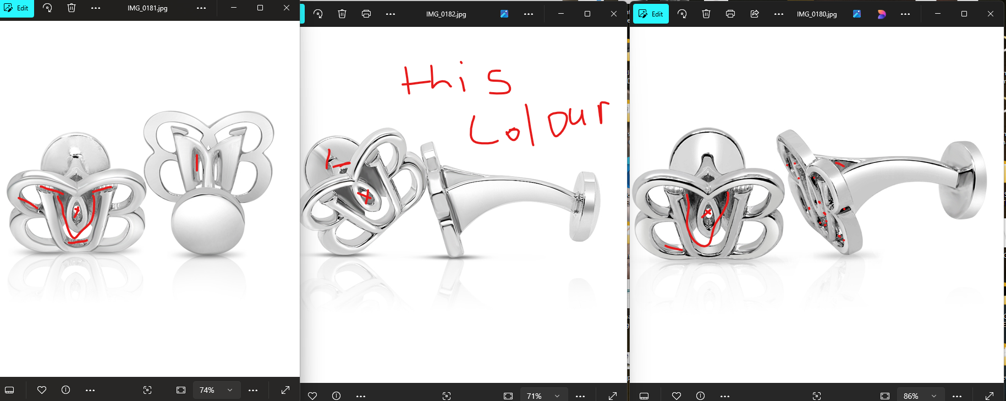

---------------------------------------------------------------------------------------------------------------------

excellent work thank you- go ahead on model now please

