Image Size: 1600 × 657 px- Please make this image into this size

fed10746-5f72-4d2a-a537-55cd1d35efc8-1.jpg

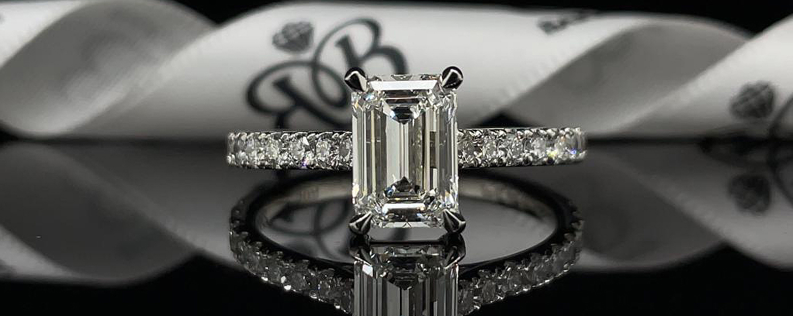
image size:1905 × 741px- Please make this image into this size
SK1069 - Diamond Ring Sketch.JPG
