please review colour its like a pale lilac purple the colour of clear purply amethyst- the other 2 are great thanks
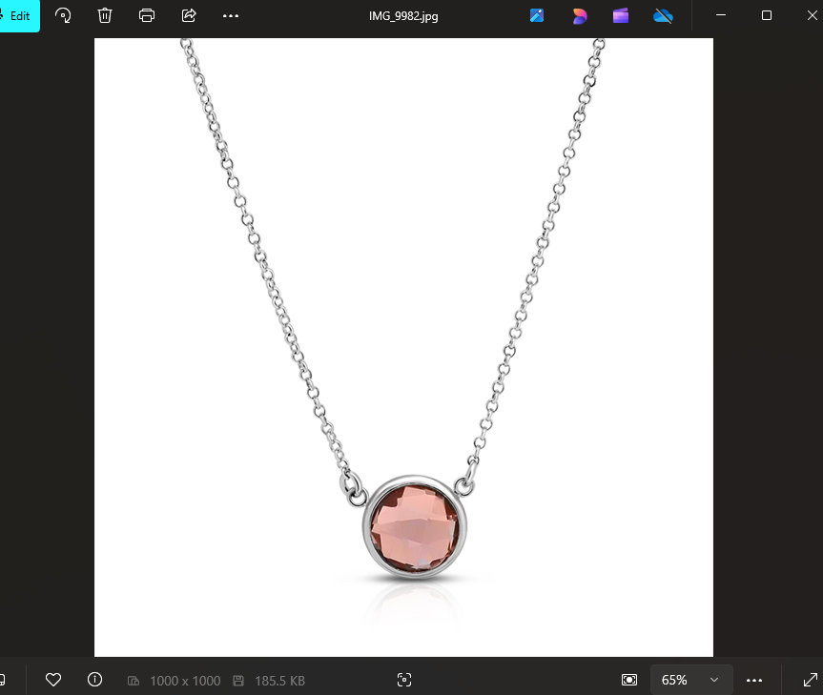

this is the colour for these cufflinks, please review. Thank You

