Please remove the stones like indicated below, please adjust the shadows.

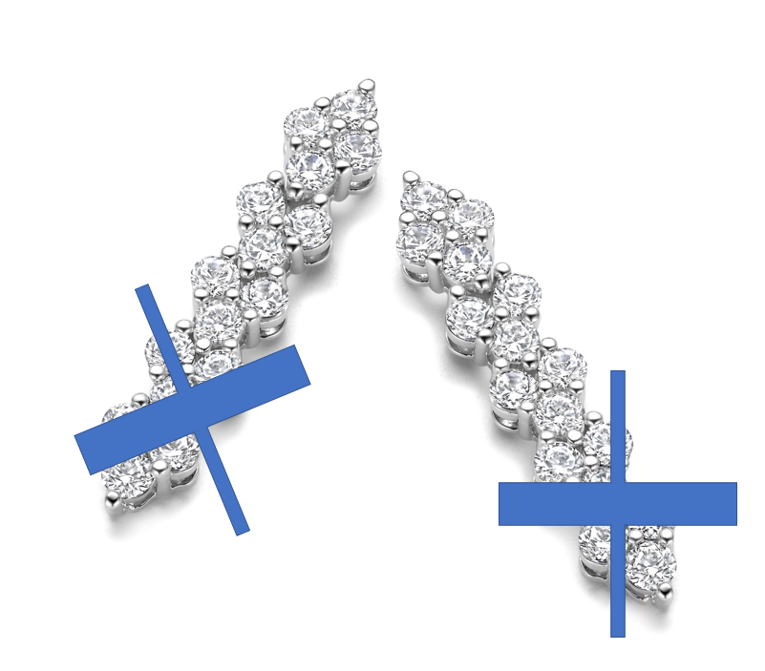

it should have this amount of stones:

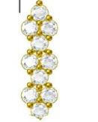

please make it for me in gold and in white.

--

Please send it to me in JPEG and TIFF format.