Attached is a new earring.

Pls send it to me in JPG format and TIFF format.

The layout of this earring should be like the earring below

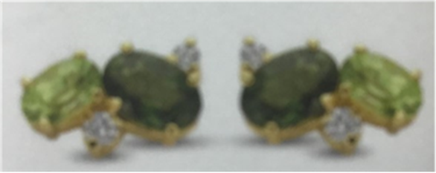

-the plating color is gold plating

-put it on a white background

-add shadow where necessary.

-pls can you make sure all stones are clear and sharp.

--

Please send it to me in JPEG and TIFF format.