Please can you change the indicated stones to

1.aqua, the same as the attached pendant

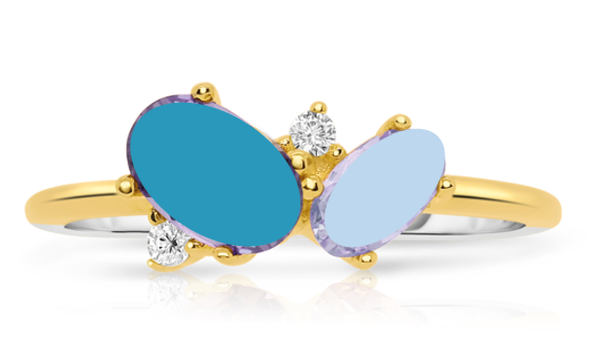

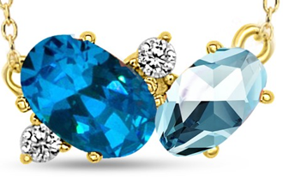

and to 2. pink, the same as the attached pendant

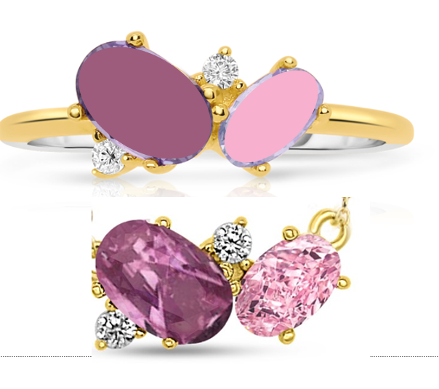

Please send it to me in JPEG and TIFF format.