Luxury Watch Photo Project - Freelancer Brief

Privacy & Access (Non-Negotiable)
- Sign NDA before access
- No portfolio use, sharing, or subcontracting
- Mask all serials/IDs on cards/invoices
- Delete local files after approval

Deliverables per SKU
MAIN_10 folder: 10 square product images
UGC_08 folder: 8 wrist/lifestyle images (no duplicates from MAIN)

The 10 MAIN slots (in order):
- 3/4 hero - dial readable, premium look, clean background

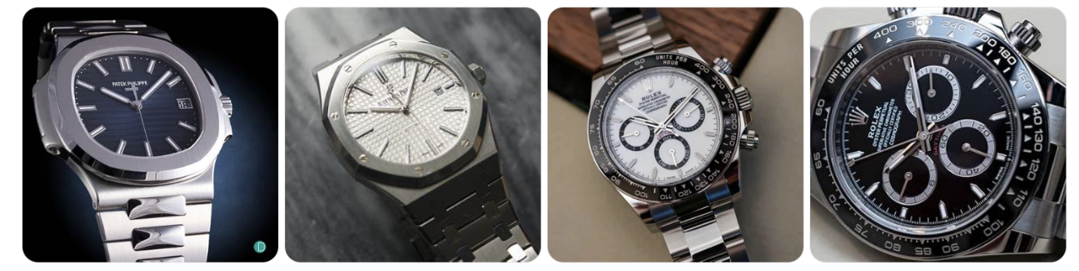
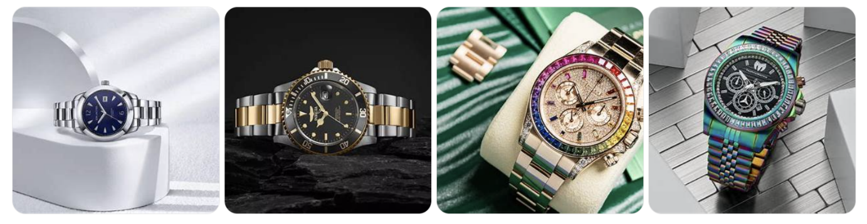

- Straight dial - perfectly centered, round bezel, lowest glare (verification shot)

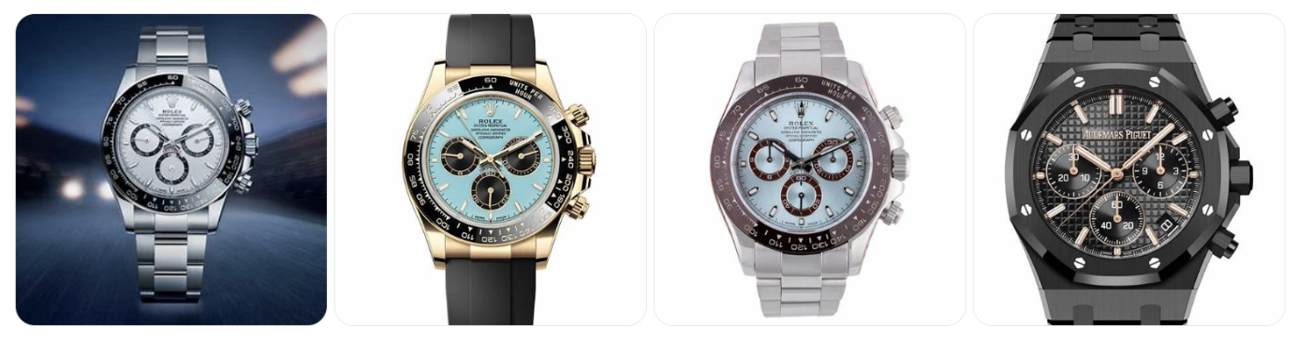
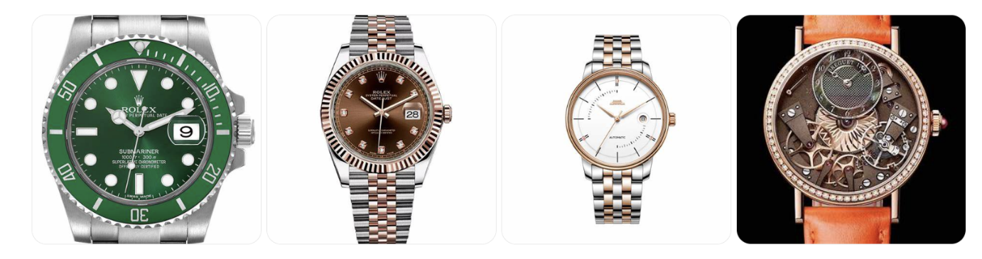

- Wrist/scale - shows real size, sharp, natural proportions

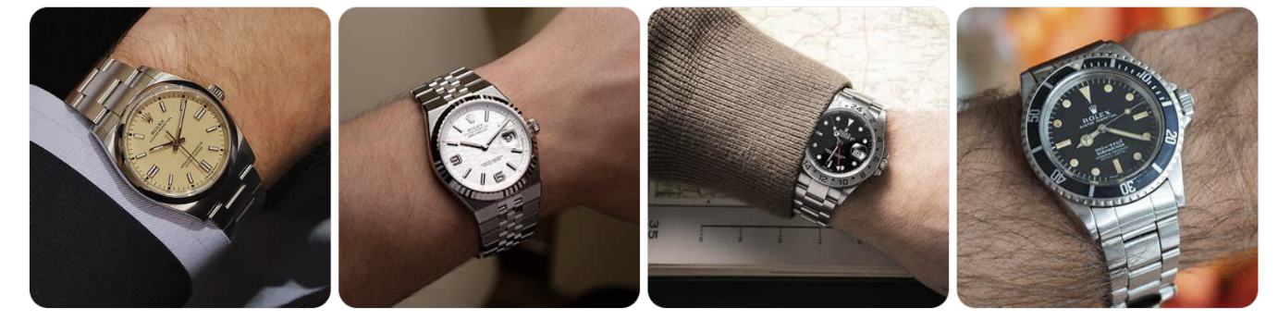
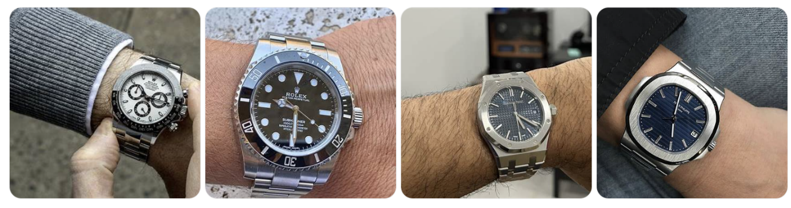
- Dial macro - brand text + indices readable, authenticity proof

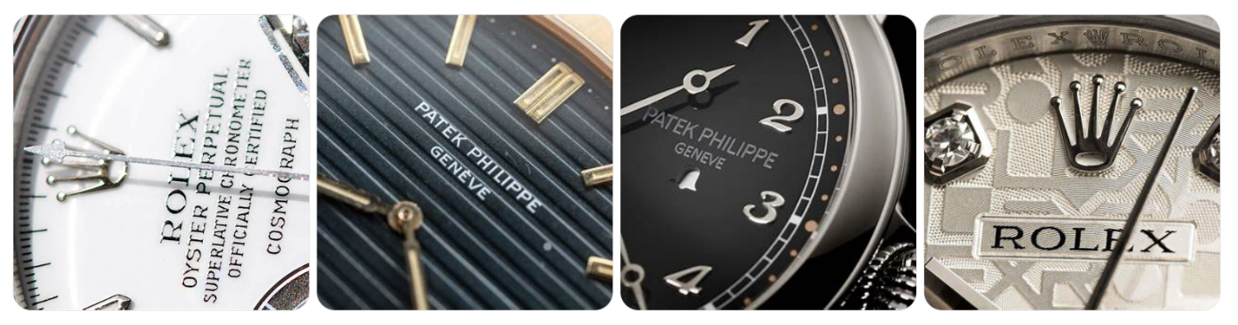
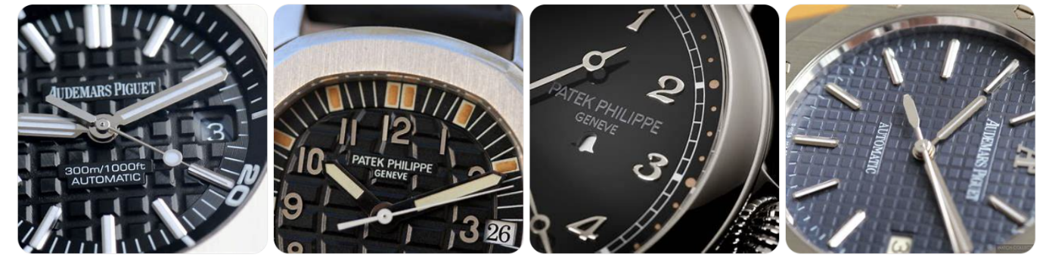

- Side + crown - case thickness, crown detail clearly visible

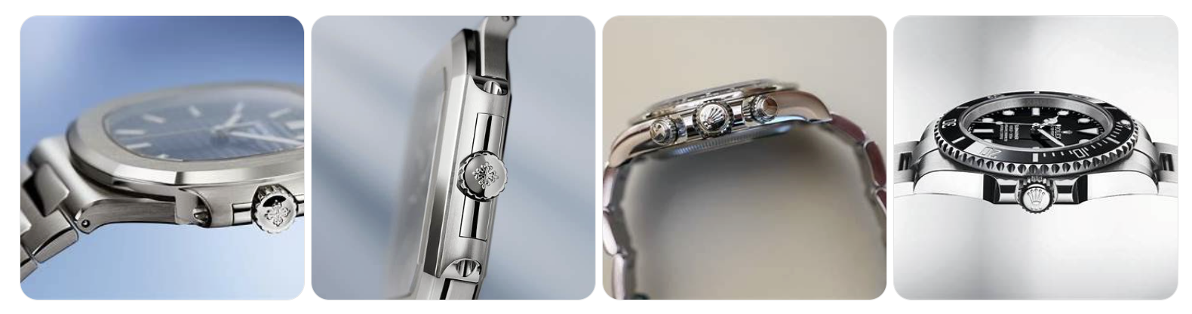
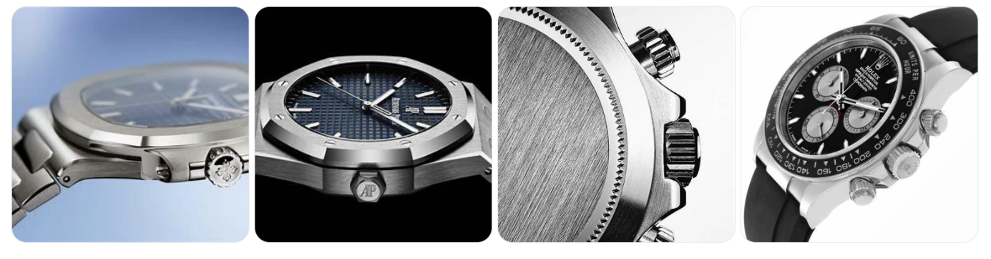
- Clasp/bracelet - brushing/polish finish clearly shown

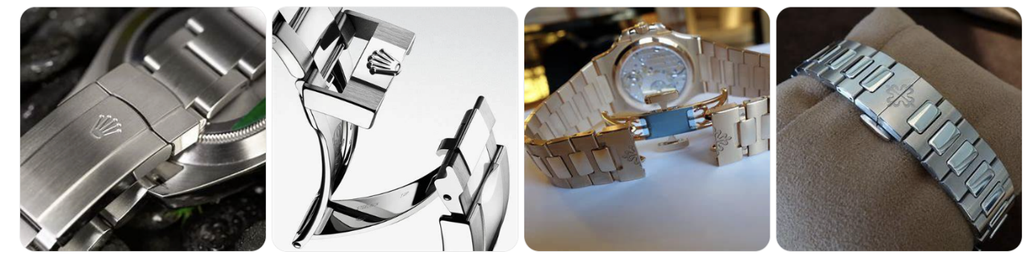
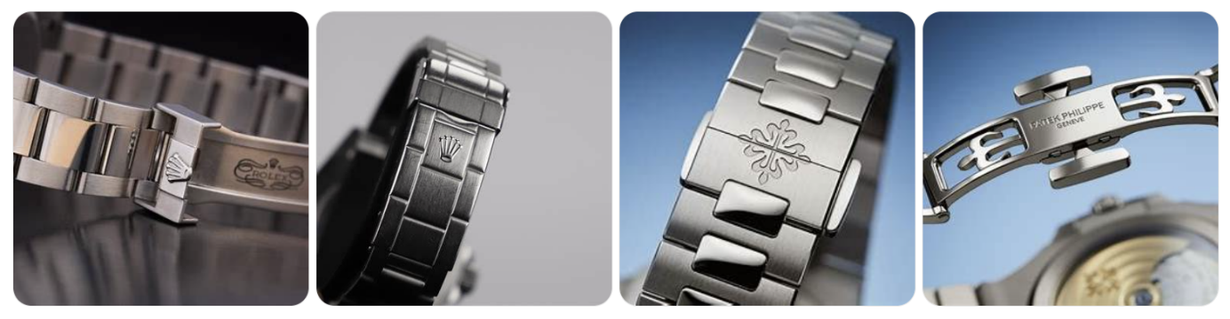
- Caseback - movement visible and sharp

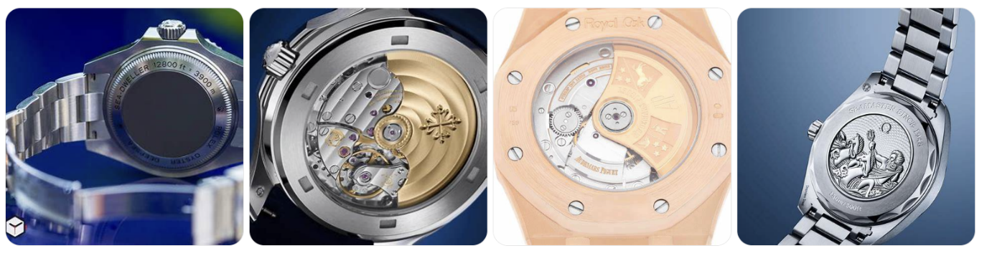
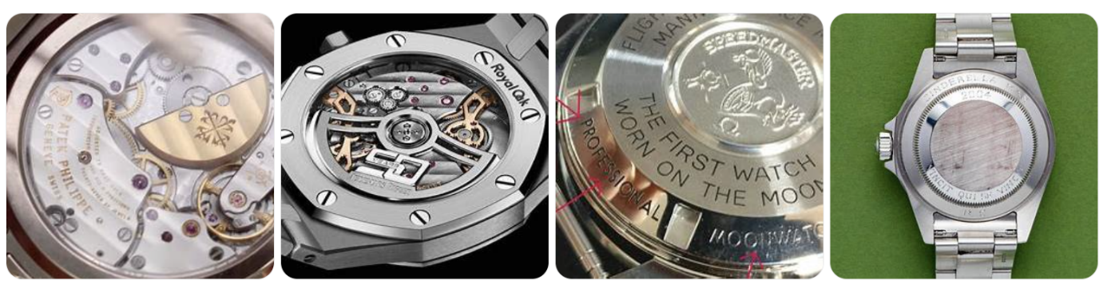

- Bezel/crystal macro - flawless look, edge detail clear

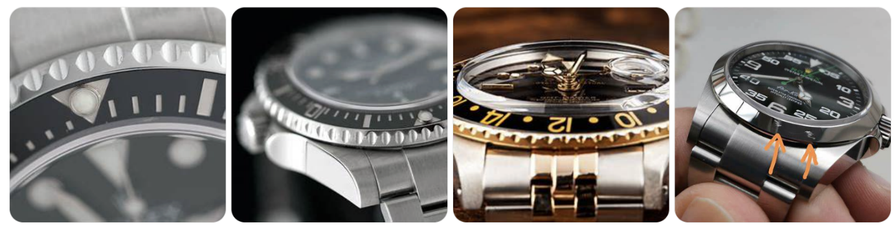
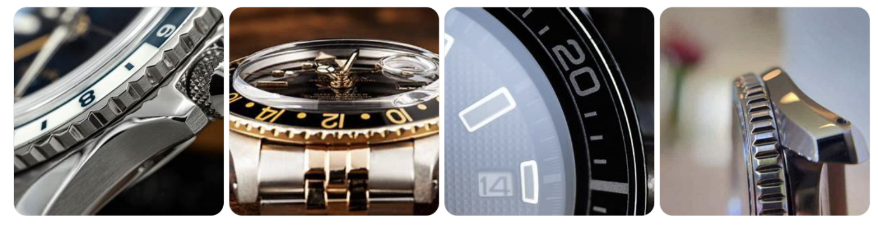

- Full set/box - mask IDs; if missing, use best proof macro

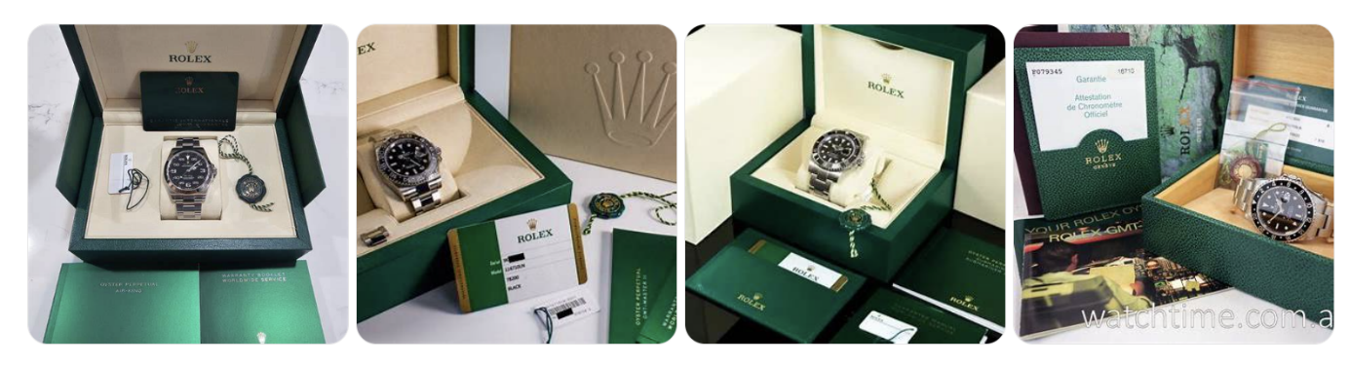
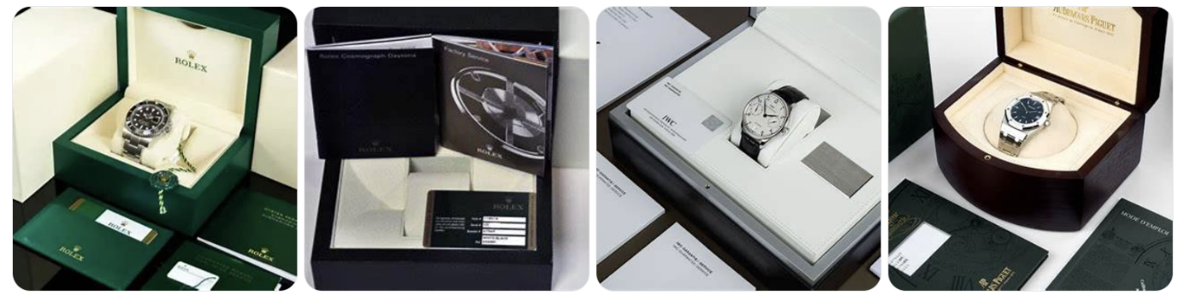

- Lume OR scale - premium lume only; otherwise use context/scale shot

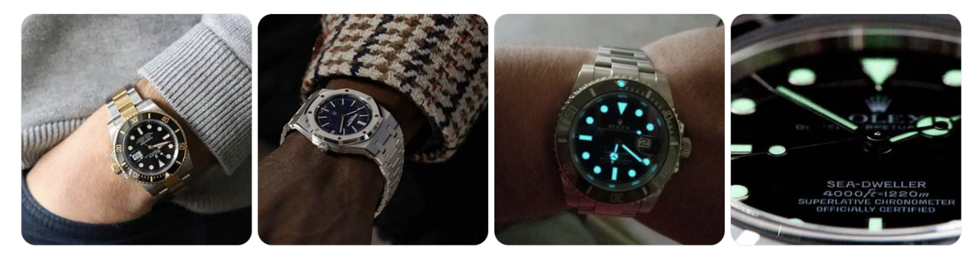

UGC_08 requirements:
- 8 varied wrist shots (different angles, lighting, contexts)
- At least 6 sharp wrist shots + max 1 lifestyle + 1 proof shot
- No bathroom/messy backgrounds
- No heavy filters or distortion
Wrist priority - but if not, we can take the others

Technical Specs
Format: Square JPEG, sRGB, 90-95% quality
- Target: 2000×2000px (don't force upscaling from small sources, you can do 800X800 and above)
- File size: <500KB per image
- Remove EXIF metadata
- Crop/recenter only - no padding, stretching, or canvas extension

Retouch Standards (Luxury/New Watches)
Must do:
- Remove dust, fingerprints, smudges (new condition)
- True-to-life colors (sRGB, consistent white balance)
- Dial perfectly level, 4-6% margin around watch
- Preserve brushed vs polished finishes
- Control reflections but keep premium shine
- Neutral white/light gray background with soft shadow
Must avoid:
- Heavy HDR or beauty blur
- Chrome halos or plastic look
- Over-sharpening (no halos on text)
- Trendy color grading
- Fake textures
Check at 100% zoom before export

File Naming (Critical)
MAIN: SKU_CODE_01_hero.jpg through SKU_CODE_10_scale.jpg
UGC: SKU_CODE_90_ugc_01.jpg through SKU_CODE_90_ugc_08.jpg

Folder Structure
DELIVERY_SITE1/
SKU_CODE/
SITE1_SELECTED/MAIN_10/ (10 files)
SITE1_SELECTED/UGC_08/ (8 files)
MININOTE.doc (explain slot choices)
ALT_SITE2_CANDIDATES/ (optional: 15-20 unused alternates)

Mini-Note Required
Write 2-3 lines per SKU explaining why you chose specific shots for key slots (#1, #2, etc.)

Workflow
- Start with 1 paid/free TEST SKU
- Work in batches of 10 after approval
- Update manifest status: Not started → Editing → Delivered
- QA reviews each batch before import

Selection Priority (CRO-First)
When choosing between similar photos, always pick:
- Clearest dial readability
- Less glare
- Sharper focus
- Cleaner background
Clarity > artistic style

