there are a couple of issues with some images. The following images hand tone is very off. Please correct on all 3 crops for the following images.

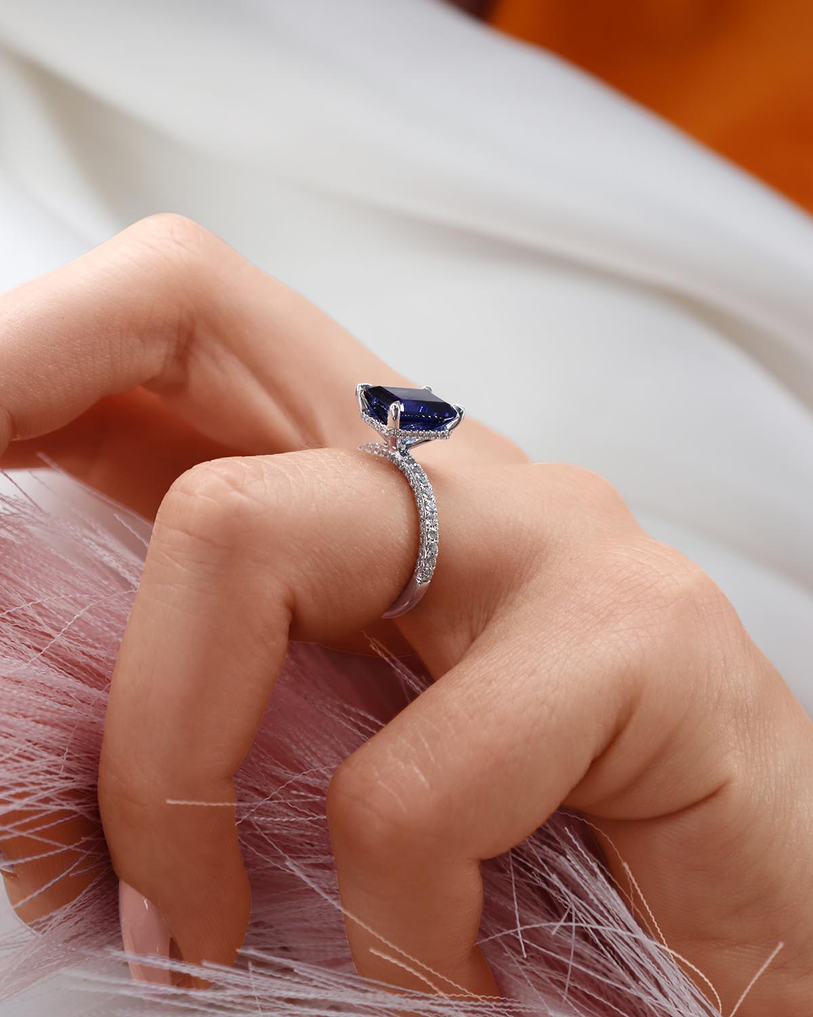

Please see the images that need editing: