Can you please photoshop these items into their boxes?
This is an example to get an idea of the proportions

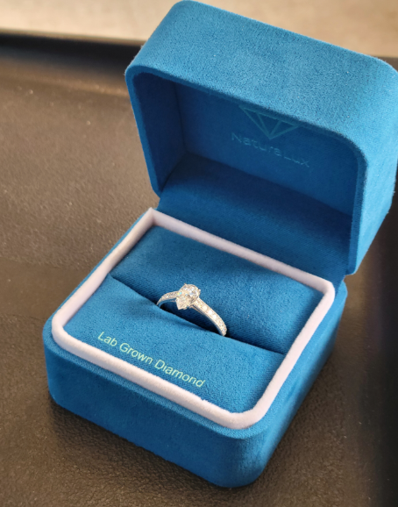

For the “bracelet boxes”, I don’t have a flat tennis bracelet, I sent what I have. Can you use that, or are you able to get from the web?
Should look something like this.

