Please re-edit the product below because the color does not match.

Thank you.
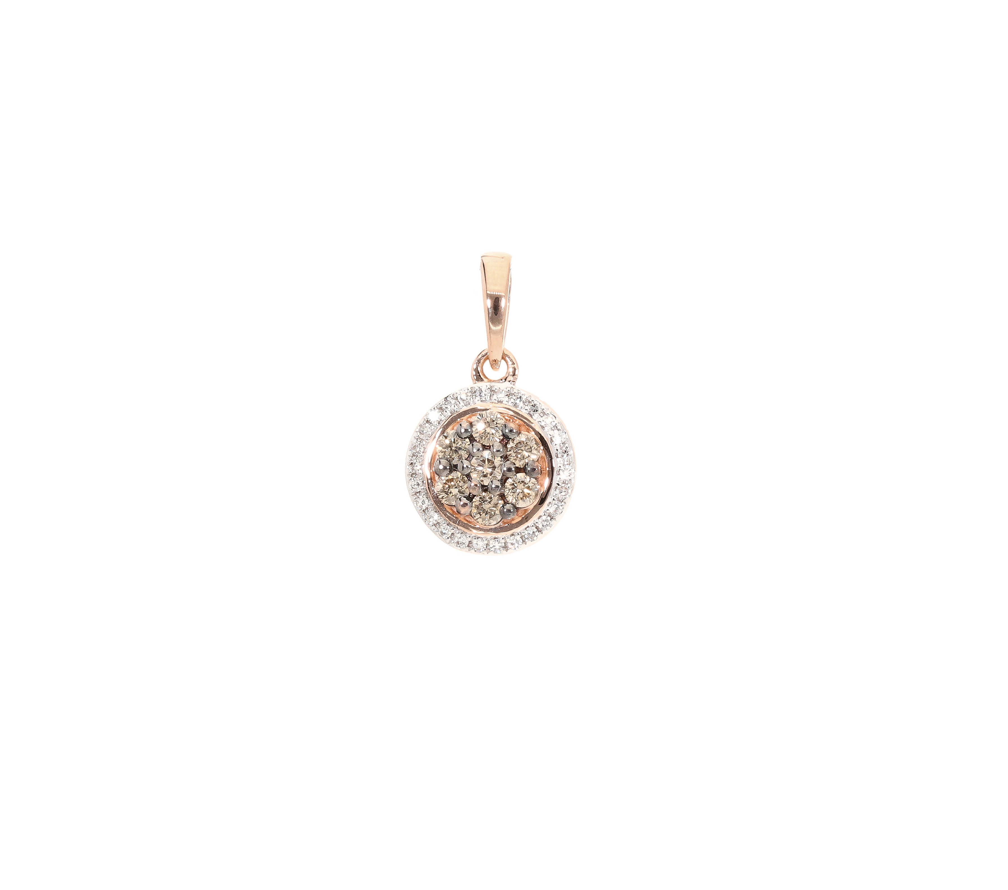

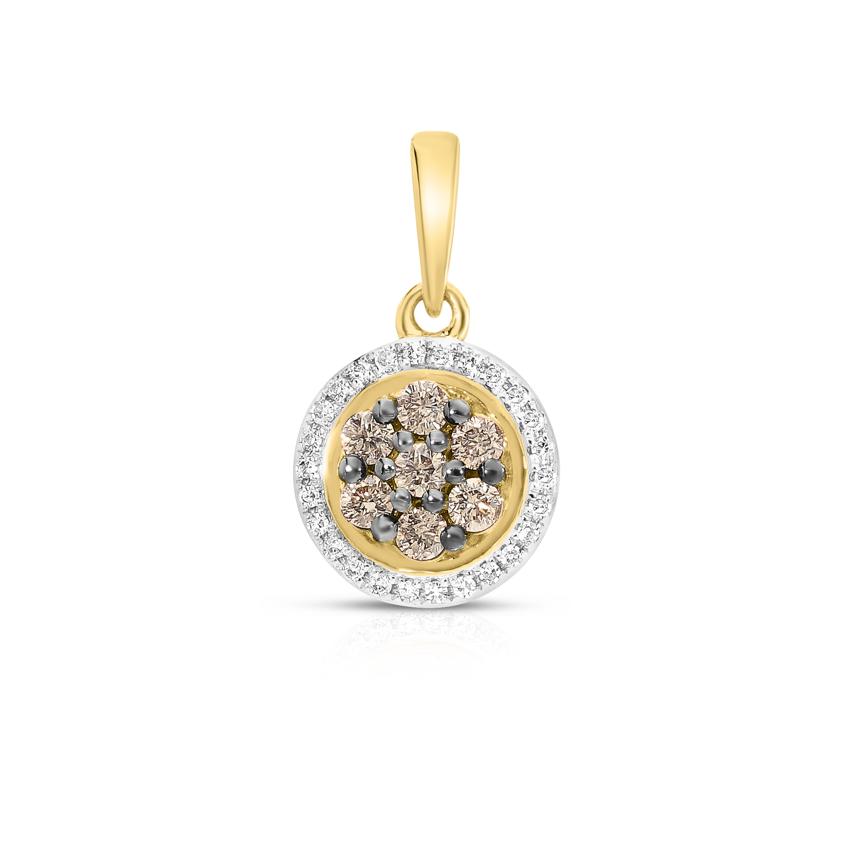

You have to do it in rose gold and you did it in yellow gold.

The code below is missing in the folder EC-FACT.1432-13.12.2024 SITE. Please edit it.

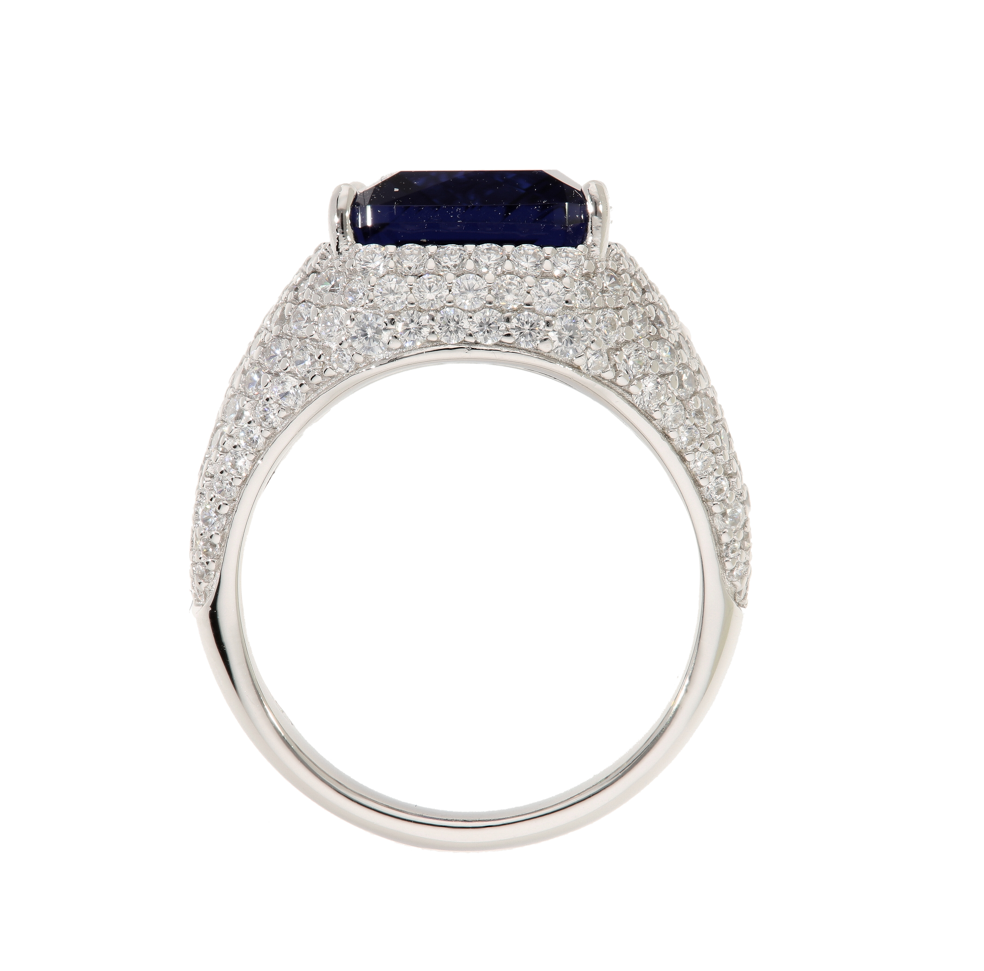
This ring is missing the stone on the top. Please re-edit it. Thank you.

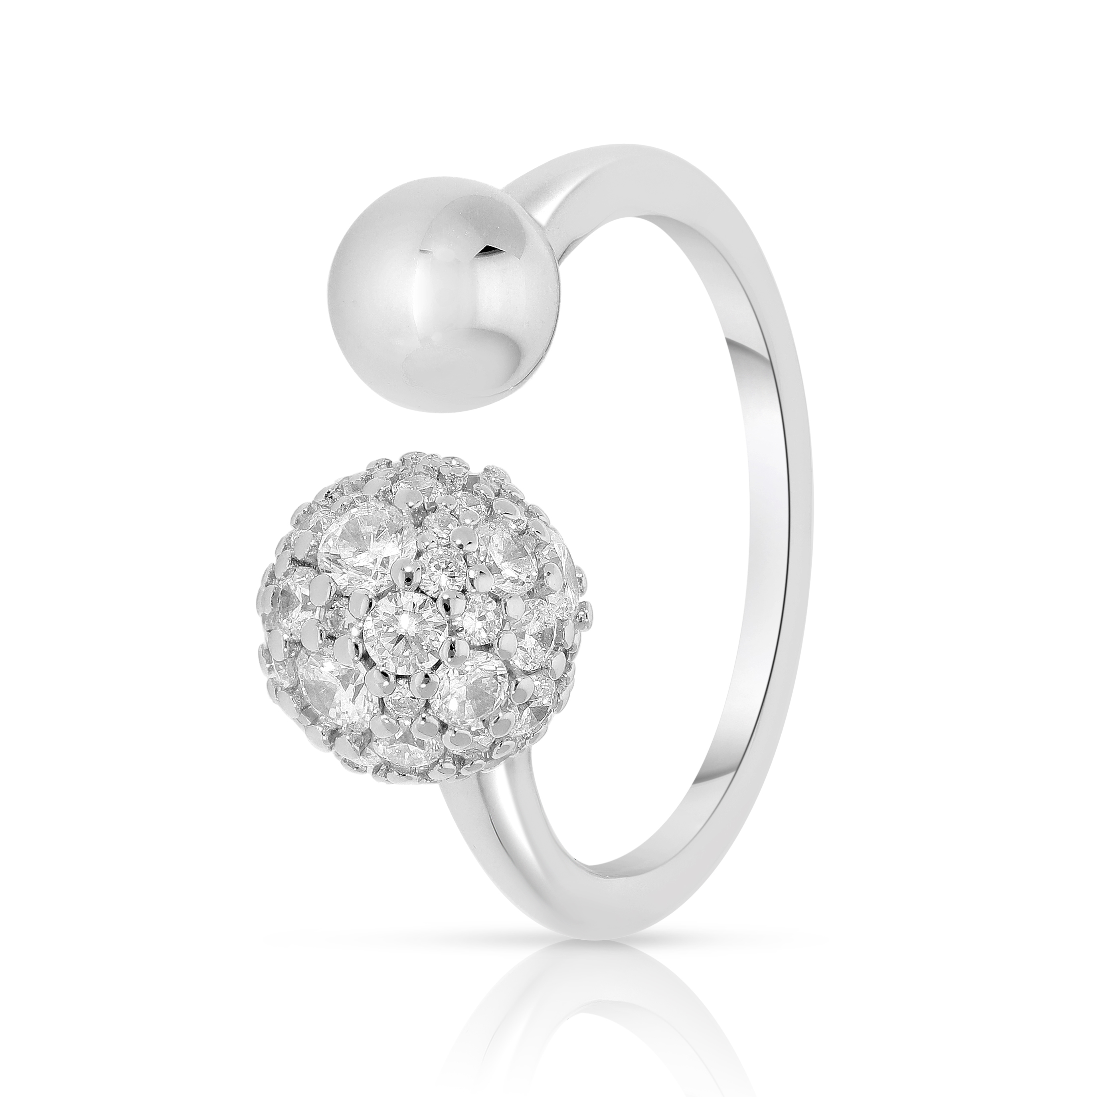
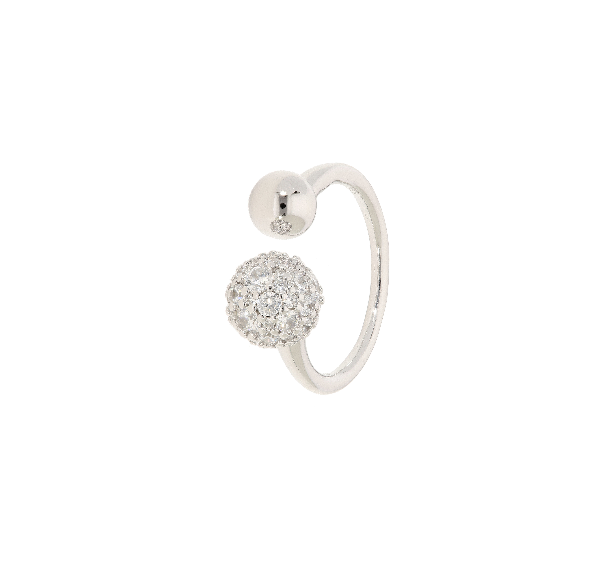

Also, please re-edit this product. The color does not match the original.

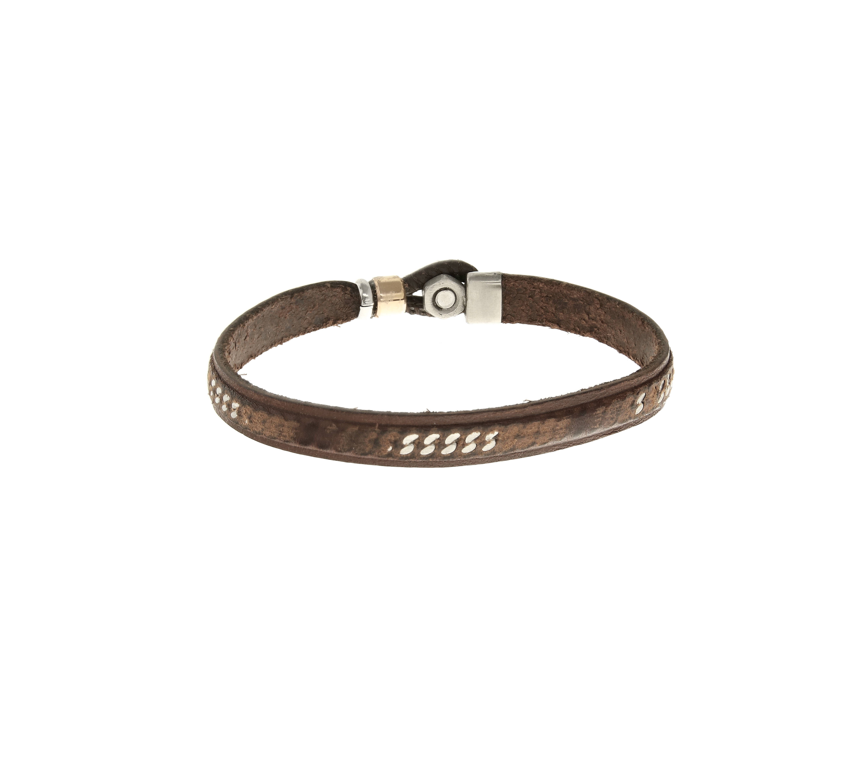
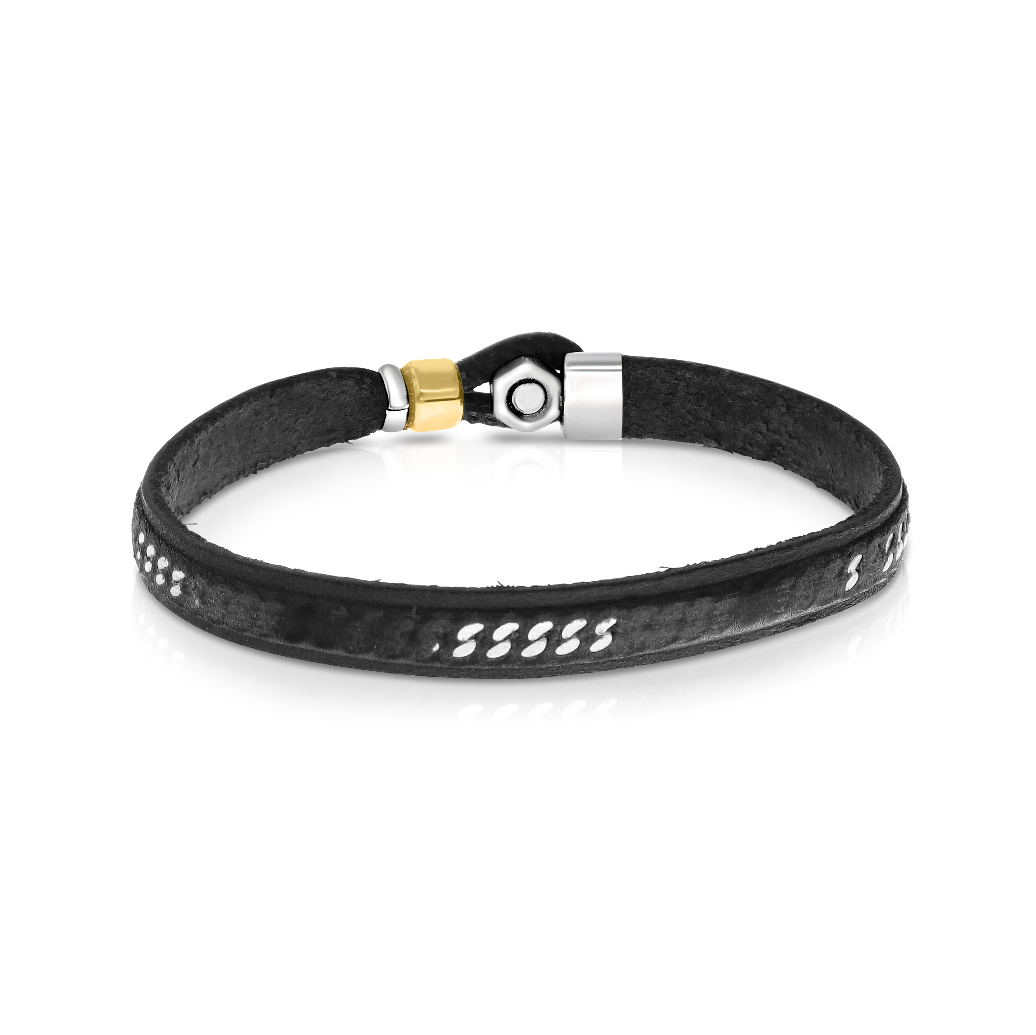
This product does not need to be re-edited. Thank you and sorry,

