<https://drive.google.com/drive/folders/1uMF9PpzCNyS6LoTL3ksz--nYpV5WQy3u?usp=drive_link>

Here is the new batch.

All products are pendants.

We want 3 pictures per product. First one only pendant. Second one with chain. And the third one from diagonal angle, the chain and pendant together on the ground.

Like this

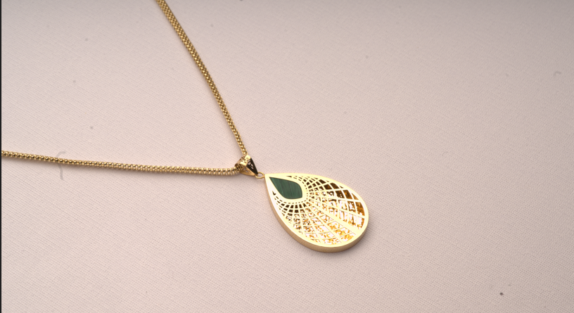

All the photos should be in the same position and please use the same chain for all the pendants as shown in the pictures that I shared with you

Products in the Folder number between 1-10 should have 3 photos. (Just Pendant, chain & pendant and diagonal angle)

Products in the folder number between 11-15 should have 2 photos.

One is from front angle and the other one is as shown above

Total 40 photos