GHP15428Y4-0-0

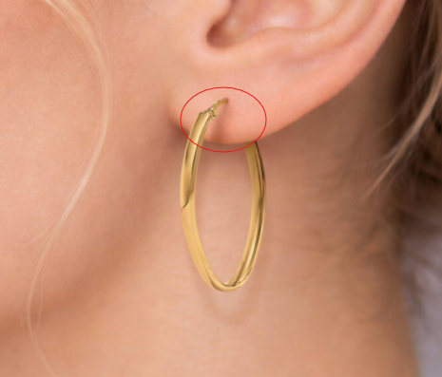

GHP13733Y4-0-0
please fix roughness in circle

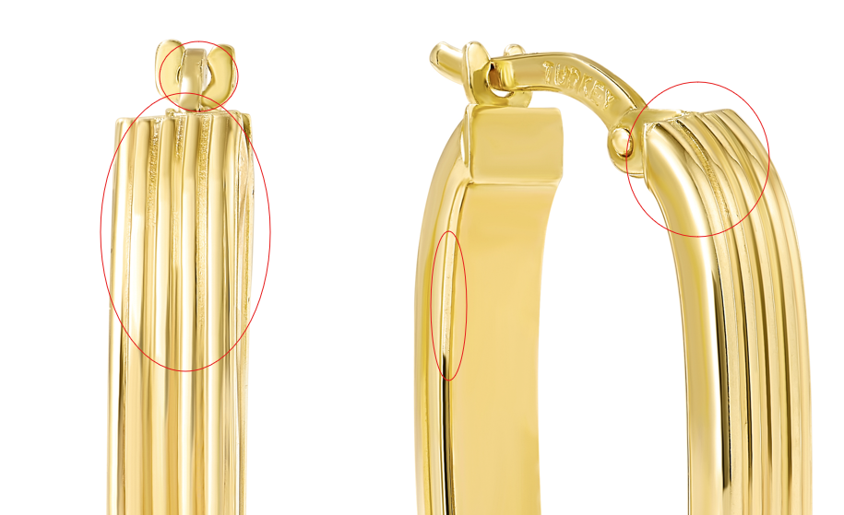

GHP15574Y4-DC-0

