GEG20073T4-0-0

clean up roughness, make line even

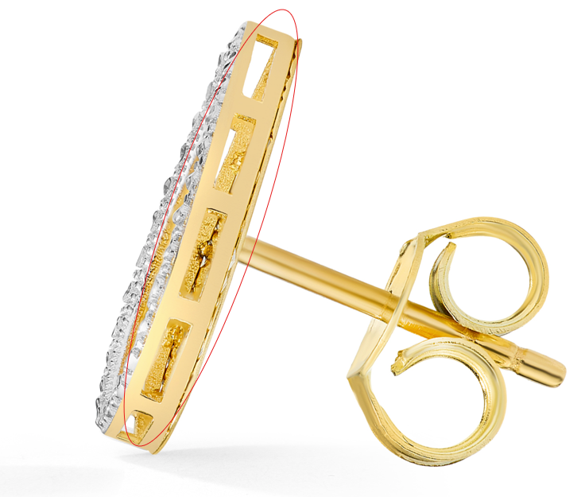

GEG17311Y4-0-0
Add Overstock Model Shots

GEG20173Y4-0-0
Needs Overstock Model Shots, fix links
please make seam here even
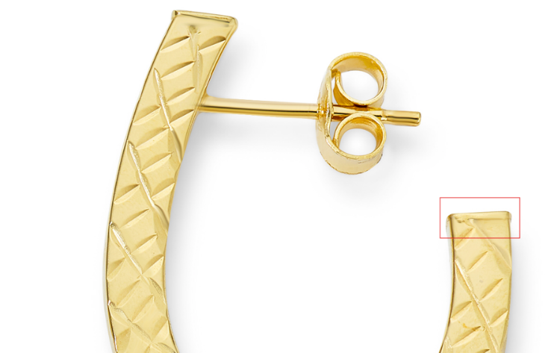
GEG17732Y4-0-0
Add Overstock Model Shot

GEG17732Y4-0-0
Add Overstock Model Shot

GEG17732Y4-0-0
again please clean these marks

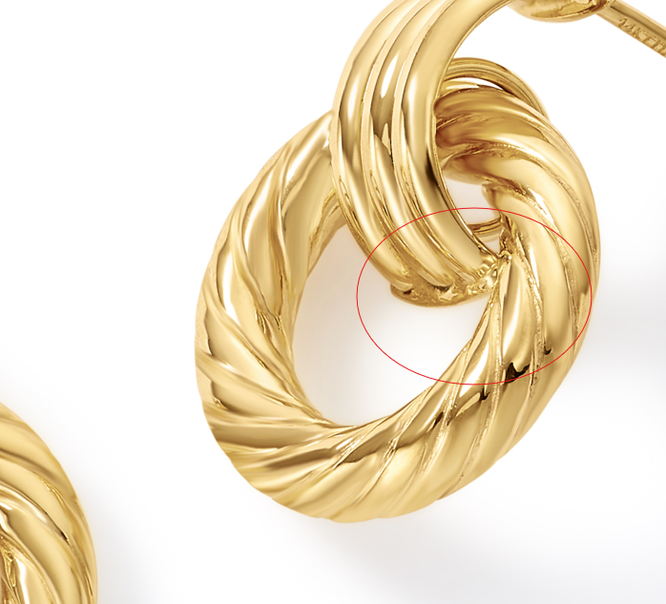

GHP20252R4-0-0
Add Overstock Model Shot

GHP20267T4-0-0
Add Overstock Model Shot

GHP20267T4-0-0
please make the silver color go to the gold seam

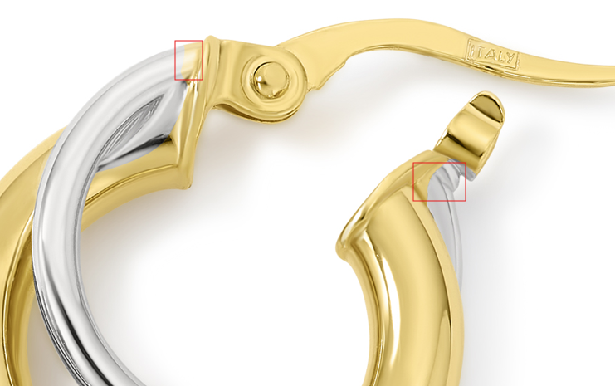

GEG20249Y4-0-0
Needs Overstock Model Shots, fix links

GEG20255Y4-0-0
Needs Overstock Model Shots, fix links

GEG20255Y4-0-0
Needs Overstock Model Shots, fix links
GEG20276Y4-0-0
Needs Overstock Model Shots, fix links
please clean up jumprings

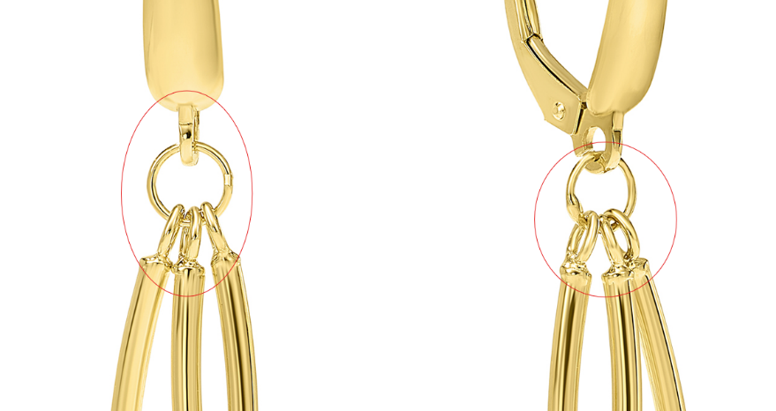

GEG20276Y4-0-0
Needs Overstock Model Shots, fix links

GEG20183Y4-0-0
Needs Overstock Model Shots, fix links

GEG20278T4-0-0
Needs Overstock Model Shots, fix links
Please clean up jumprings

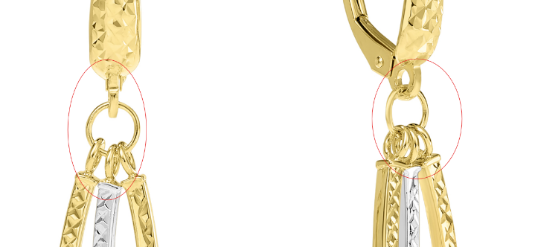
GHP20257Y4-0-0
Needs Overstock Model Shots
This is the width
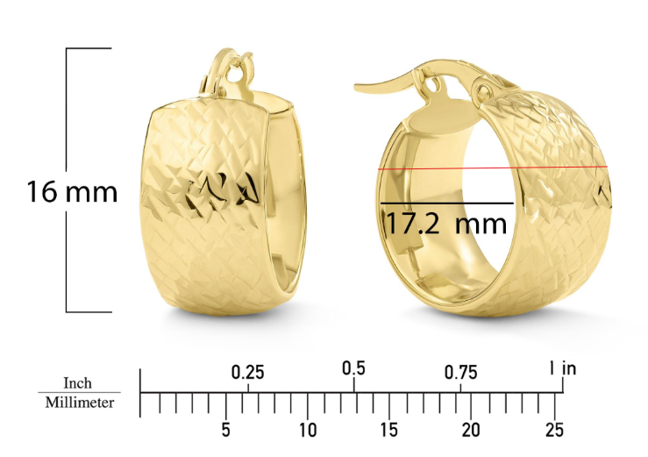

GHP20257Y4-0-0
Needs Overstock Model Shots

GHP20040Y4-0-0
Add with in ruler shot
Needs Overstock Model Shots, fix links

GHP15072Y4-0-0
needs Overstock model image

GHP15072Y4-0-0
please clean up marks

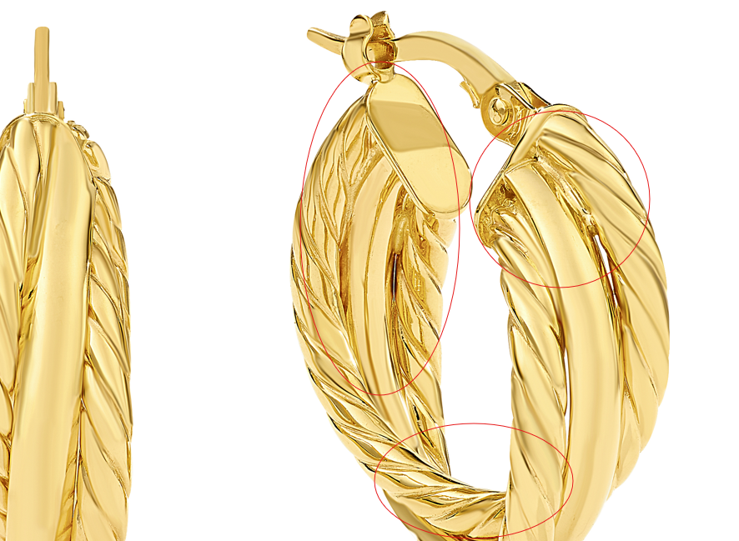

here too, thanks
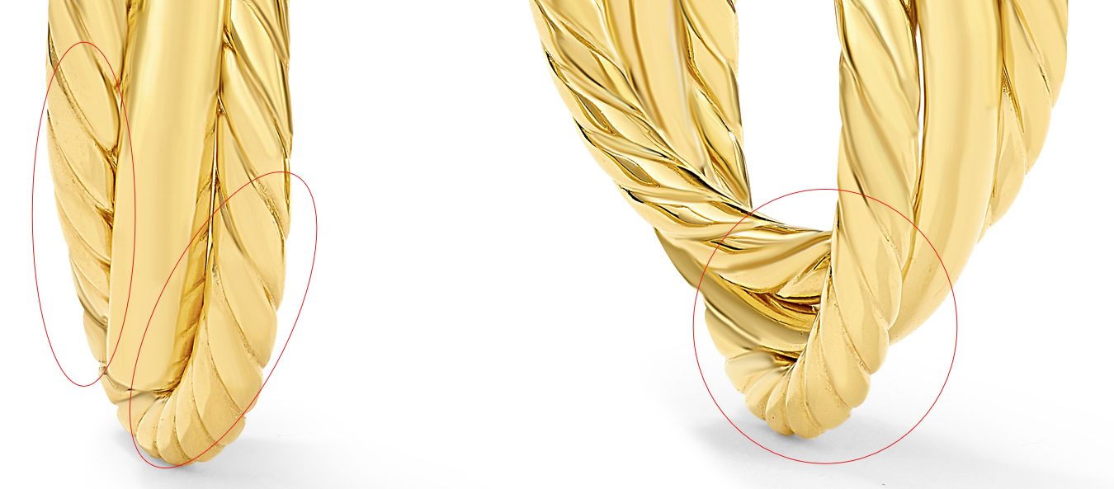

GHP16040T4-0-0
Add Overstock Model Shot
Please clean up roughness

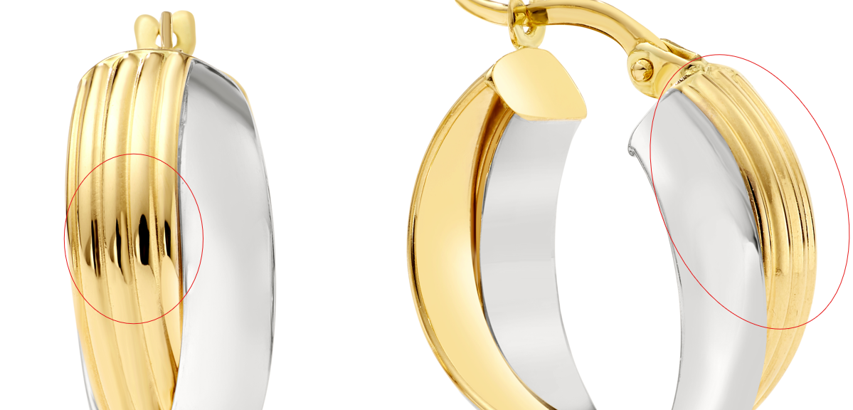

GEG20227Y4-0-0
Needs Overstock Model Shots, fix links
please clean these marks
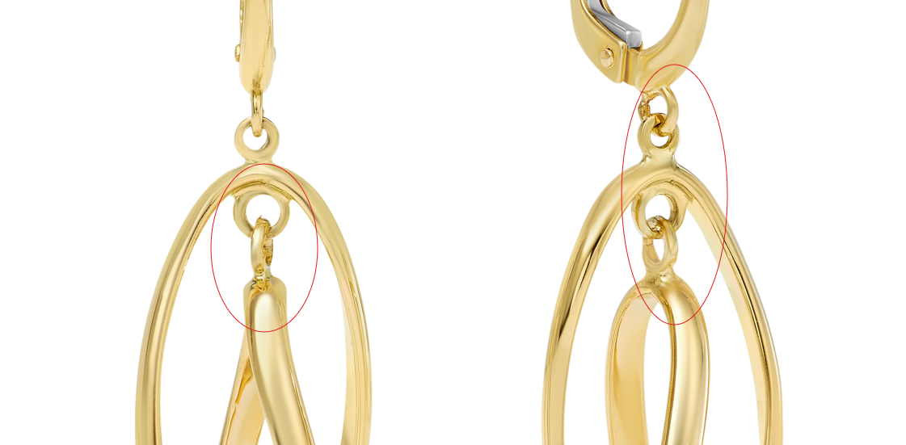
GEG20244Y4-0-0
Needs Overstock Model Shots, fix links
can you please clean this up and remove reflections

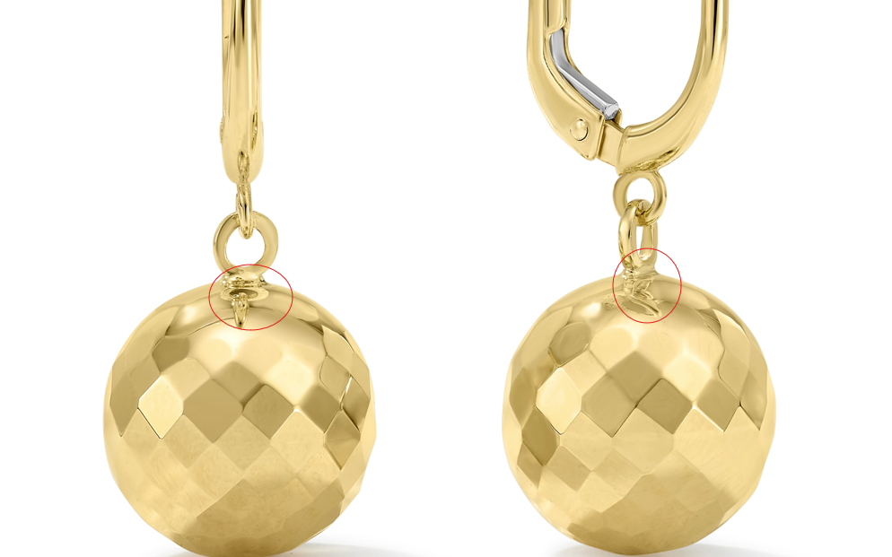

GEG15714T4-0-0
add ruler shot
can you please clean up these silver lines and make color and shape more even

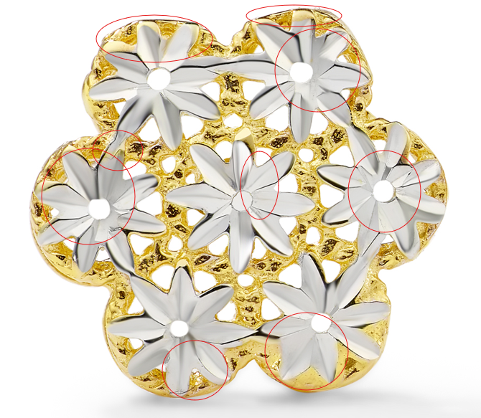
GHP20109Y4-0-0
Needs Overstock Model Shots, fix links

GHP15428Y4-0-0
Needs Overstock Model Shots, fix links

GHP13733Y4-0-0
add Overstock model shot
again please fix
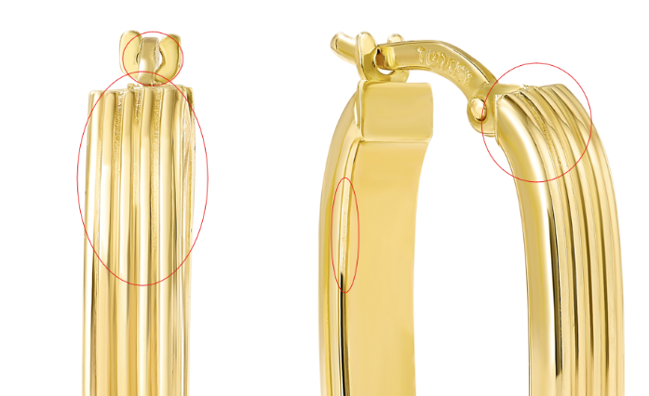

GHP20014Y4-0-0
Add Overstock Model Shot
shorten post
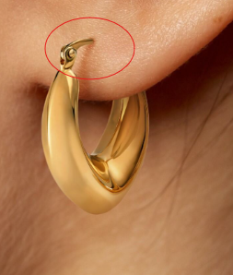

please clean up scratch marks
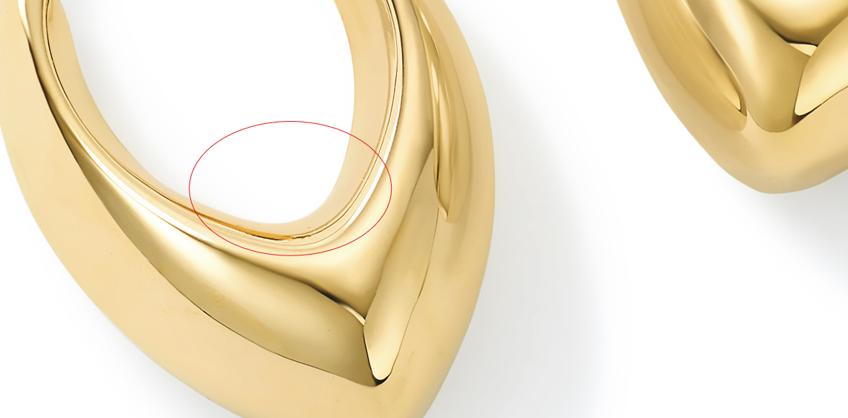

GHP15574Y4-DC-0
Needs Overstock Model Shot
please make both of these the same size
