CLP11421Y4-PD-0

please add measurements

please fix marks



CHN11472Y0-0-18
this is the width

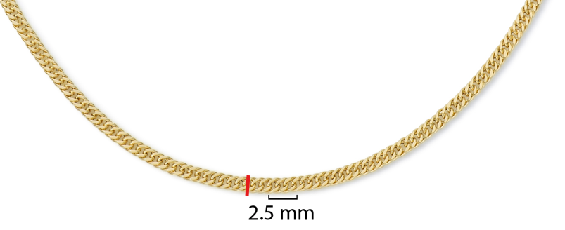

CHN11425Y0-0-20
clean up rough marks and dust

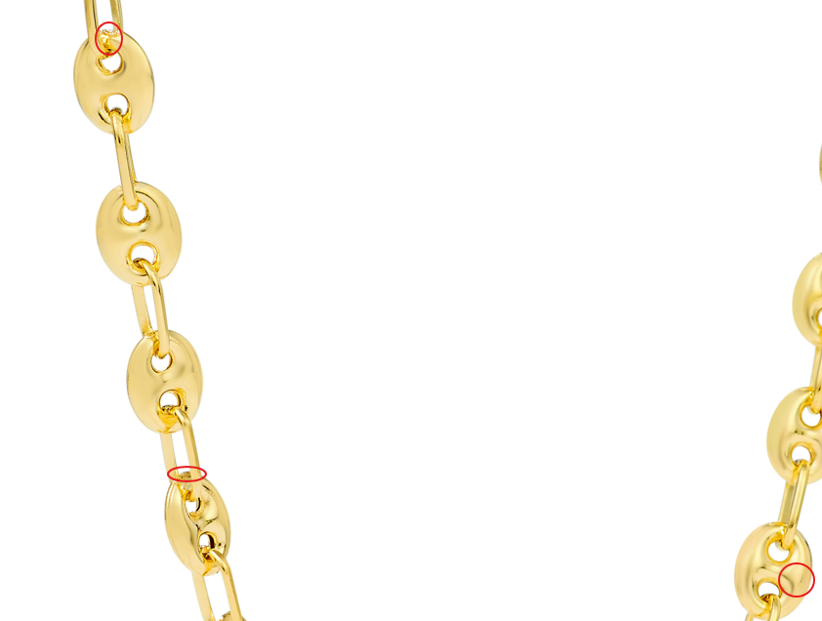

GCH20168T4-0-0
again please fix, make lines clean

GCH14795T4-0-0

please fix these marks

