Hoop Group Shots

We need a group shot of the following, both front & side profile:
GHP20401Y4-0-0
GHP20402Y4-0-0
GHP20403Y4-0-0
GHP20404Y4-0-0

We need a group shot of the following, both front & side profile:
GHP20413Y4-0-0
GHP20414Y4-0-0

GCH14795T4-0-0
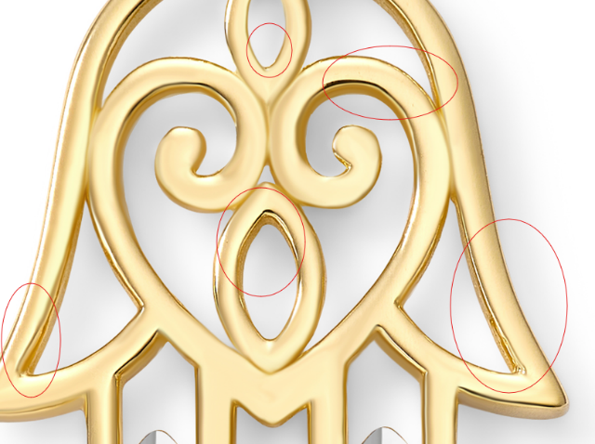

GCH14724T4-0-0

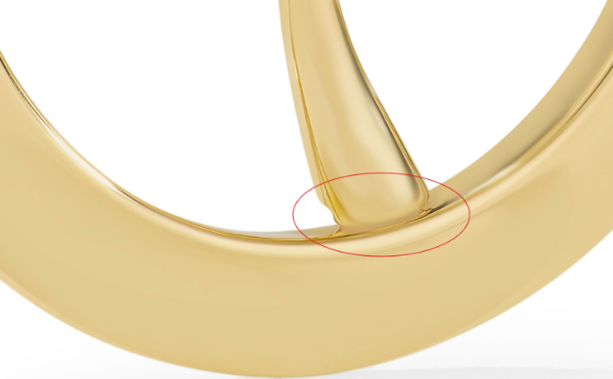

GBA20187Y4-0-7.5
Overstock
And rest of the images

GNK14475Y4-0-16.18

GCH15233T0-TUA-0
Add both model images
Use rope chains in this folder: Chains for Model_Yellow

GCH15233T0-TUA-0
Add both model images

GCH15233T0-TUA-0
Use rope chains in this folder: Chains for Model_Yellow

GCH15233T0-TUA-0

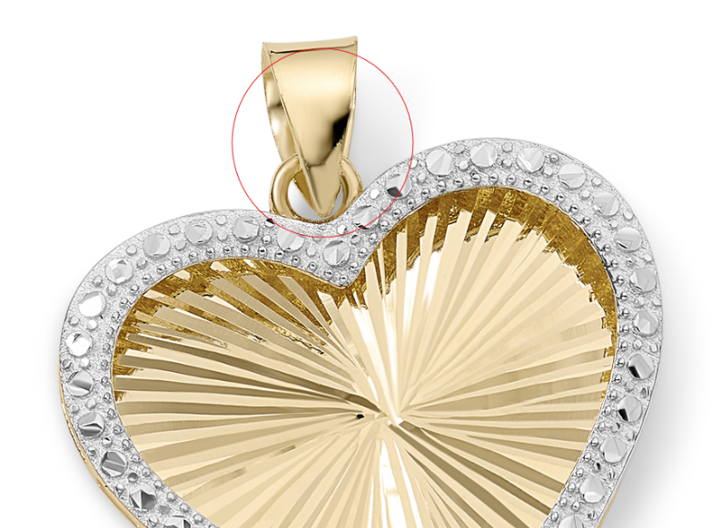

GNK14213T4-0-16.18
please fix this on jumpring

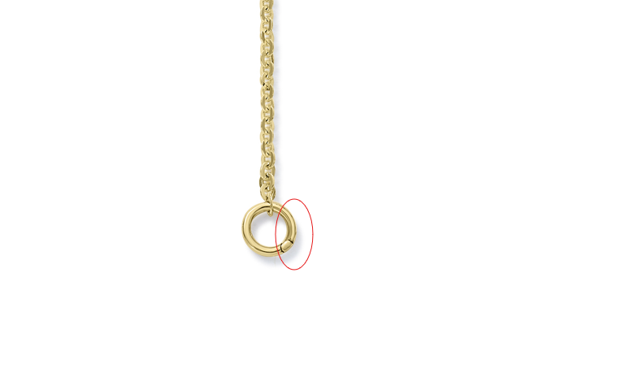

GNK13847Y4-0-16.18
add Overstock model shot

