GCH20168T4-0-0
again please fix, make lines clean
Please add Overstock model with just 18-20" rope chain

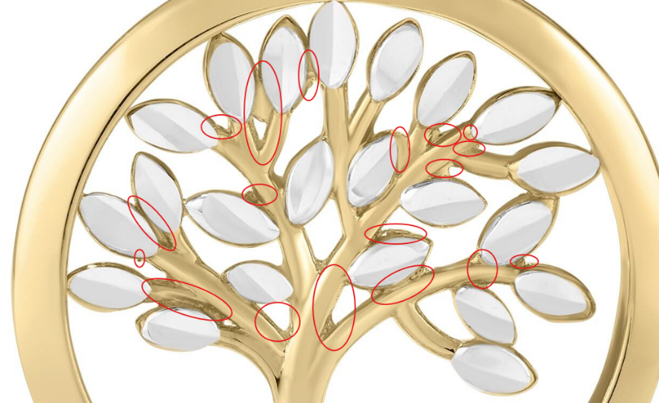

GCH15417Y4-0-0
Please only use rope chain

GCH15417W4-0-0
Please only use rope chain

GCH15496T4-0-0
Please only use rope chain
just 18-20" rope chain

GCH15063Y4-DC-0
Please only use rope chain

GCH14795T4-0-0
Please only use rope chain
please fix these marks

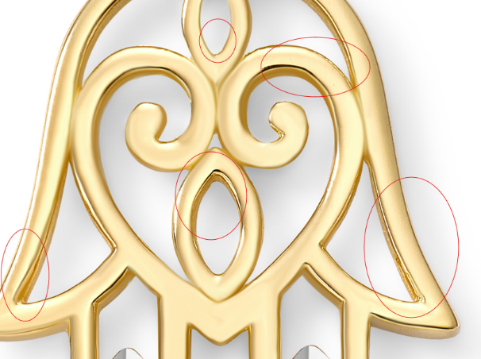

GCH15360Y4-0-0
Please only use rope chain
make lines clean and even
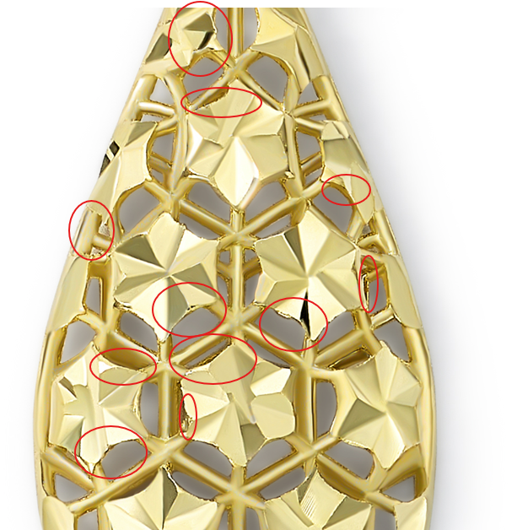

GCH14724T4-0-0
Please only use rope chain

