GNK20071Y4-0-18
Please add Overstock Necklace Model shot

GNK14477Y4-0-16.18
Please add Overstock Necklace Model shot

GNK14476Y4-0-16.18
Please add Overstock Necklace Model shot

GNK14475Y4-0-16.18
Please add Overstock Necklace Model shot
please fix bottom circled

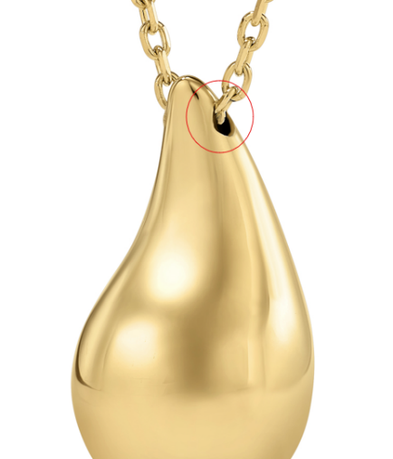

GNK14467Y4-0-16.18
Please add Overstock Necklace Model shot

GNK14213T4-0-16.18
please fix
Please add Overstock Necklace Model shot
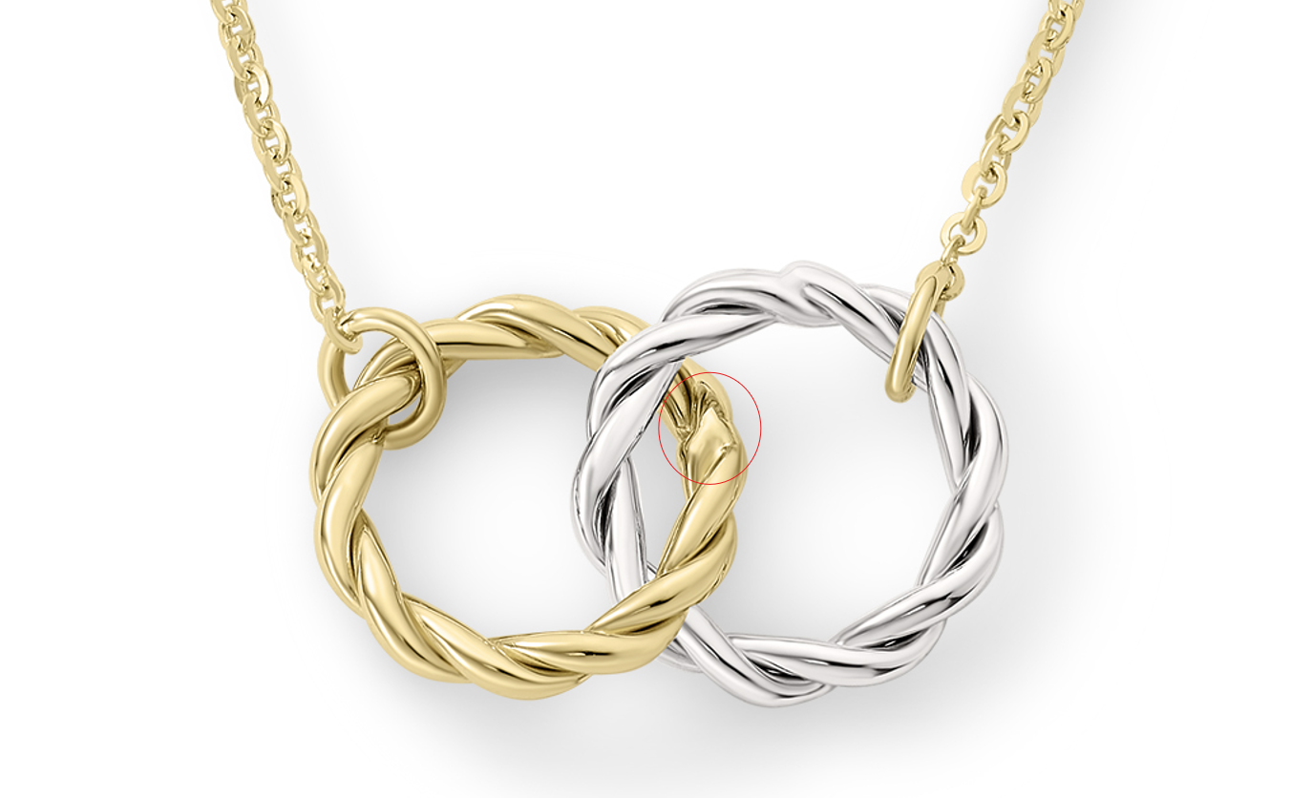

GNK14173Y4-0-16.18
Please add Overstock Necklace Model shot

GNK14104T4-0-16.18
Please add Overstock Necklace Model shot

GNK13847Y4-0-16.18
please add pendant size on ruler image
add 4 X 25.5MM pendant size

