GCH20078T4-TUA-0

Please add Overstock model with just 18-20" rope chain

GCH15496T4-0-0
needs overstock model photo
just 18-20" rope chain

GCH15360Y4-0-0
Please add Overstock model with just 18-20" rope chain

GCH15360Y4-0-0

make lines high polished in image A and B

clean up rough lines

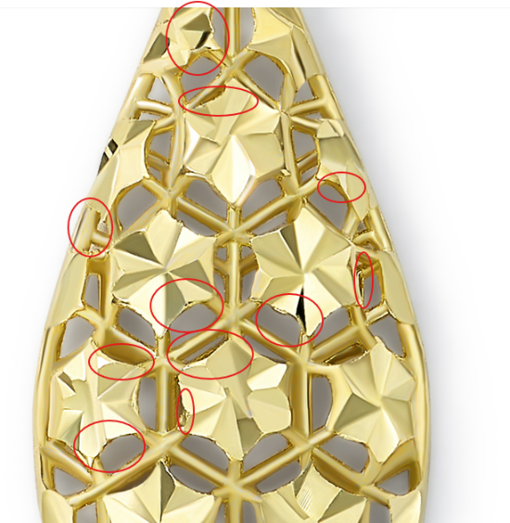

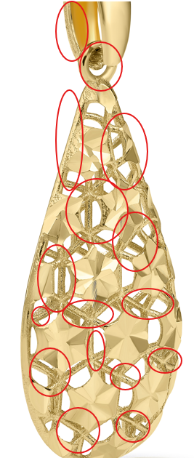

GCH15063Y4-DC-0
Please add Overstock model with just 18-20" rope chain

GCH15063Y4-DC-0
Please add Overstock model with just 18-20" rope chain

GCH14795T4-0-0
Please add Overstock model with just 18-20" rope chain

GCH14795T4-0-0
Please add Overstock model with just 18-20" rope chain

GCH15233T0-TUA-0
Please add Overstock model with just 18-20" rope chain

GCH14724T4-0-0
Please add Overstock model with just 18-20" rope chain

GCH14724T4-0-0
again please fix

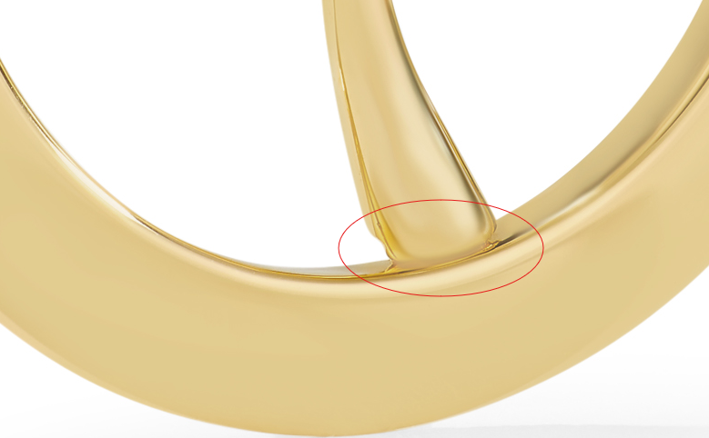.

GCH15417W4-0-0

Please add Overstock model with just 18-20" rope chain

GCH15417W4-0-0

Please add Overstock model with just 18-20" rope chain

GCH15417Y4-0-0

Please add Overstock model with just 18-20" rope chain

