GNK20331Y4-0-16.18
add overstock model shot

GNK20330Y4-0-16.18
add overstock model shot

GNK20332Y4-0-16.18
add overstock model shot

GNK20331Y4-0-16.18
add overstock model shot

GNK20332Y4-0-16.18
add overstock model shot

GHP15153Y4-0-0
Needs Overstock model shot
please add
Ear_Woman_Closeup

GHP20392T4-0-0

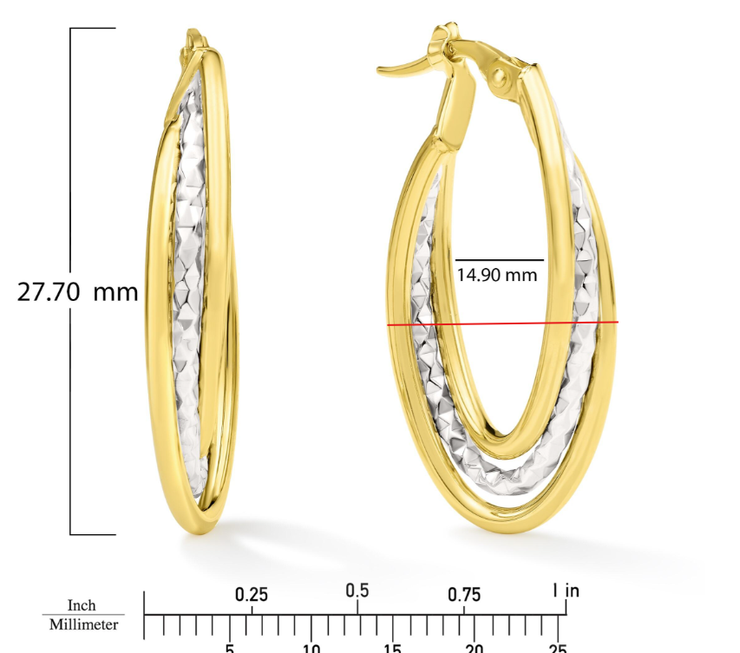

GHP20393R4-0-0
Measurements: 27.10 X 14.60 X 4.68MM
Please use: Ear_Woman_Closeup.png

GHP20404Y4-0-0

needs overstock model image
please add Ear_Woman_Closeup

GBA20003Y4-0-7.5
again fix in ruler image

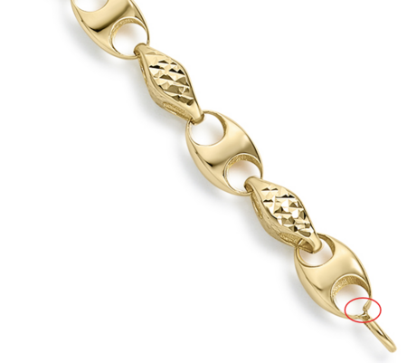

GBA20187Y4-0-7.5
Fix in image A and group shot

