GCH15496T4-0-0
needs overstock model photo

GCH15360Y4-0-0
make lines high polished in image A and B

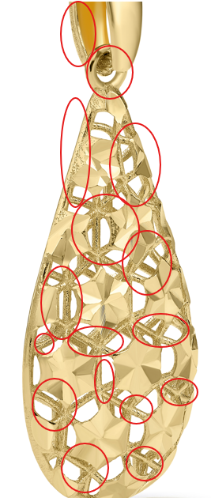

GCH14795T4-0-0

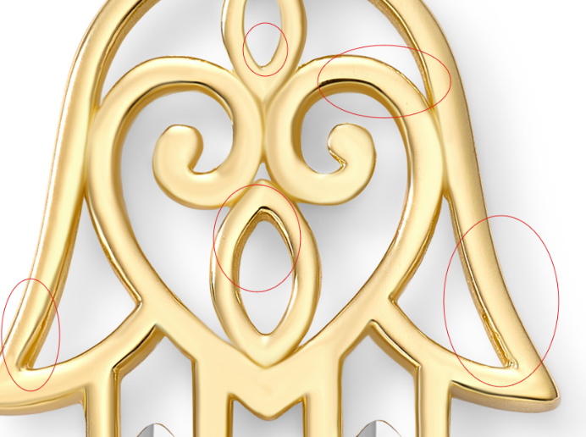

GCH14724T4-0-0

GCH20168T4-0-0
please clean up marks

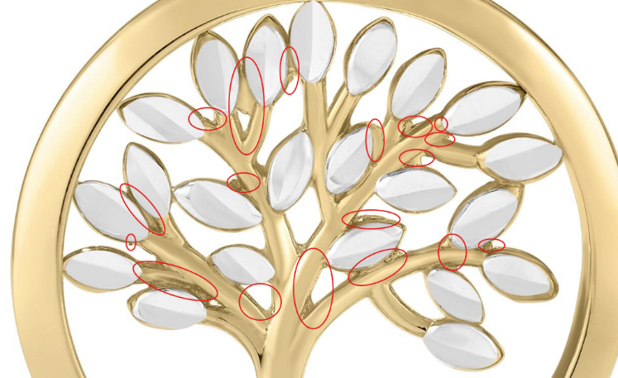

GCH15233T0-TUA-0
Please add both chain images

