GNK20330Y4-0-16.18
please fix marks

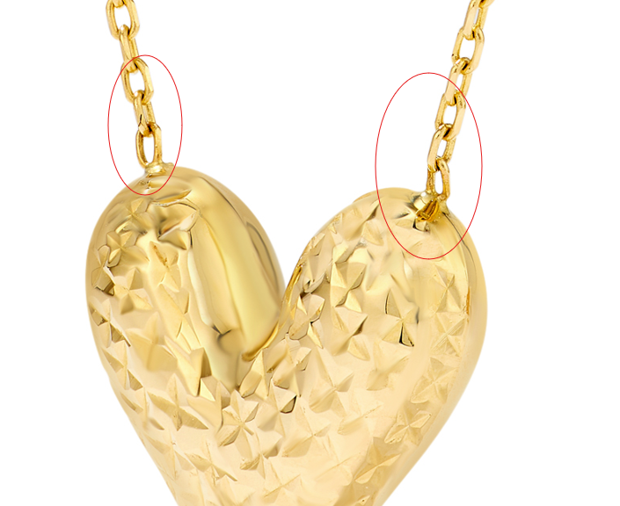

GNK20321Y4-0-16.18
fix marks

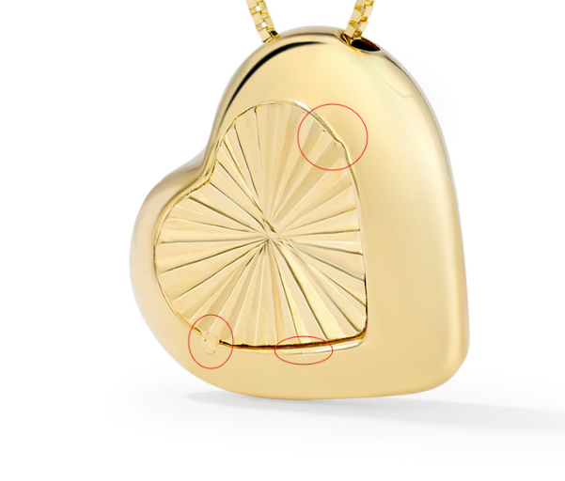

GNK14420Y0-ADJ-16.18
change this to 16-18" Adjustable
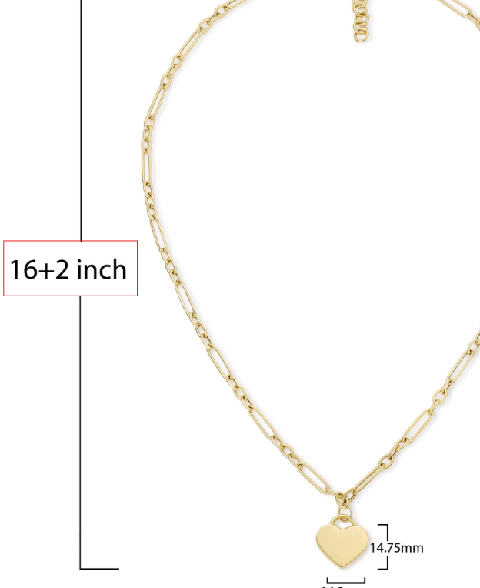

GHP20267T4-0-0
here too, thanks
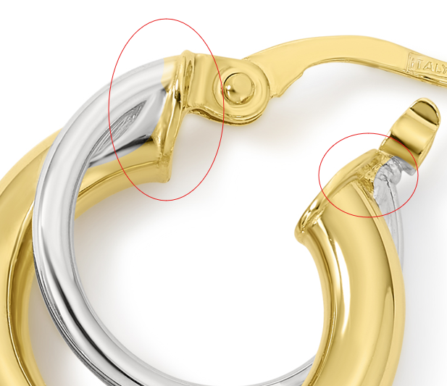

GHP20024T4-0-0
please fix
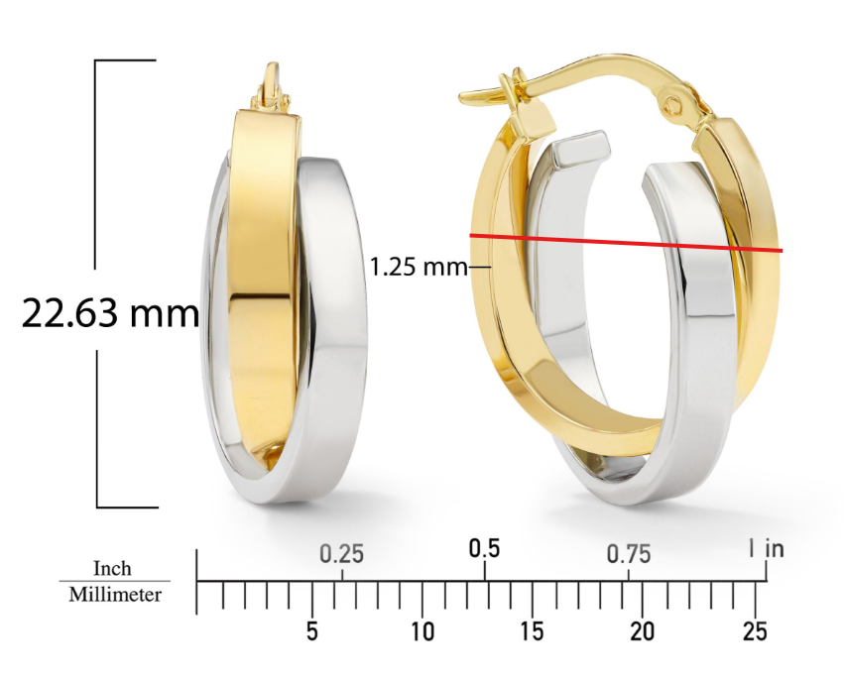

GHP15072Y4-0-0
needs Overstock model image

GEG17808Y4-0-0
please fix bottom two circled
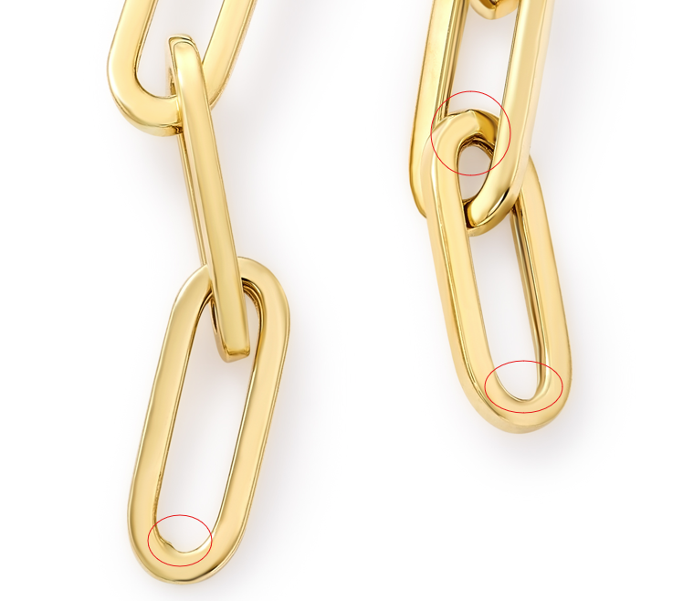

GEG17732Y4-0-0
clean up roughness, fix link
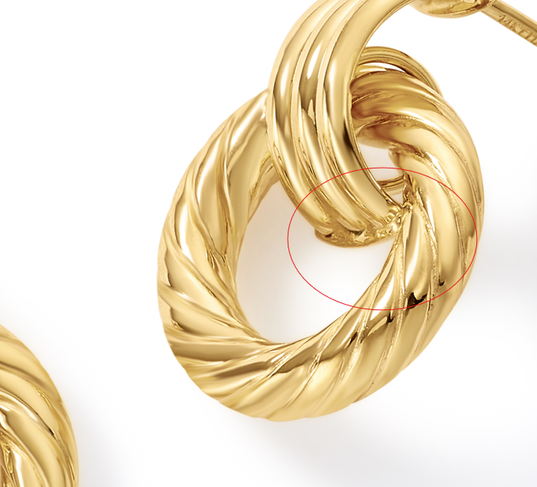

GEG16472Y4-0-0
add ruler shot

GCH15233T0-TUA-0
here too, thanks
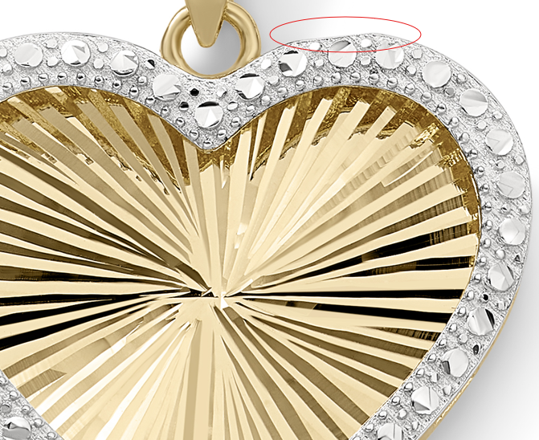

GCH14724T4-0-0

GHP13733Y4-0-0
add model images
please fix circled
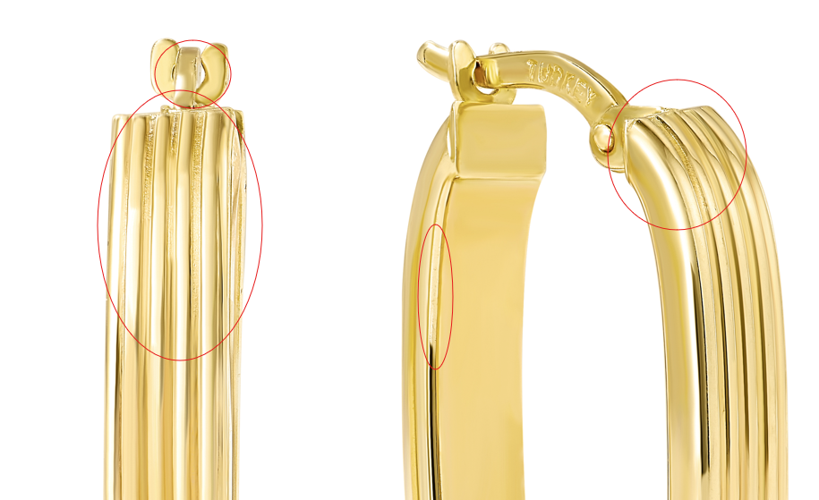

GEG15714T4-0-0
here too, thanks
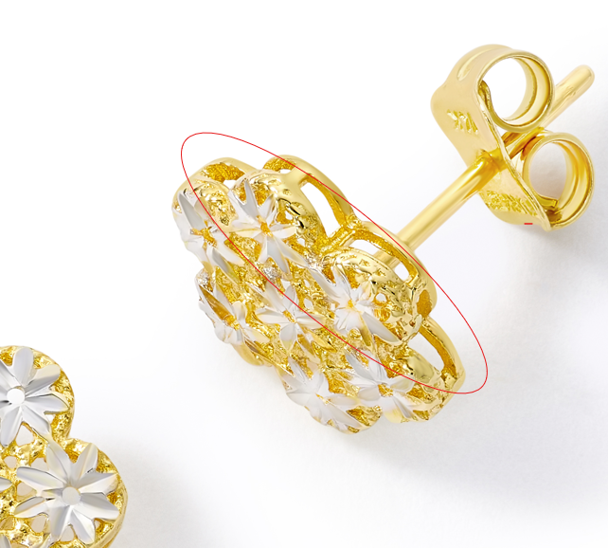

GHP20414Y4-0-0
needs Overstock model image

GHP20406Y4-0-0
needs overstock model image

GHP20404Y4-0-0
please add Ear_Woman_Closeup

GHP20413Y4-0-0
add overstock model photo

GHP15153Y4-0-0
please add
Ear_Woman_Closeup

GEG17687Y4-0-0
Ear_Woman_Closeup
please add

GCH20166W0-0-0
Measurements: 25.45 X 12.45 X 2MM

GEG20073T4-0-0
can you flip this the other way so it looks like a teardrop and please retake, thank you!!

