GBA20187Y4-0-7.5
clean up hole and fix these in group shot as well please

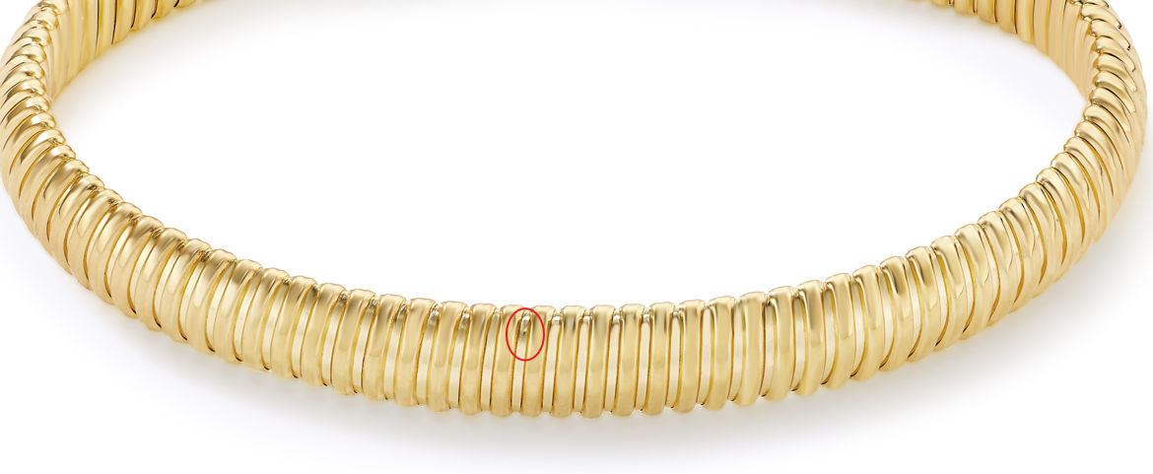

GBA20003Y4-0-7.5
fix in ruler image

