GBA20187Y4-0-7.5
clean up sharp edge & dust
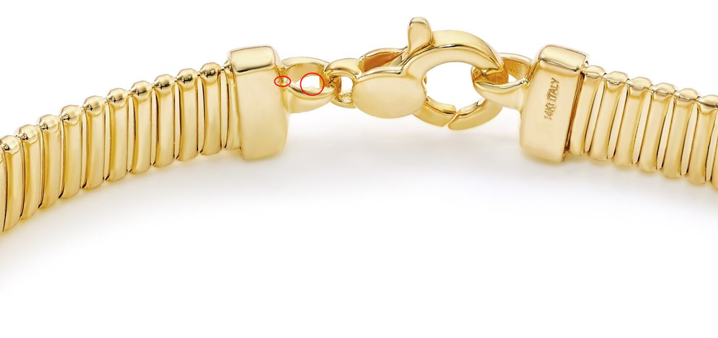

8mm 7.5", please update ruler image

GBA20060Y4-0-7.5
please make the same color as GBA20003Y4-0-7.5

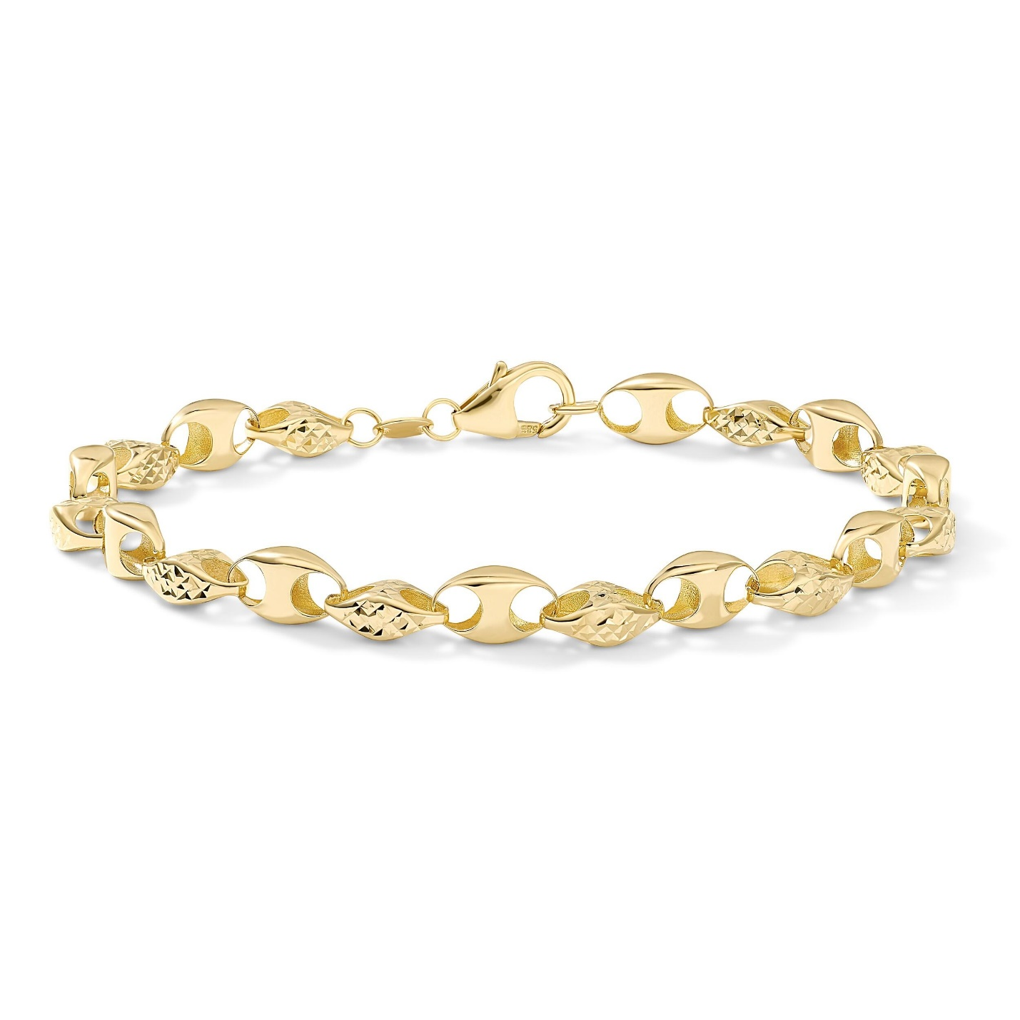

add color back in here
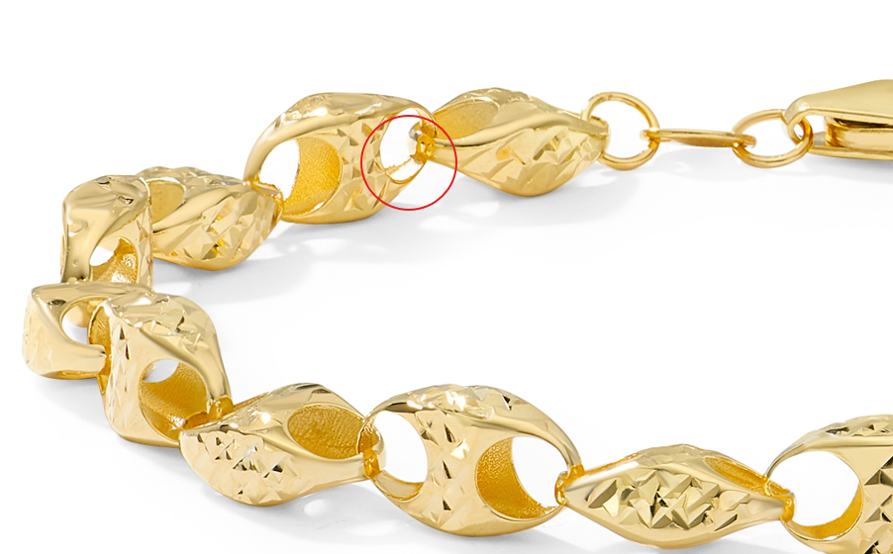

GBA20003Y4-0-7.5
also here in image D, fix link
