GHP15153Y4-0-0
Needs Overstock model shot

GEG15035T4-0-0
Measurements: 10.1 X 9.6 X 6 MM

GEG17732Y4-0-0
Measurements: 19.4 x 14 x 3MM
Overstock

GHP20407Y4-0-0
needs overstock model image

GHP20408Y4-0-0
needs overstock model image

GHP20409Y4-0-0
needs overstock model image

GHP20406Y4-0-0
needs overstock model image

GHP20405Y4-0-0
needs overstock model image

GHP20409Y4-0-0
needs overstock model image

GHP20408Y4-0-0
needs overstock model image

GHP20407Y4-0-0
needs overstock model image

GHP20406Y4-0-0
needs overstock model image

GHP20405Y4-0-0
needs overstock model image

GHP20404Y4-0-0
needs overstock model image

GHP20401Y4-0-0
needs overstock model image

GHP20403Y4-0-0
needs overstock model image

GHP20402Y4-0-0
needs overstock model image

GHP20404Y4-0-0
needs overstock model image

GHP20403Y4-0-0
needs overstock model image

GHP20402Y4-0-0
needs overstock model image

GHP20401Y4-0-0
needs overstock model image

GCH20167R0-0-0
Measurements: 21.10 X 16.68 X 1.00MM

GCH20166Y0-0-0

Measurements: 25.45 X 12.45 X 2MM

GCH20166W4-0-0
Measurements: 25.45 X 12.45 X 2MM

GCH20166W0-0-0
Measurements: 25.45 X 12.45 X 2MM

GHP20024T4-0-0
needs overstock model image

GHP20024T4-0-0
needs overstock model image

GEG20073T4-0-0
can you flip this the other way so it looks like a teardrop and please retake, thank you!!
needs Overstock model image

GHP15249Y4-0-0
needs Overstock Image

GHP15249Y4-0-0
needs Overstock Image
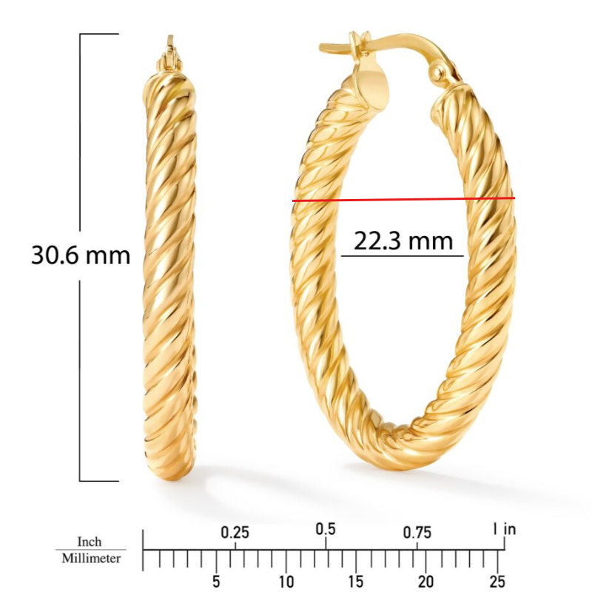
GEG17311Y4-0-0

GHP20252R4-0-0
Please clean up circled
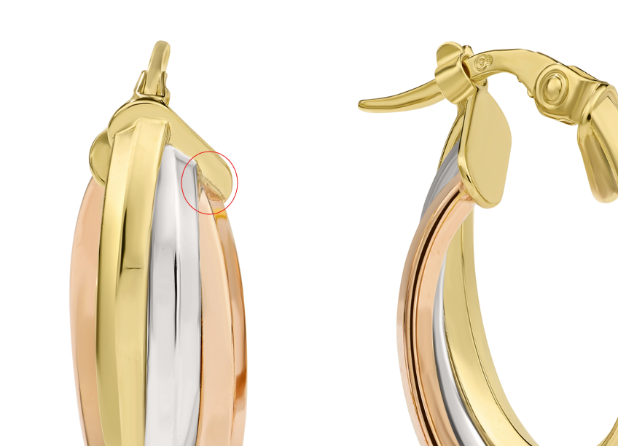

GHP20267T4-0-0
please clean up marks

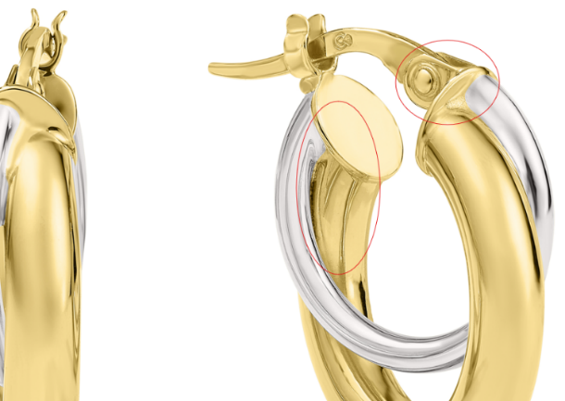

GHP15153Y4-0-0
Needs Overstock model shot

GHP15072Y4-0-0
please clean up marks

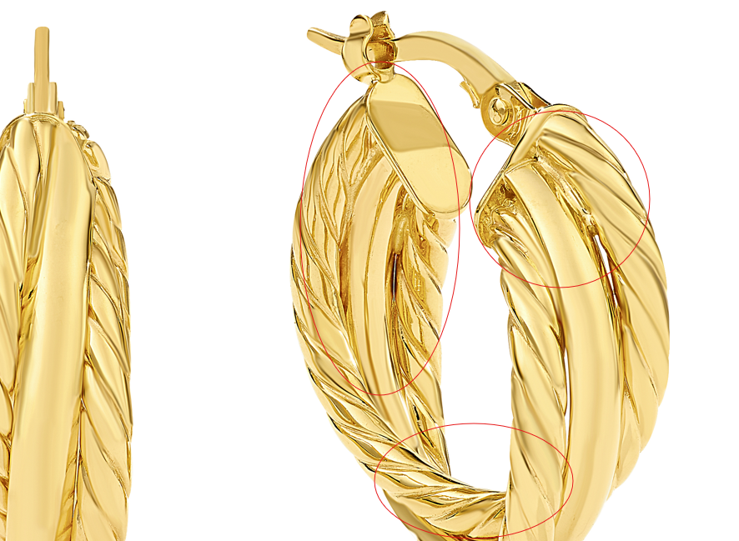

GHP20266Y4-0-0
needs Overstock model shot

GEG17687Y4-0-0
needs Overstock model shot

GEG17687Y4-0-0
needs Overstock model shot

GEG20328Y4-0-0
Needs Overstock model shot

GEG20161Y4-0-0
Needs Overstock Model Shot

GHP16006T4-0-0
add Overstock model shot

GHP16006T4-0-0
add Overstock model shot

GEG16627T4-0-0
add Overstock model shot

GEG16627T4-0-0
clean up roughness
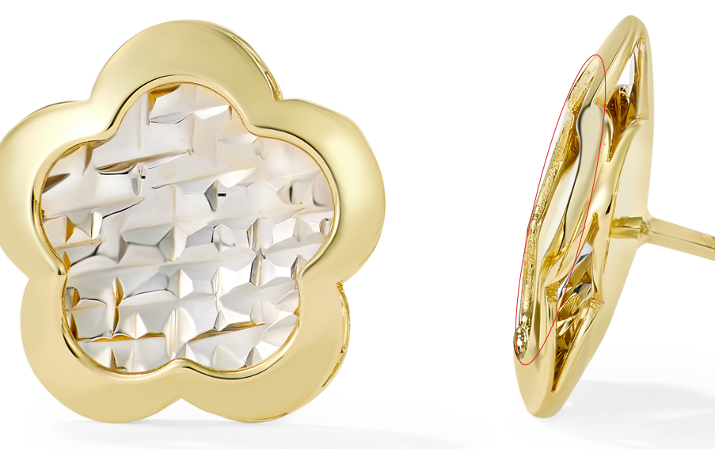
GEG17808Y4-0-0
add Overstock Model shot

GEG17808Y4-0-0
please fix roughness and color

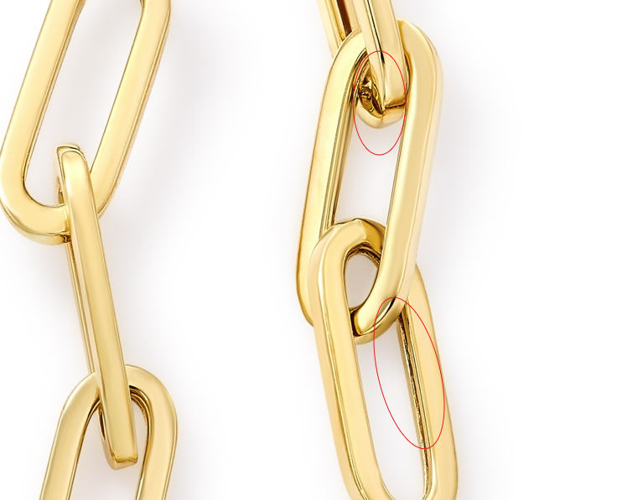

also here, these look dented please make them a rounded oval
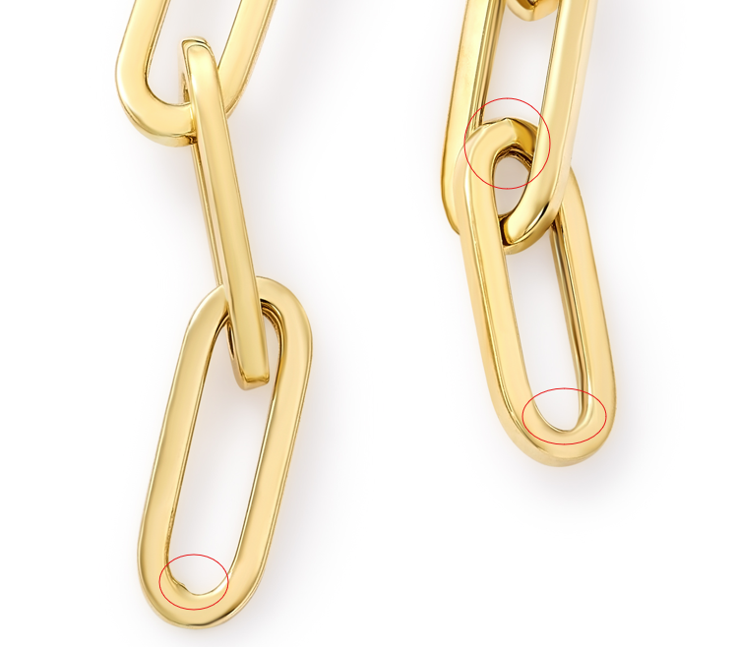

GEG20308Y4-0-0
add width and thickness on measurements
add Overstock model shot
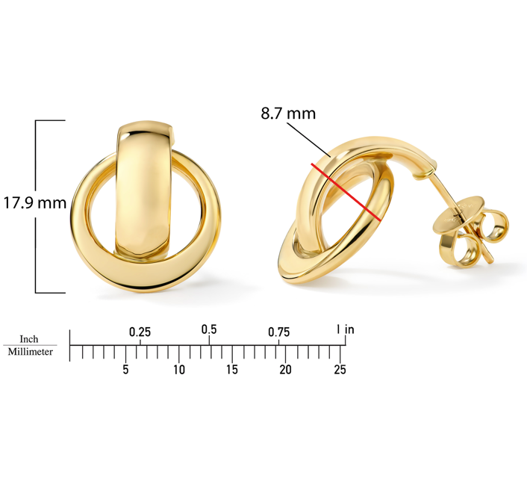
GEG16472Y4-0-0
same in image B, thanks!

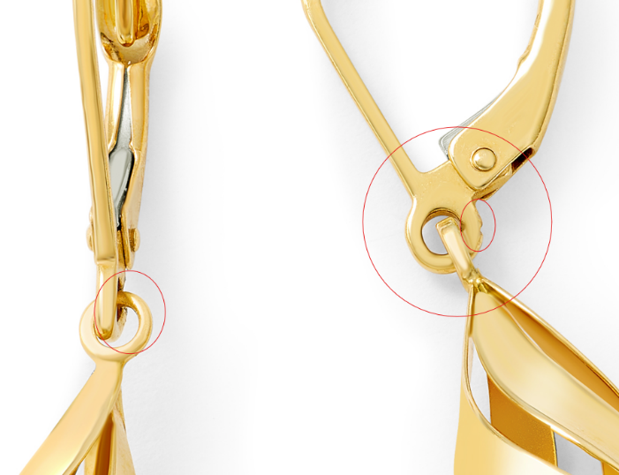

GEG15714T4-0-0
clean up roughness

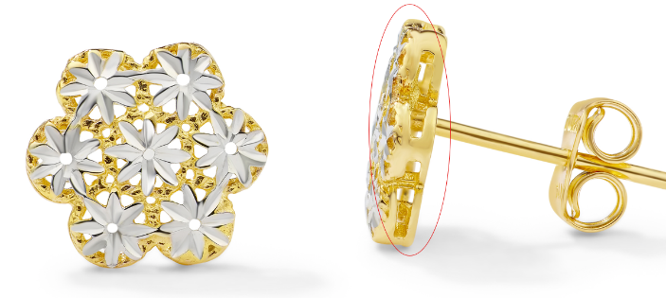

GHP13733Y4-0-0
24.5 X 15.6 X 3.9 MM

GNK20331Y4-0-16.18
match color to GNK20330Y4-0-16.18

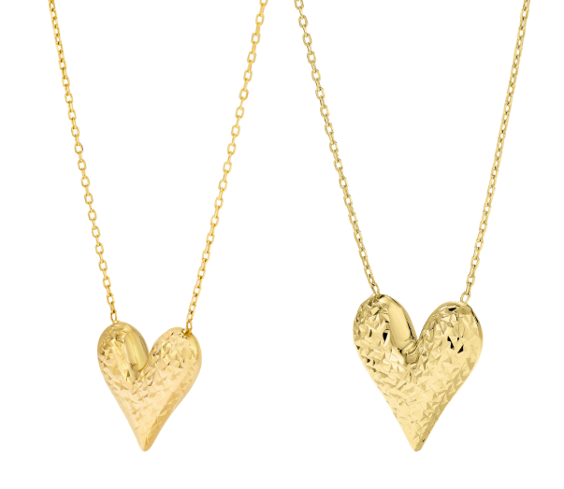

GEG16627T4-0-0
add Overstock model shot

