Priorirtize these today

GEG17311Y4-0-0

GEG20192Y4-0-0
this is the width
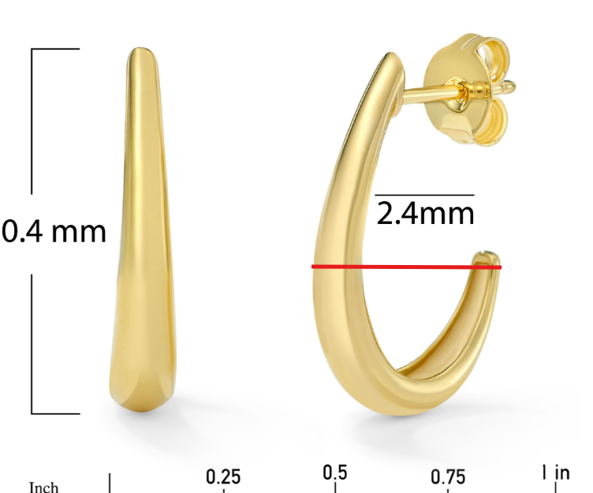

GEG20278T4-0-0
please center ruler image
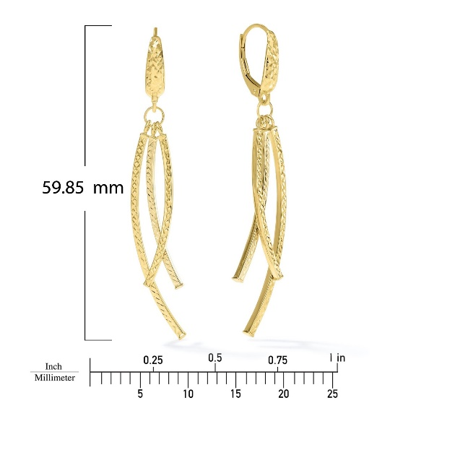
GBA20003Y4-0-7.5
same here too, thanks
make this curved and the symmetrical to the other side so it doesn't look sharp, fix all links

