GEG17710Y4-0-0
add Overstock model shot

GEG20188Y4-0-0
add Overstock model shot

GHP20287Y4-0-0
add Overstock model shot

GEG17808Y4-0-0
add Overstock Model shot
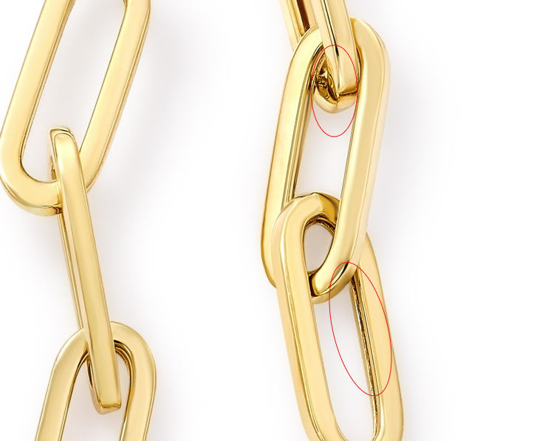

GEG20308Y4-0-0
add width and thickness on measurements
17.9 X 14 X 8.7MM
add Overstock model shot

GHP15352T4-0-0
please add Overstock Model shot
measurement is outer diameter not inner

GEG16472Y4-0-0
add ruler shot
Measurements: 39.5 X 7.5 X 7.5 MM
clean up jumpring & marks

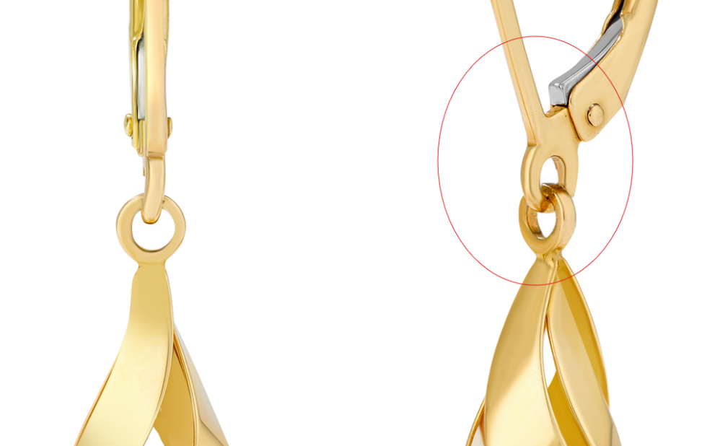

GEG15714T4-0-0
add ruler shot
10 X 10 X 2 MM
clean up roughness

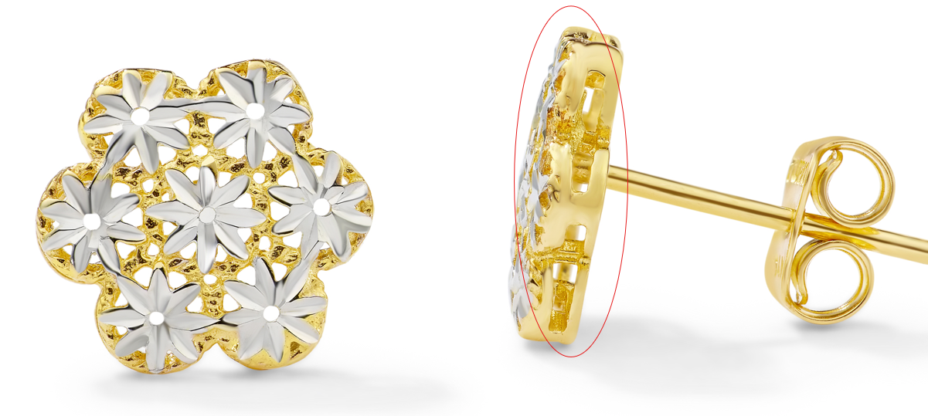

GHP20409Y4-0-0
add ruler and model shot
3MM X 36MM

GHP13733Y4-0-0
clean up rough marks
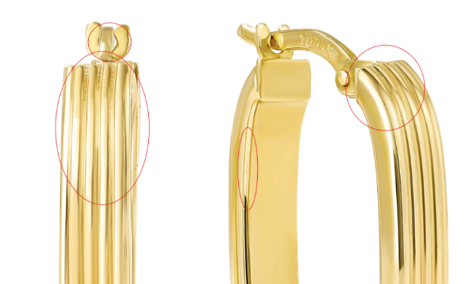

GNK20331Y4-0-16.18
match color to GNK20330Y4-0-16.18

GNK20205Y4-0-18
add 6mm thickness to ruler shot
18" 6MM

GNK14477Y4-0-16.18
move lines on this closer to product so height is more clear

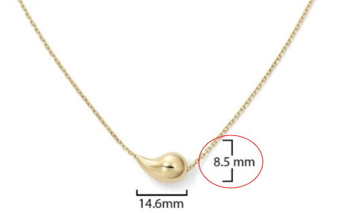

GNK14476Y4-0-16.18
please make opening a refined circle

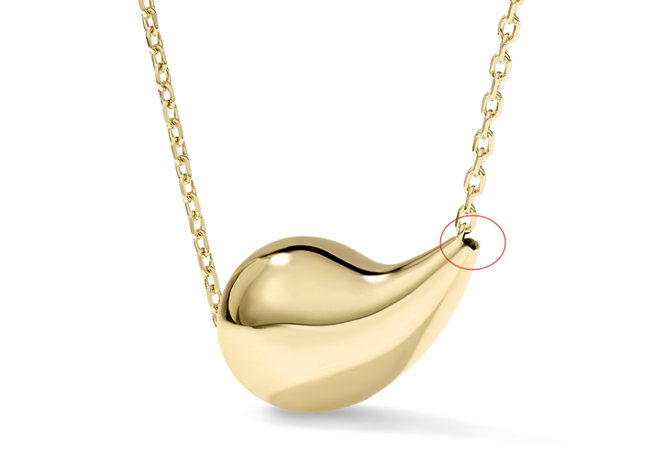

GNK14475Y4-0-16.18
can you please make the opening a refined circle

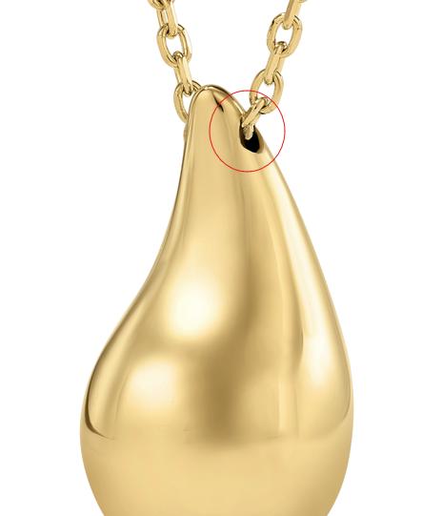
GNK14467Y4-0-16.18
can you please make the opening a refined circle
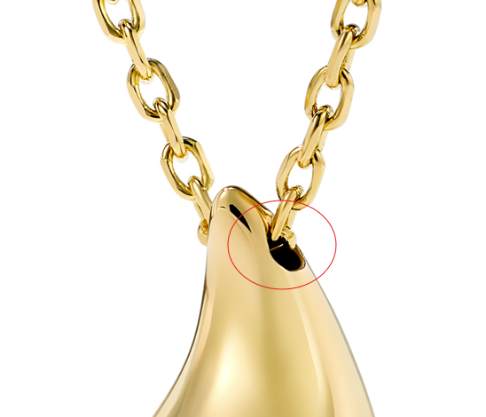

GNK13847Y4-0-16.18
make the white reflection darker/same shade

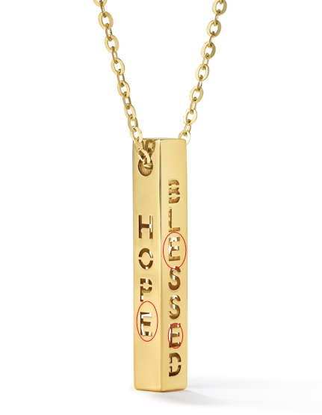
GEG16627T4-0-0
Measurements: 12 X 12 X 2.5 MM

GCH15233T0-TUA-0
Measurements: 21 X 17 X 2 MM

GCH15063Y4-DC-0
Measurements: 27 X 22.8 X 1.4 MM

GEG15714T4-0-0
10 X 10 X 2 MM

GEG16472Y4-0-0
Measurements: 39.5 X 7.5 X 7.5 MM

GCH20078Y0-TUA-0
Please fix this on jumpring
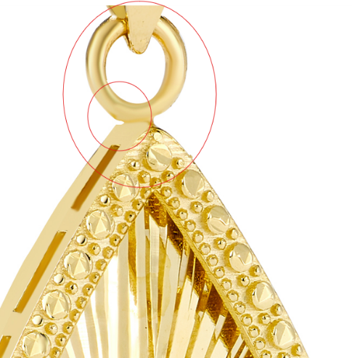

GCH20078T4-TUA-0
please clean up marks fix jumpring
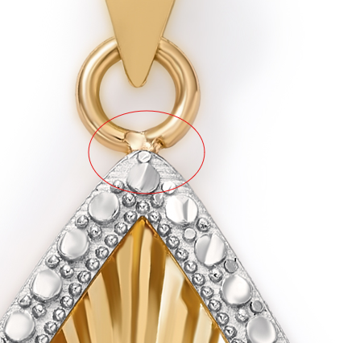

GCH15496T4-0-0
Clean up cracks and spot on gold, make jumpring more circular

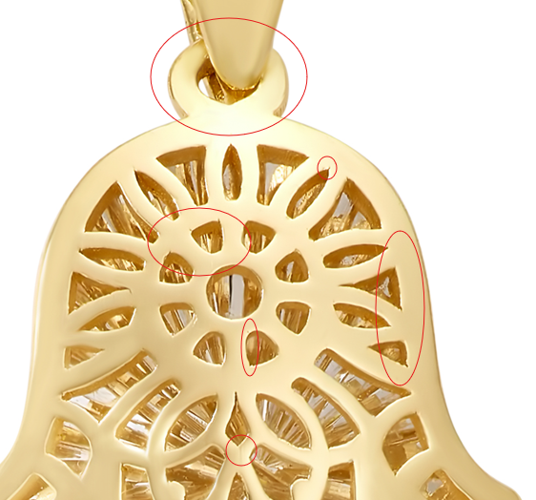

GCH15233T0-TUA-0
21 X 17 X 2 MM
clean up roughness on gold, make silver edge circled more rounded to match other side

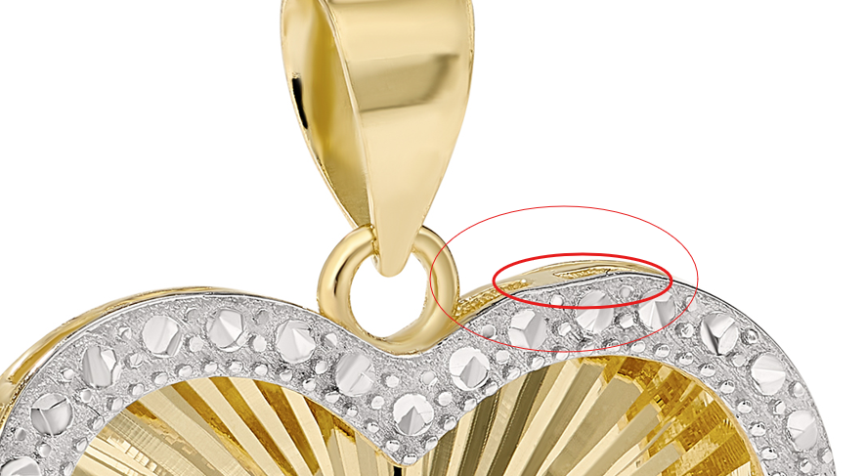

GCH14795T4-0-0
clean up roughness and fix color

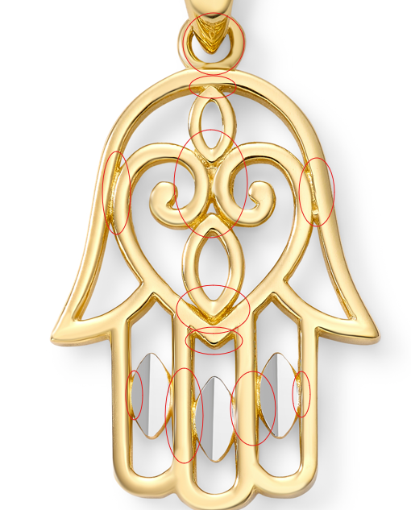

GCH14724T4-0-0
straighten line circled on the bottom

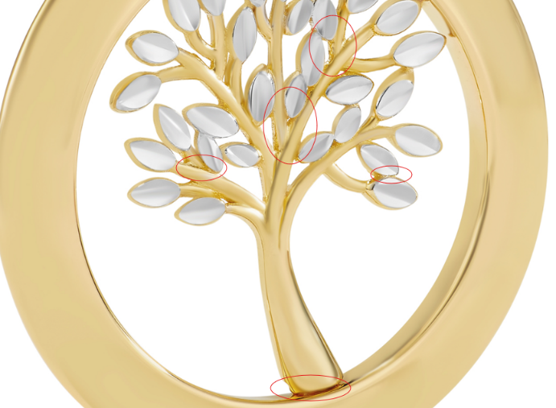

GEG17687Y4-0-0
9 X 4.75MM

