GEG20284Y4-REGNUT-0

Crop Closer
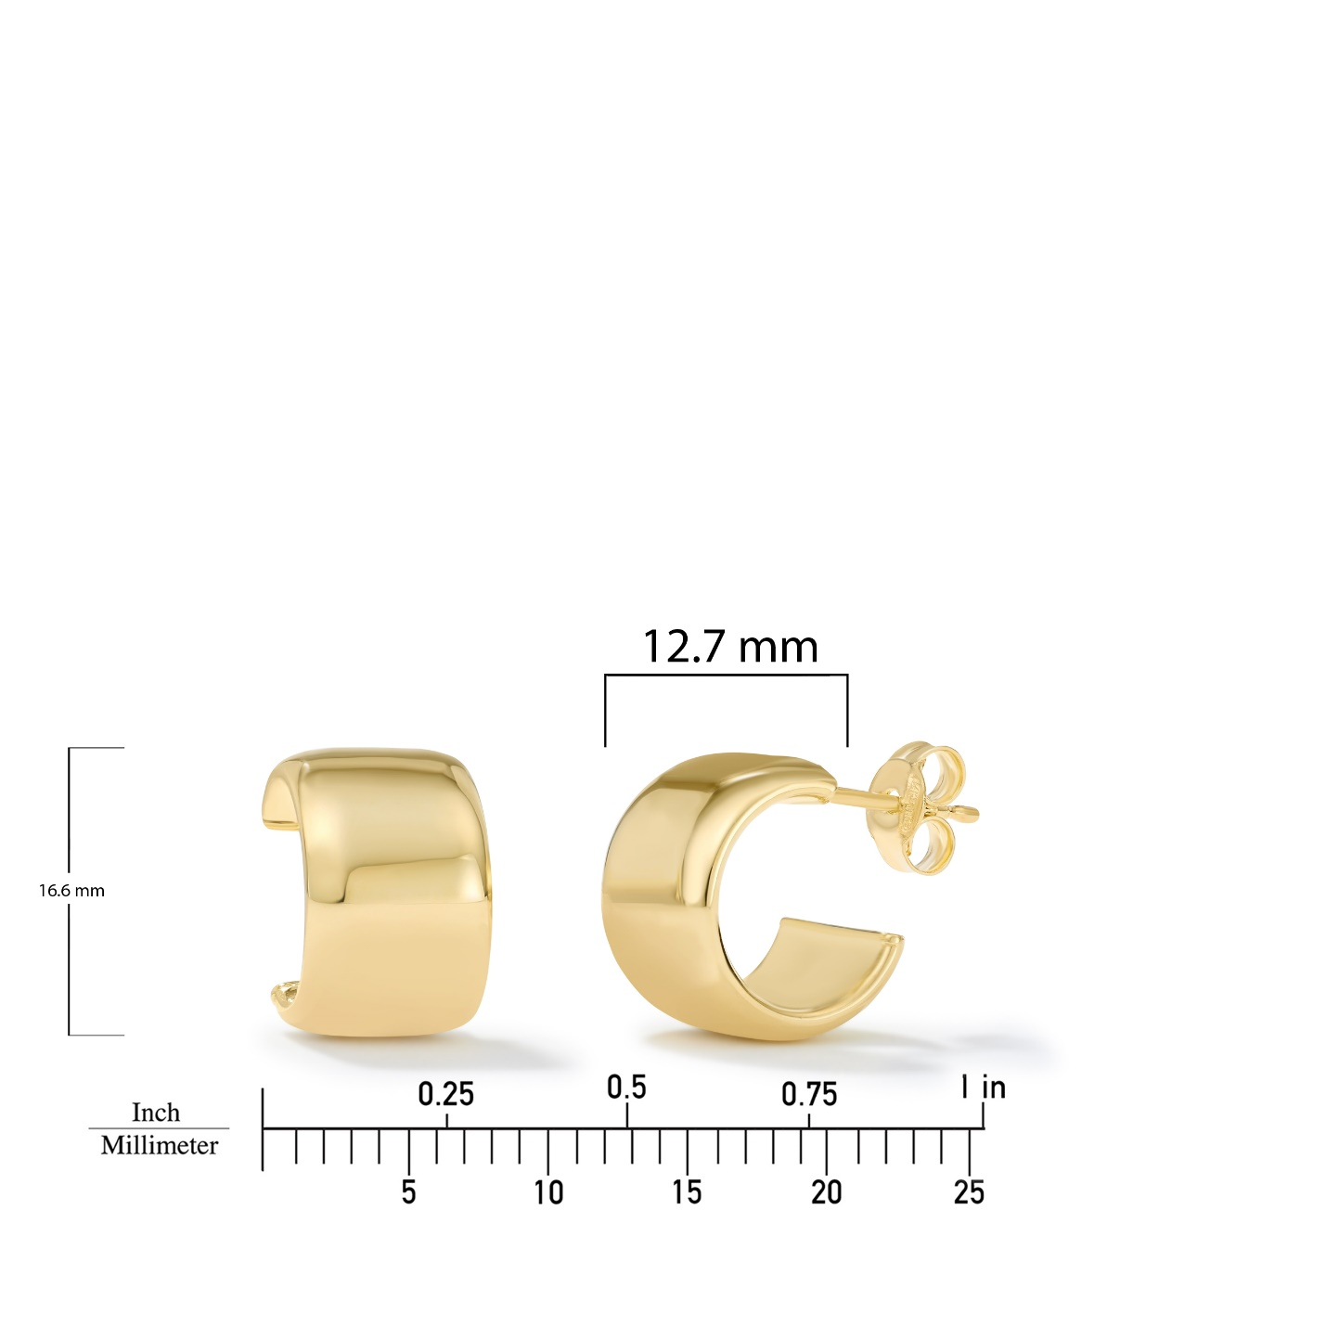

GEG20192Y4-0-0

20.4 X 3.8 X 2.4MM

