GBA20030Y4-0-7.5
this is the width

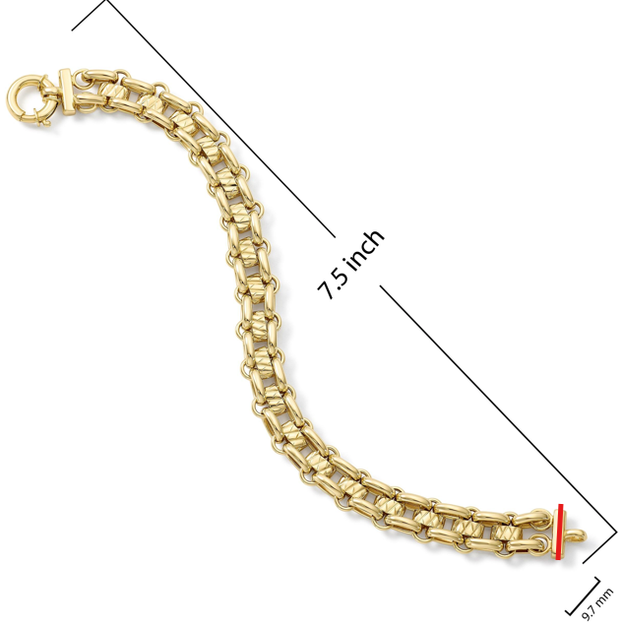

GBA20003Y4-0-7.5
make this curved and the symmetrical to the other side so it doesn't look sharp, fix all links

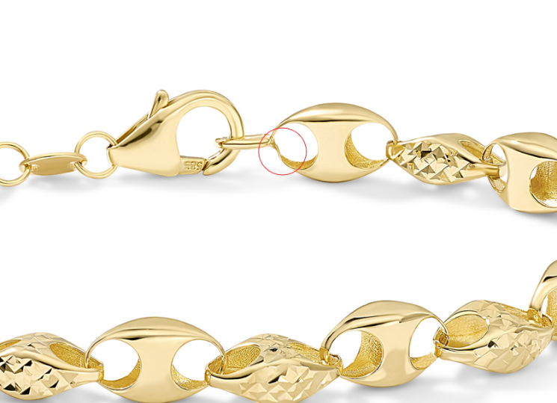

GBA20003Y4-0-7.5
make this curved and the symmetrical to the other side so it doesn't look sharp, fix all links

GNK14467Y4-0-16.18
please only use the longer length

GNK14475Y4-0-16.18
please only use longer length on this model

GEG17732Y4-0-0
this is the width
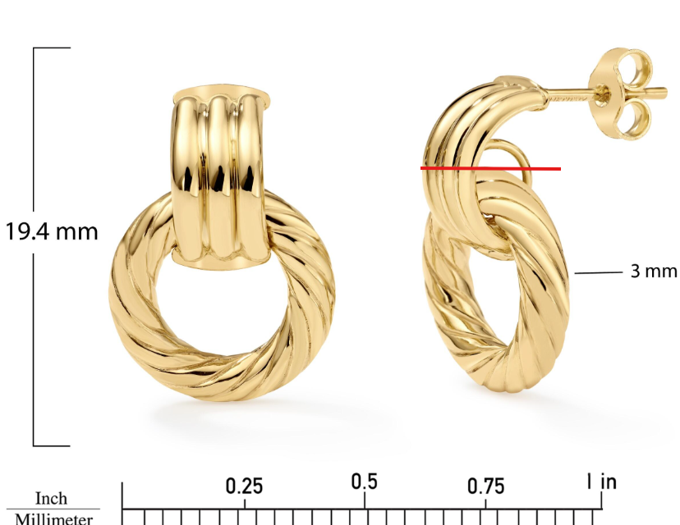

GEG17732Y4-0-0
Add Overstock Model Shot

GEG20192Y4-0-0
20.4 X 3.8 X 2.4MM

GEG20284Y4-REGNUT-0
crop closer

GEG20227Y4-0-0
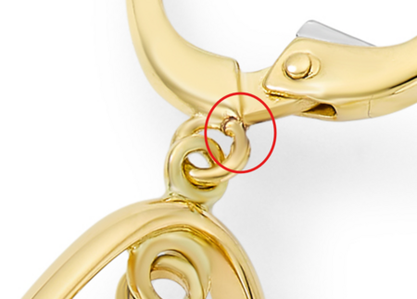

GEG20227Y4-0-0
please fix bottom circled

GEG15714T4-0-0
clean up the holes circled above, use the same image as image A in the ruler shot and model shot

