GEG16627T4-0-0
add model shots
GEG16627T4-0-0
add model shots

GEG15714T4-0-0

add normal and overstock model shot

GEG16472Y4-0-0

add normal and overstock model shot

GEG15714T4-0-0
add normal and overstock model shot

GCH20078Y0-TUA-0
clean up side seam

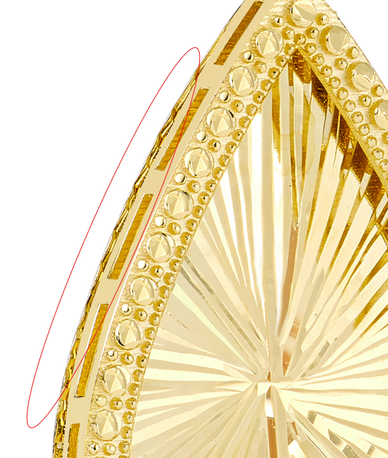

GCH20078T4-TUA-0
please clean up marks

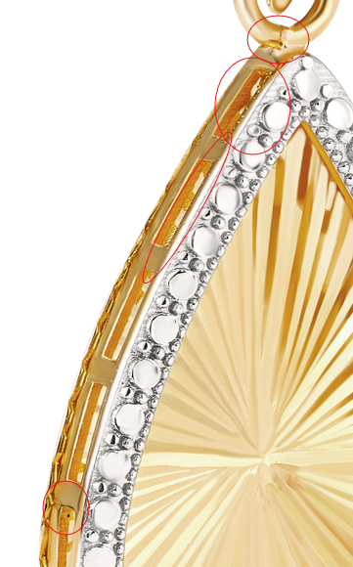

GCH15496T4-0-0

please clean up rough edges and fix color

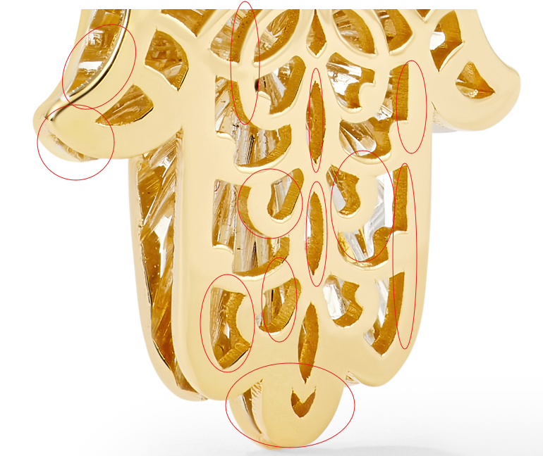

GCH15233T0-TUA-0

Please fix circled

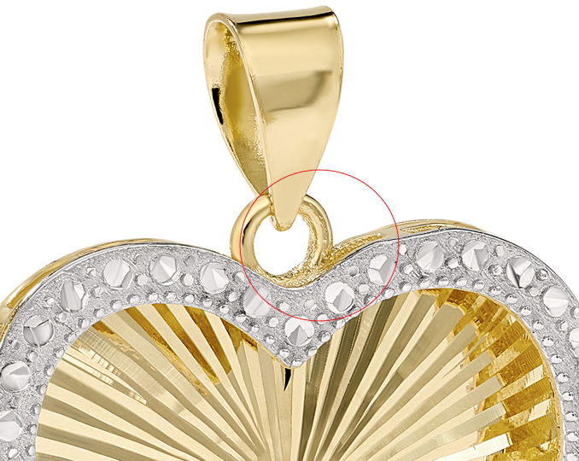

GCH14795T4-0-0

clean up marks, make gold high polish

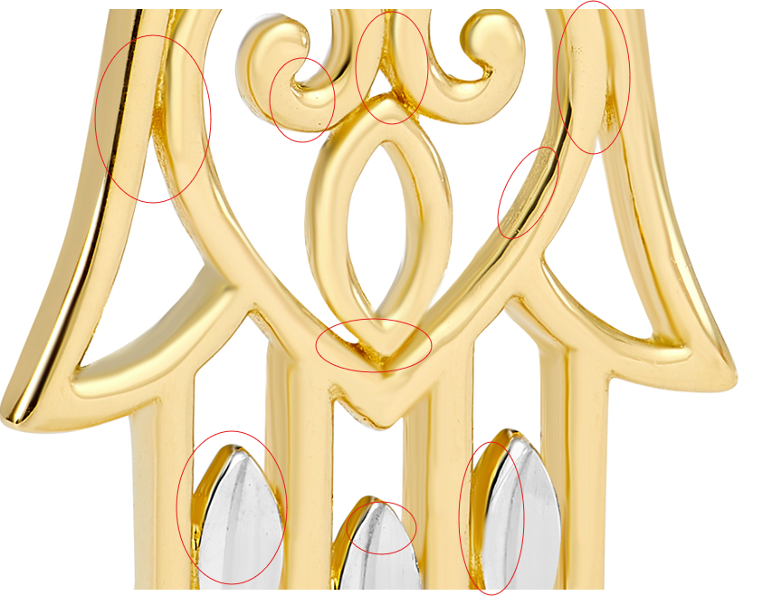

GCH14724T4-0-0



GCH13591R0-0-18

GEG20073T4-0-0
13.3 X 9.3 X 2.33MM

GEG17687Y4-0-0
9 X 4.75MM

