GNK14993Y4-0-18
Needs Overstock model shot

GNK14475Y4-0-16.18
Please add Overstock Necklace Model shot


fix this in ruler image too thanks

GHP15308Y4-0-0
needs overstock model

GEG20216Y4-HP-0
needs overstock model

GEG20284Y4-REGNUT-0

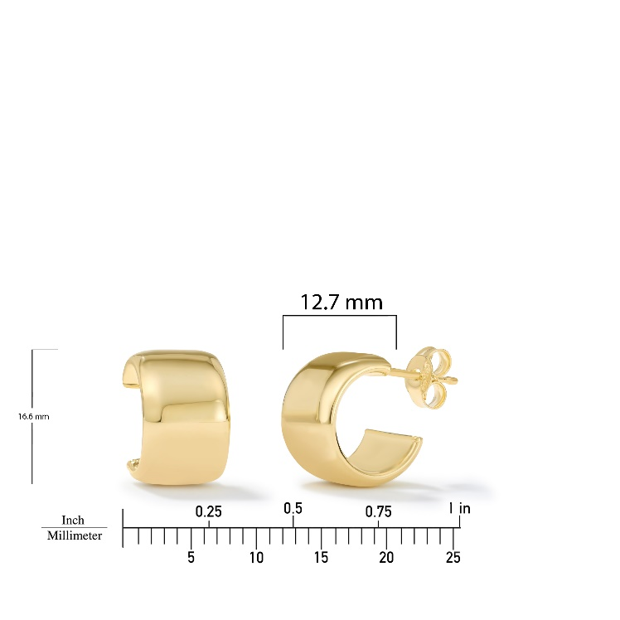

needs Overstock model

GEG20221Y4-REGNUT-0
Needs Overstock Model image

GEG20227Y4-0-0
Needs Overstock Model Shots, fix links

please fix bottom circled

GEG15714T4-0-0
make border high polished

