GNK14475Y4-0-16.18
please fix above in image B

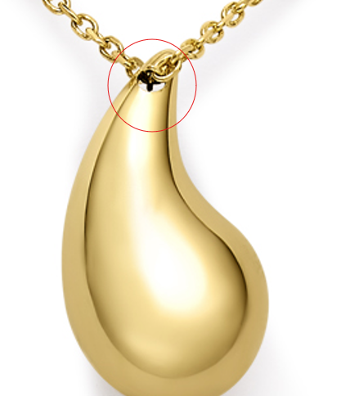

GHP20252R4-0-0
here too please
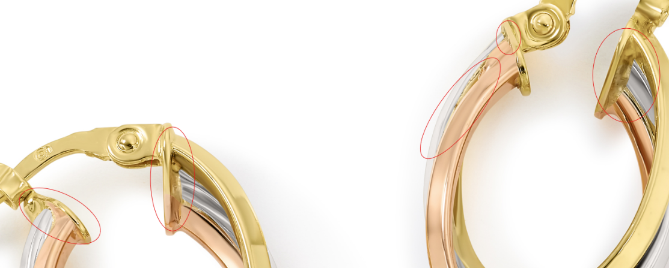

GEG20221Y4-REGNUT-0
20.3 X 8 X 2.75MM

GEG20221Y4-REGNUT-0
please clean
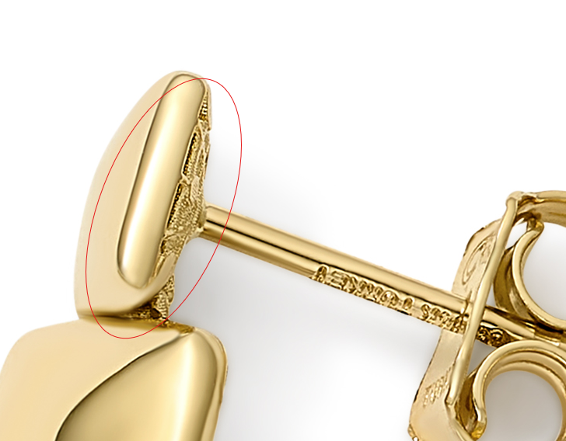

GEG15714T4-0-0
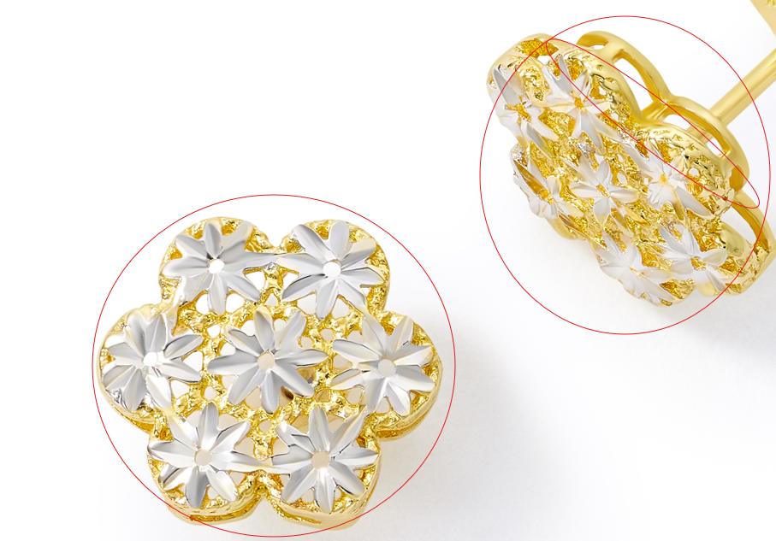

GEG20227Y4-0-0

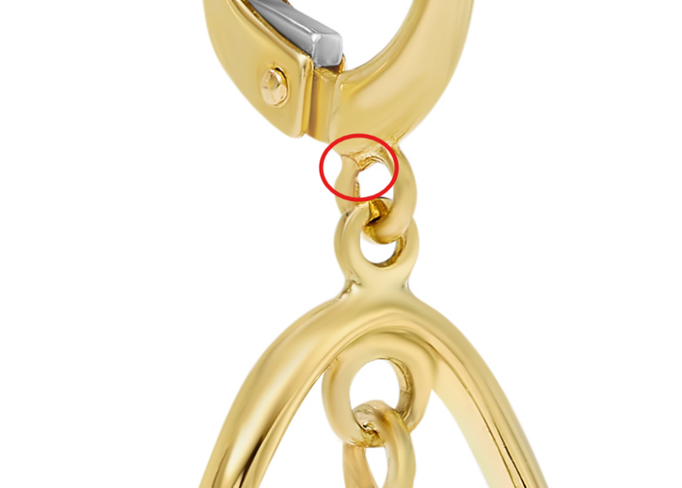

GEG20255Y4-0-0
please remove mark
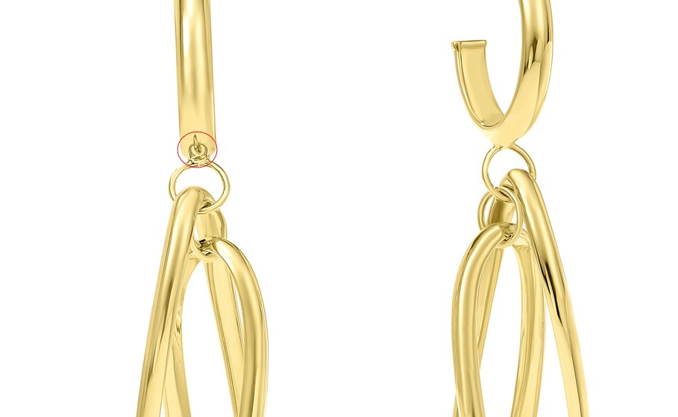

GEG17732Y4-0-0
please add
Add Overstock Model Shot

GEG17311Y4-0-0

