GEG17732Y4-0-0
this is the width
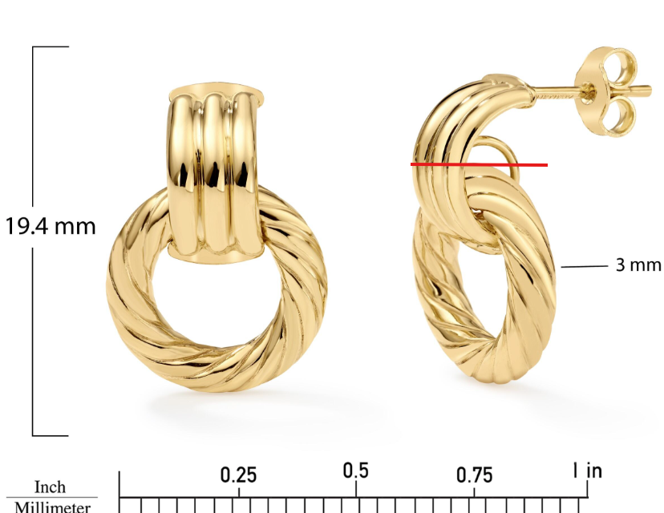

GHP20252R4-0-0
please clean up above circled
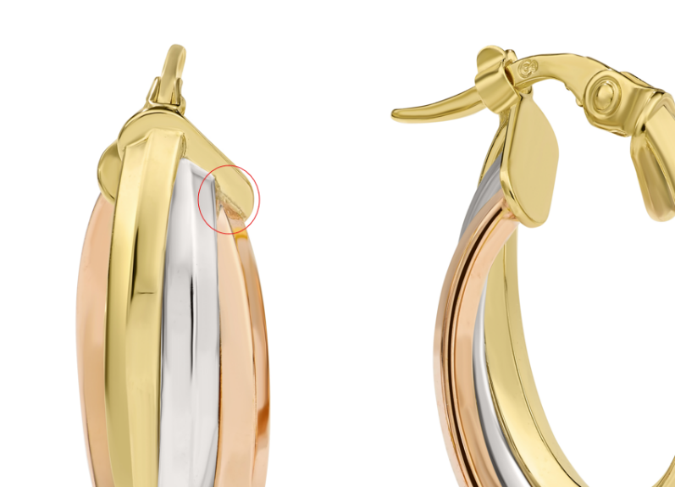
GEG20249Y4-0-0
Needs Overstock Model Shots, fix links

GEG20255Y4-0-0
please remove mark
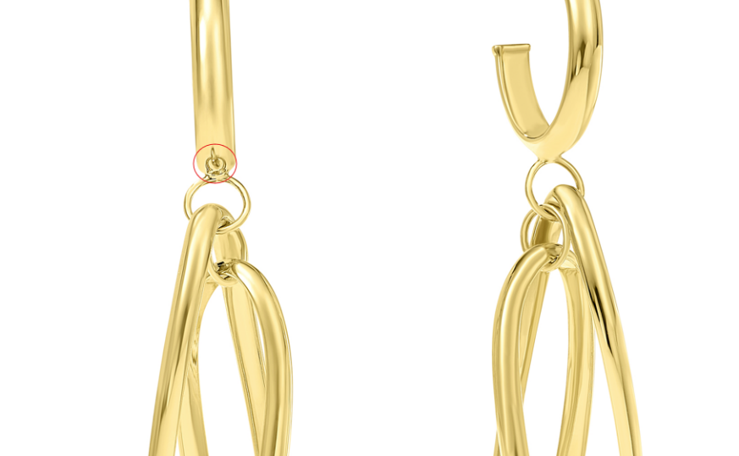

GEG20278T4-0-0
please center ruler image
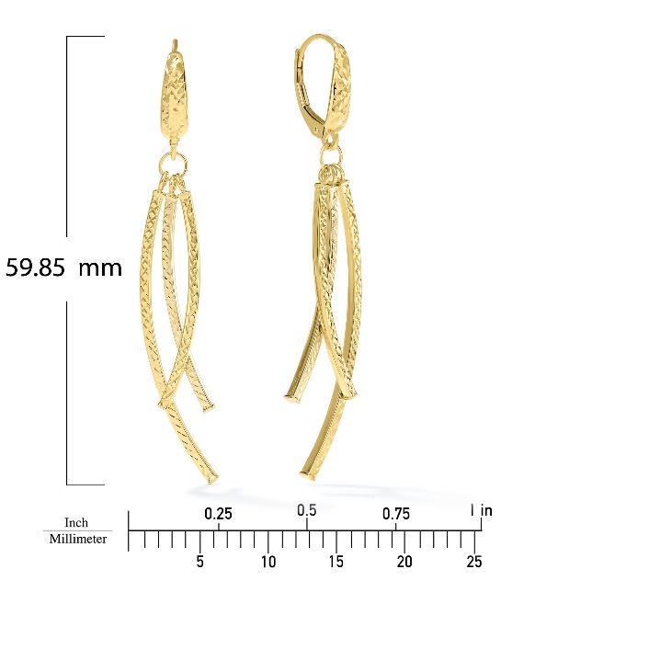

GHP16040T4-0-0
please fix﻿
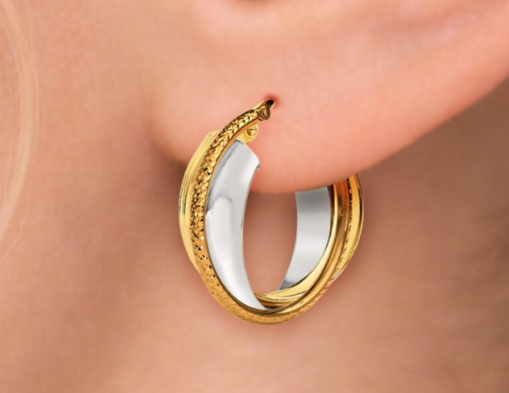

GEG20227Y4-0-0
same here & please clean up dust marks, fix links

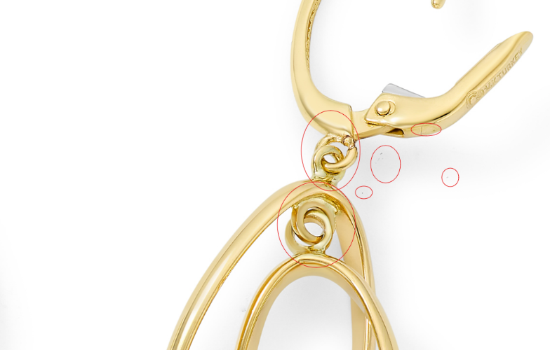

GEG15714T4-0-0
this is better, can you please make the flowers look more similar to the middle flower and make all the lines clean and defined.
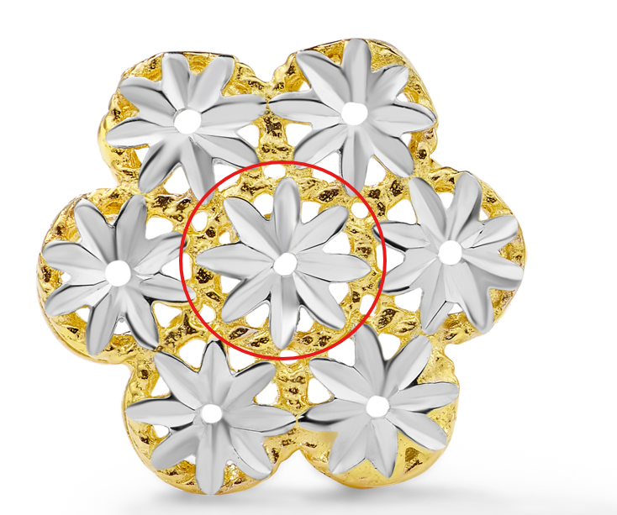

GEG20073T4-0-0
same here, clean up roughness, make line even
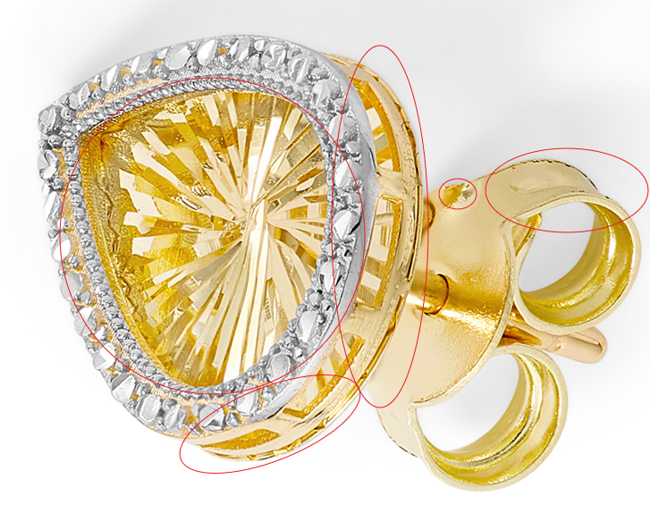

GEG17311Y4-0-0
have all over floral pattern look more like this and even

