GHP13733Y4-0-0

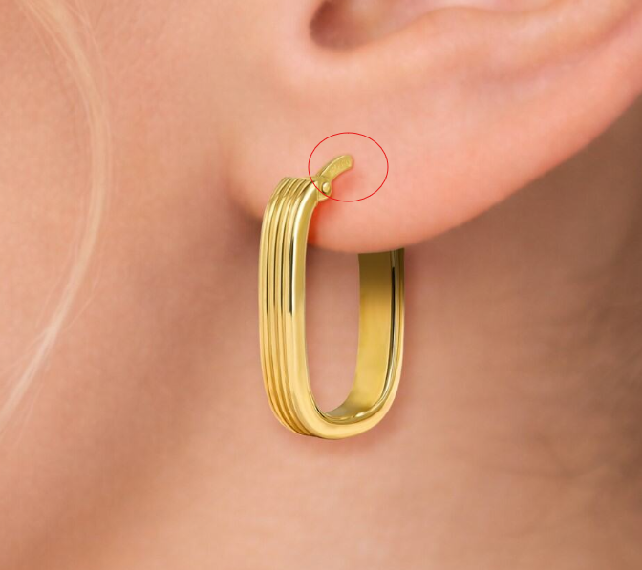

GHP16040T4-0-0
again please fix circled

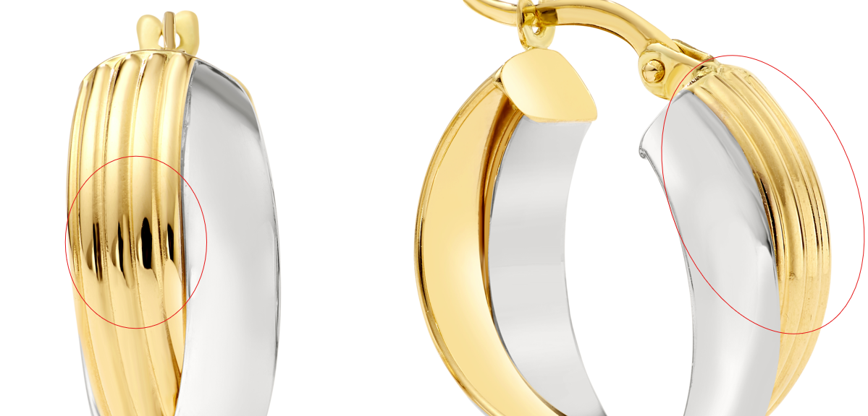

again please fix circled

GEG20227Y4-0-0
again please fix circled

GHP13733Y4-0-0

GEG20227Y4-0-0
again please fix circled﻿﻿
GEG20244Y4-0-0

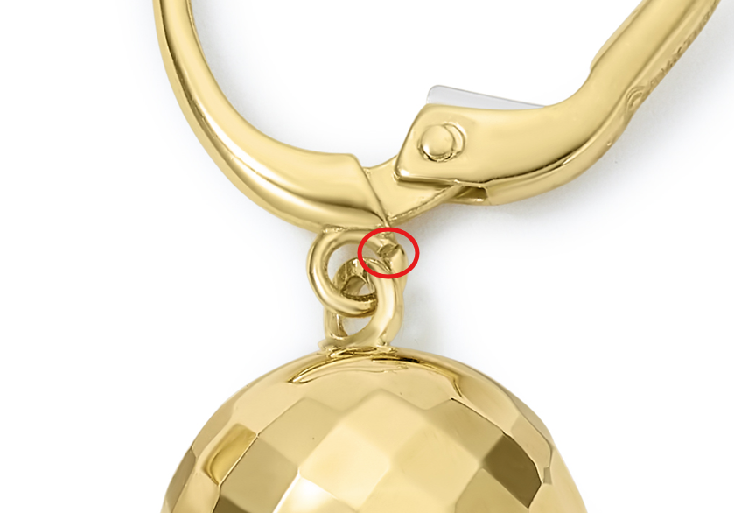
GEG15714T4-0-0
please make each of these a defined flower shape

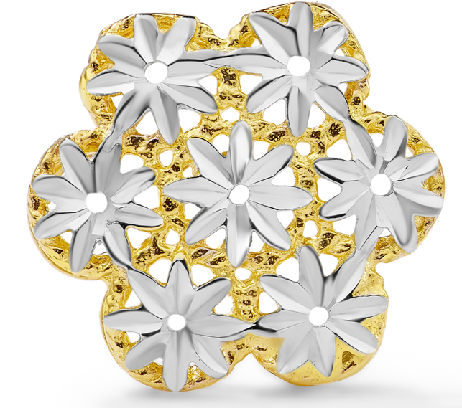

GHP20109Y4-0-0
shorten post
