Suman, missing the following images

EMSN04-PURPLE IMAGE 2,3,5

EMSN05-PURPLE. IMAGE 3,4

EMSN05-RED. IMAGE 3

Suman please review and edit these pictures.
EMSN05-BLUE-1. Stones are blurry and just overall low quality. Please fix

EMSN05-BLUE-2. Stones are blurry and low quality. Outline of gold is weird and fuzzy and overall has bad masks. See below

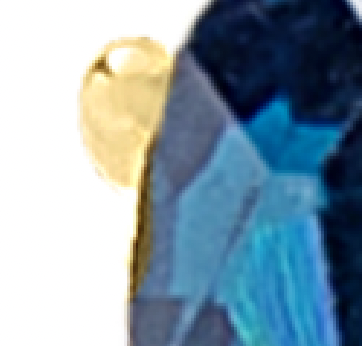
EMSN05-BLUE-5 outline of gems very rough need to be redone
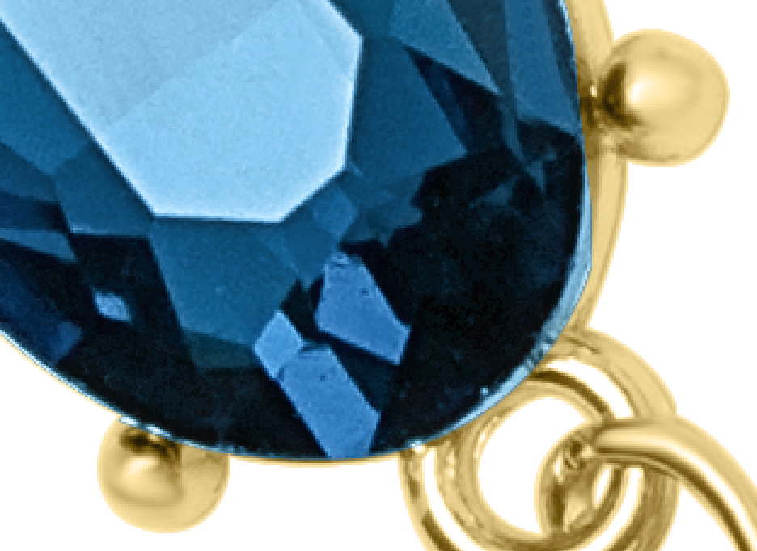
EMSN05-RED-1. Mannequin too desaturated needs to be fixed. I supplied the mannequin within the folder to match it to.

EMSN05-green-1. Stones a little rough on outline and need more clean up

