the work is good, needs just a little bit of light, as you can see, your picture is on the darker side.  
Sometimes th emodel's face is too red

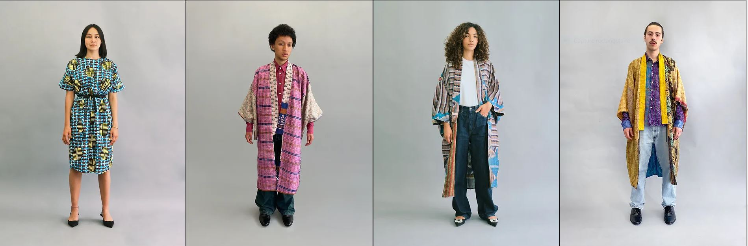

regarding the face these are ok

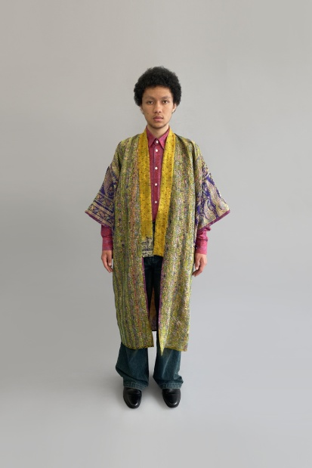

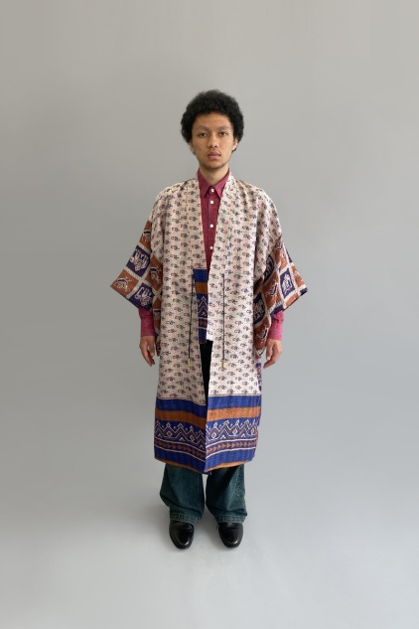

this one is too red

9808 is definitly too red.

