Hello, this part has to be gold too
image.png
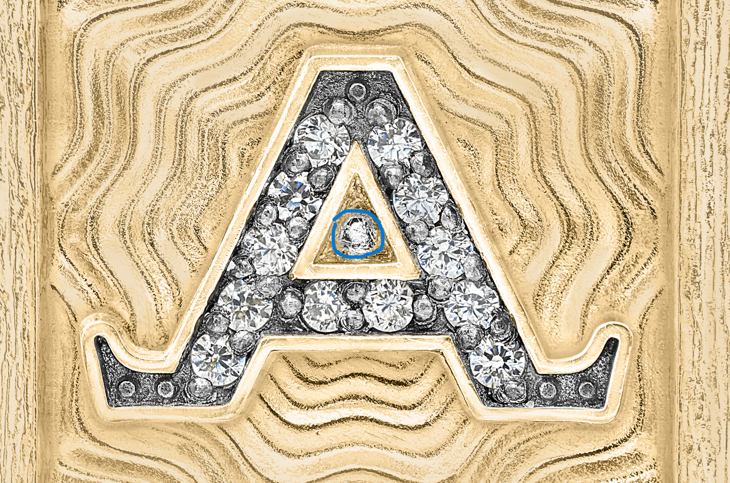

And the darker shadows that were here should have stayed, only the white parts had to be removed
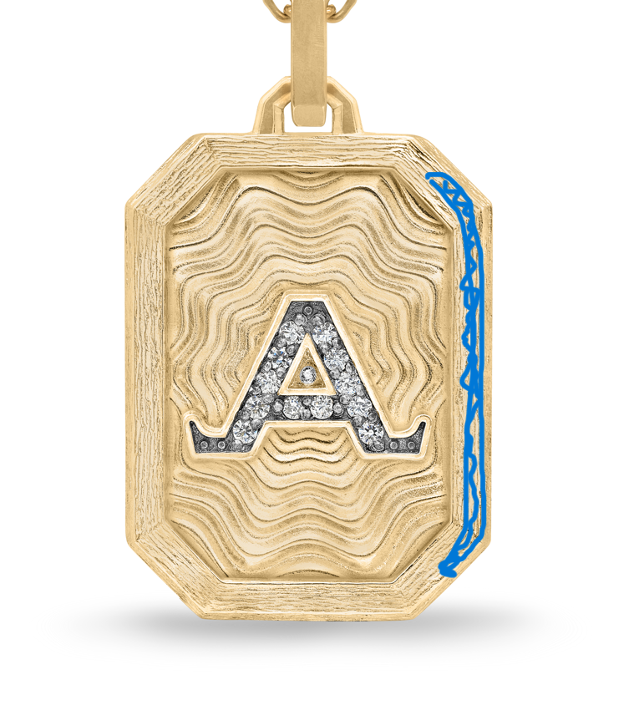
image(1).png

