Thanks Kaushik, lets try move the logo to the left where i have shown with the arrow- The text move to the right a little so its sitting on her hand and possibly reduce the size a little- Please remove upper case from all text except for W for which- so it should look like " Which style tells your Story?" Please try this-
image.png

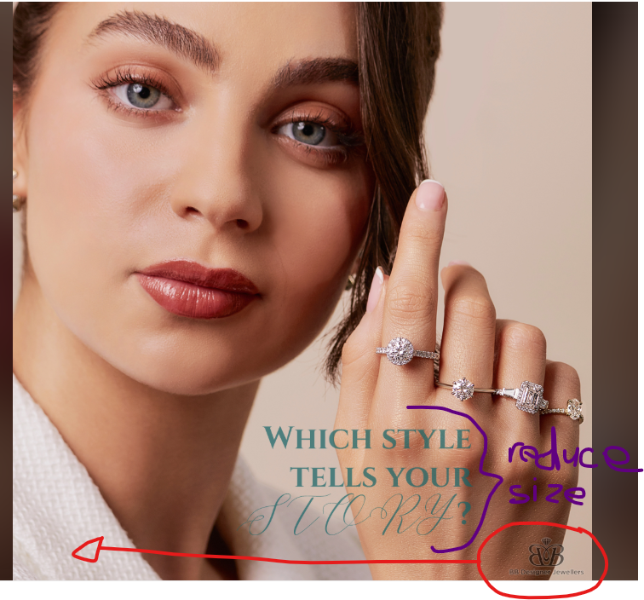
Hi Kaushik, thanks for these samples- here is some feedback i have marked- cleaner finer, less shadowing plz-

