i need this on a yellow gold chain please can u do now????? i need to send to promotions team

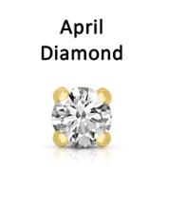
i need by today please

