plz see this feedbakc and follow the linking of the bracelet procedure
image.png

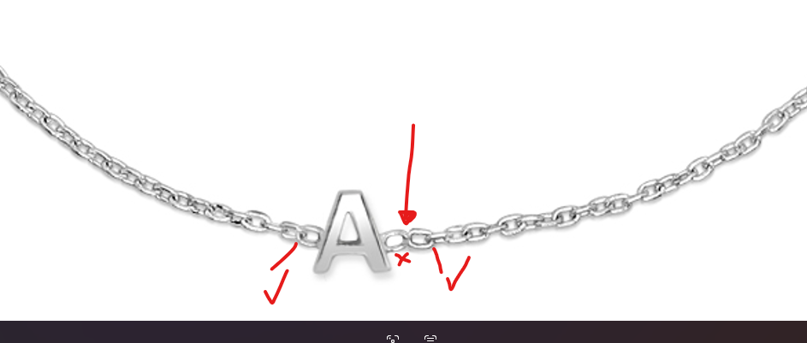
the S heart and A is good

