Please change the jewelry on this model with the jewelry attached.

also- please move her dark brown tshirt up, like indicated below;

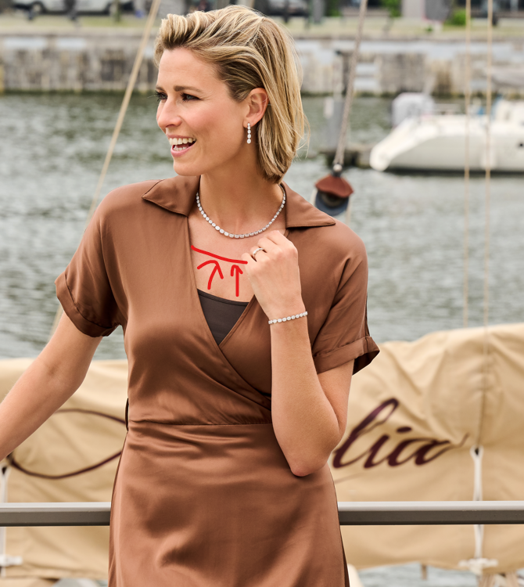

Please send it to me in JPEG and TIFF format.