Please make me matching earrings for the attached pendant, it should look like below; Use the pendant to create it. It should be nice clear and sharp.

Please make a nice layout for it.

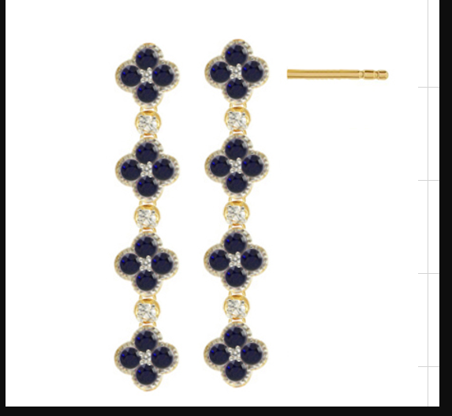

--

Please send it to me in JPEG and TIFF format.