Photo Guidelines For Amazon, Overstock, Walmart, and Other Online Marketplaces

1. Objective
These guidelines ensure all jewelry product images are consistent, high-quality, and compliant with major online marketplace standards. The goal is to present each item clearly and attractively, highlighting craftsmanship, material quality, and design accuracy.

2. Image Specifications
Requirement | Description
Ideal Size | 2000 × 2000 pixels. (Min. 1000 x 1000; Max. 3500 x 3500)
Aspect Ratio | Square (1:1) unless otherwise specified.
Product Coverage | Product should fill 85% of the frame.
Background | Pure white with RGB values (255, 255, 255).
Resolution | 300 DPI (for crisp detail and zoom functionality).
File Format | JPEG (.jpg or .jpeg) recommended; TIFF (.tif), PNG (.png), or non-animated GIF (.gif) also accepted.
Color Profile | sRGB color space.
Clarity | Image must be sharp, clear, and free of pixelation, jagged edges, or noise.
Compression | Use high-quality compression; avoid visible artifacts.

3. Required Image Set
For each product (SKU), provide the following five final images:
Image Type | Description
1️⃣ Main Image | Front-on view from slightly above of the full jewelry piece. Pure white background. No props, logos, or text.
2️⃣ Alternate Angle | Show a different angle or perspective to highlight depth and structure.
3️⃣ Close-Up / Detail Shot | Highlight specific craftsmanship details such as gold stamp, clasp, back, stone setting, or engraving.
4️⃣ Measurement Image | Show clear measurements (in millimeters or inches) using clean, legible overlay graphics.
5️⃣ Lifestyle Image | Display product in context (e.g., on model or styled setting). Background should be soft, neutral, and complementary to the jewelry.

4. Retouching Guidelines
4.1. General Quality
- Images should look high-end, clean, and realistic — not over-edited.
- No distortion or misrepresentation of product color, size, or finish.
- Avoid excessive glow, fake sparkles, or over-smoothing.
4.2. Metal Retouching
- Polish and smooth metal surfaces to remove dust, scratches, and blemishes.
- Preserve natural reflections and gradients — avoid making metal look flat or plastic.
- Maintain true color (e.g., yellow gold vs. rose gold vs. white gold).

Yellow Gold Color Reference 10k vs. 14k
Note: 10k is paler; 14k is warmer and richer
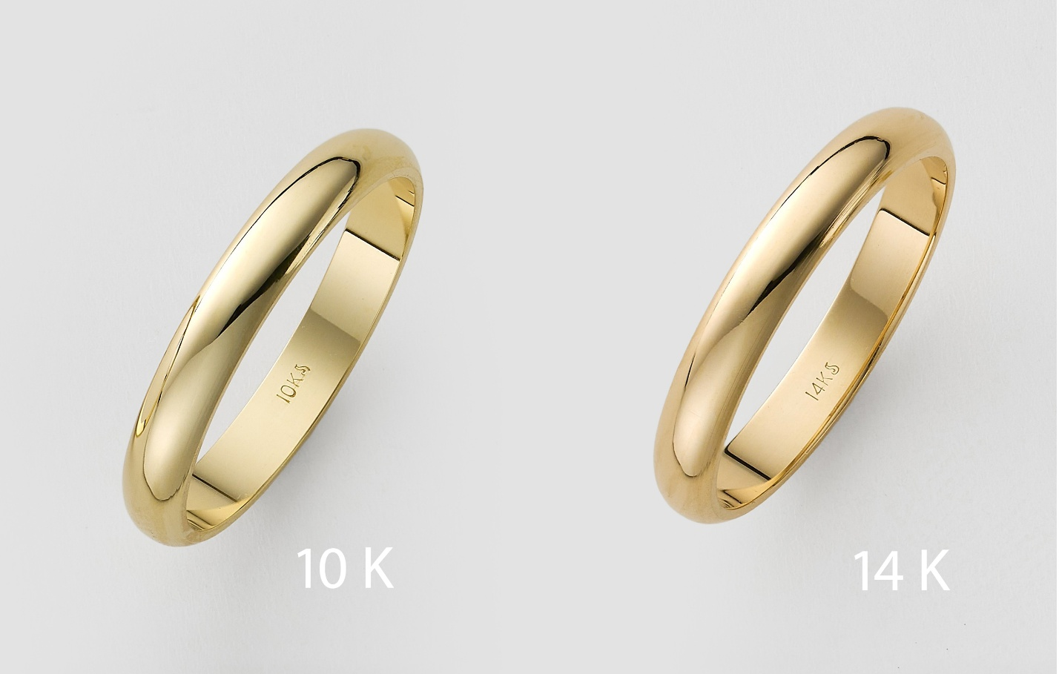
White Gold Color Reference 10k vs. 14k
Note: 10k is warmer shade; 14k is a cooler shade
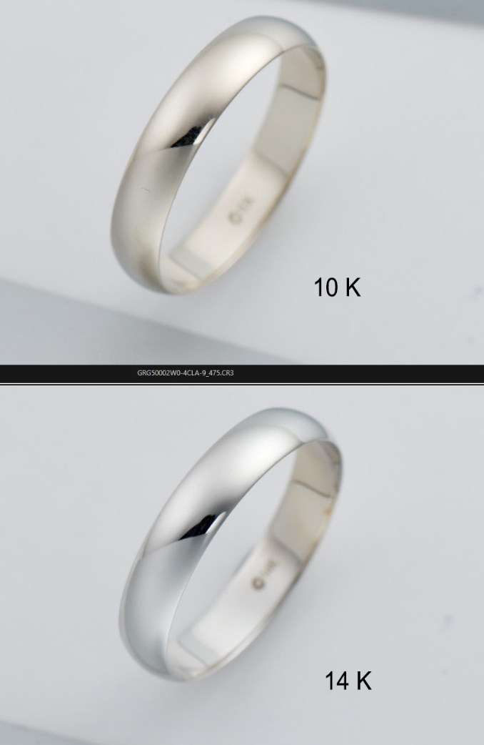
4.3. Gemstones & Diamonds
- Enhance brilliance and contrast slightly to emphasize sparkle.
- Preserve natural inclusions unless specified for removal.
- Ensure consistent color and lighting across all gemstones in a single image.
4.4. Shadows & Reflections
- Add soft, natural shadows or reflections beneath the jewelry when appropriate.
- Shadows must be subtle and realistic — avoid dark or heavy drop shadows.
- Reflections should enhance realism without cluttering the image.

5. Color Accuracy & Tone
- White balance must be neutral — no yellow, blue, or gray color cast.
- Colors should match the physical product accurately (especially metal tone).
- Avoid over-saturation; aim for realistic contrast and brightness.

6. Composition & Cropping
- Jewelry should be centered and symmetrically aligned.
- Maintain consistent framing and zoom level across all product images.
- Leave a small uniform margin (~5–10%) around the jewelry.
- Follow the 85% product fill rule strictly.

7. Consistency
- All images from the same collection or product type must have:
  - Consistent lighting and exposure.
  - Uniform color temperature.
  - Identical cropping and centering.

8. File Naming Convention
Use clear, structured filenames for delivery:
SKU_Main.jpg
SKU_Angle.jpg
SKU_CloseUp.jpg
SKU_Measurement.jpg
SKU_Lifestyle.jpg
Ensure each filename matches the SKU and image type for easy cataloging.

9. Delivery Requirements
- Deliver final, full-resolution files.
- Include web-optimized versions (under 1 MB each, 2000 px min) if requested.
- Submit via agreed cloud folder or delivery system.
- Maintain editable layered files (PSD or TIFF) for future adjustments.

10. Quality Control Checklist ✅
Before submission, verify each image:
- Dimensions: ≥ 3500 × 3500 px
- Product covers 85% of the frame
- Background is pure white (RGB 255, 255, 255)
- Image is clear, no pixelation or jagged edges
- Colors match actual jewelry
- Lighting is consistent and neutral
- Correct file naming convention used
- Shadows/reflections look natural
- Meets marketplace technical standards
High Polished Band Example:
NO! Over-retouched- Product looks matte and has lost shine and dimensions
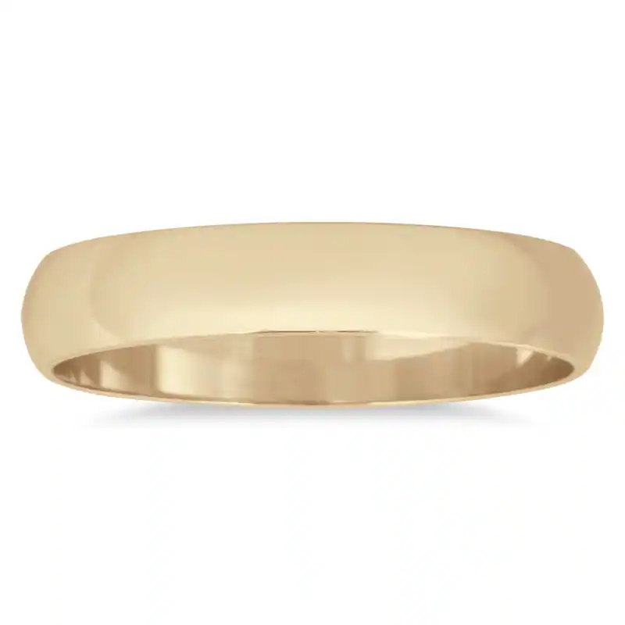
YES! Product looks shiny, high-polished, both versions are consistent, gold colors are accurate.
Ruler Shot Example
Shows product measurements accurately in both inches and millimeters