Hi Suman,
I have a small batch of images to send to you, please see the below file:
-Correct the skin tone and remove hairs from fingers and arms
-Fix the nail varnish, its starting to grow out a little
-Stone replacement
-White backgrounds only

Can you make all the images the same lighting / tone so they look like a set of images?

3 Crop like you used to do with the original batches:
-High res original
-Square (low res)
-l8:10

Please let me know the price?

IMG_8046 copy.JPG

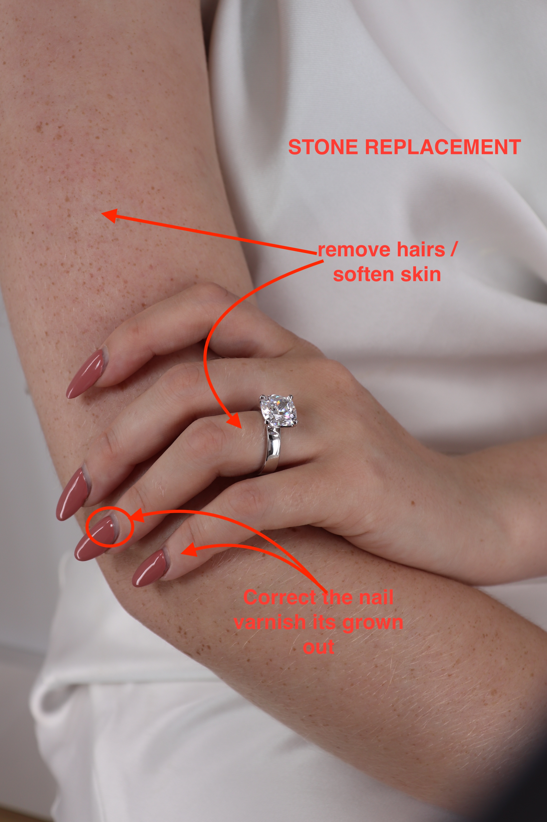
https://we.tl/t-jpTeLEhYbs

Also when you get the chance please could you re send these 3 images to me? I didn't seem to download them properly last time?
Screenshot 2025-09-23 at 09.41.08.png
