Kaushik I have had a look through and there are still some issues with some of the images - the yellow gold on the following images looks too dull - It also looks like band of the image might have been blurred a bit, meaning the dimension and the shine of the ring has been lost on this ring:
083FB8F8-AD55-4CF2-985C-BA0D864C04CF.jpeg
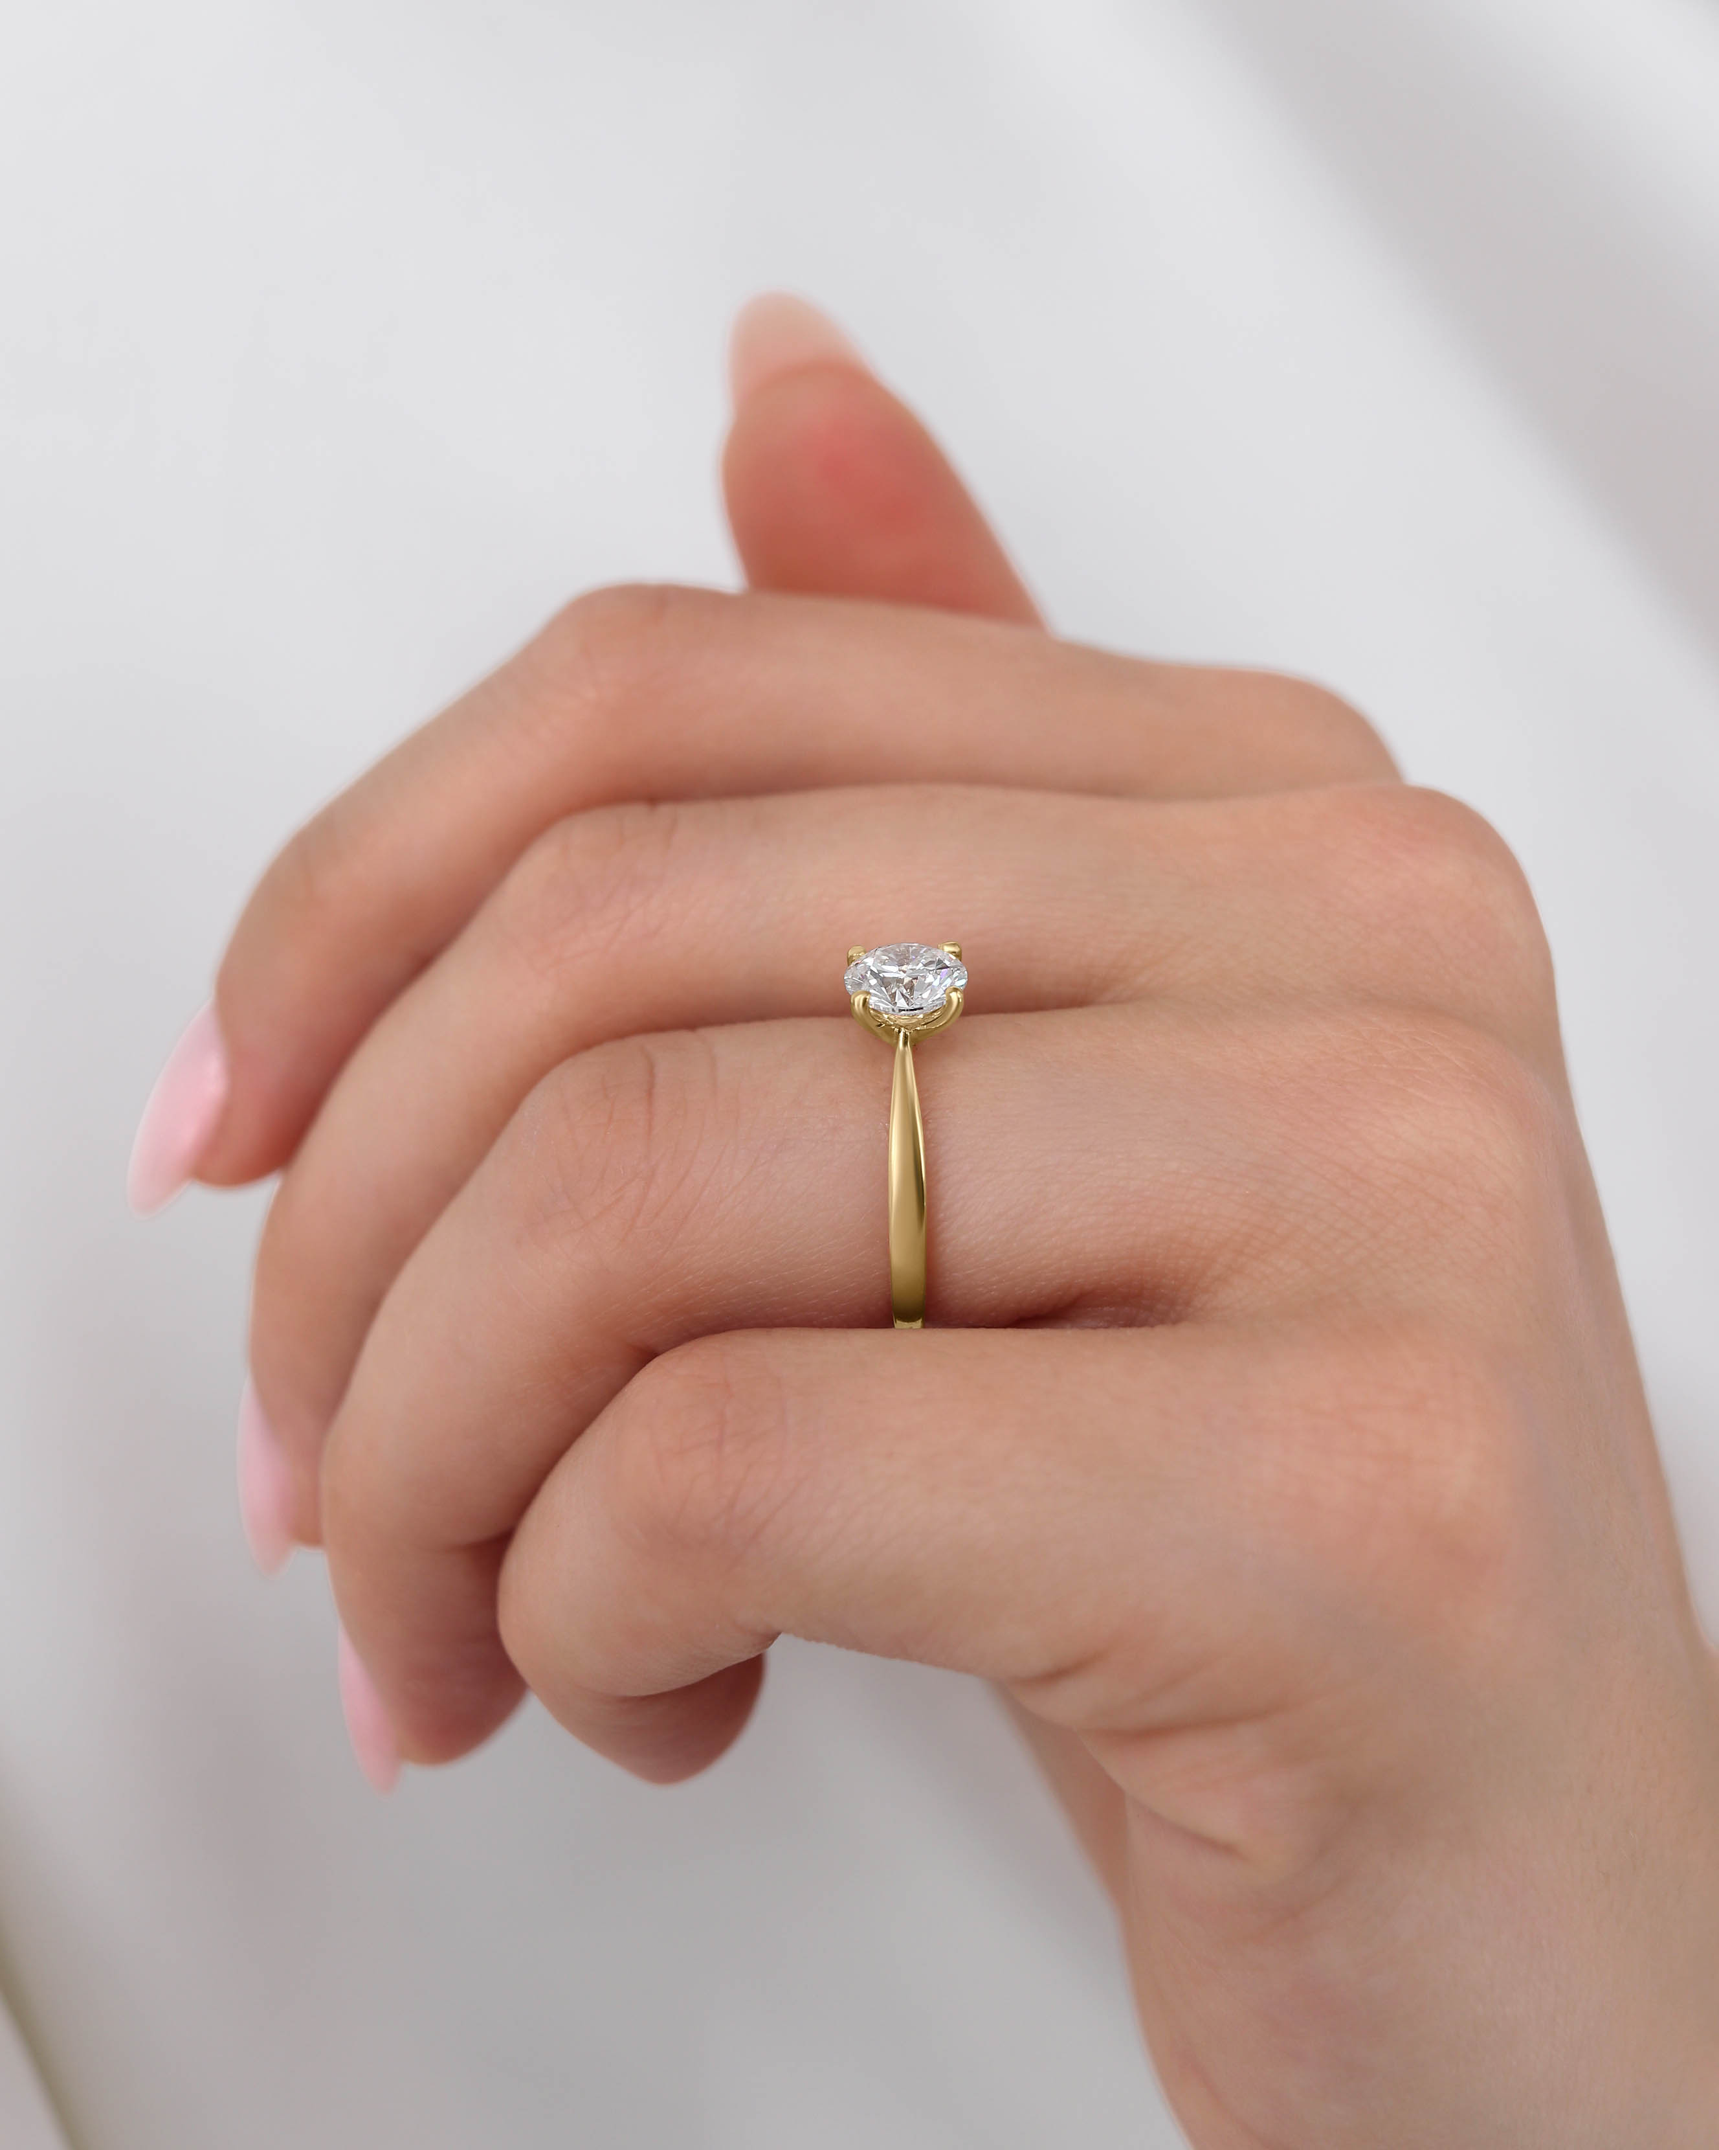
This yellow gold is is also too dull:

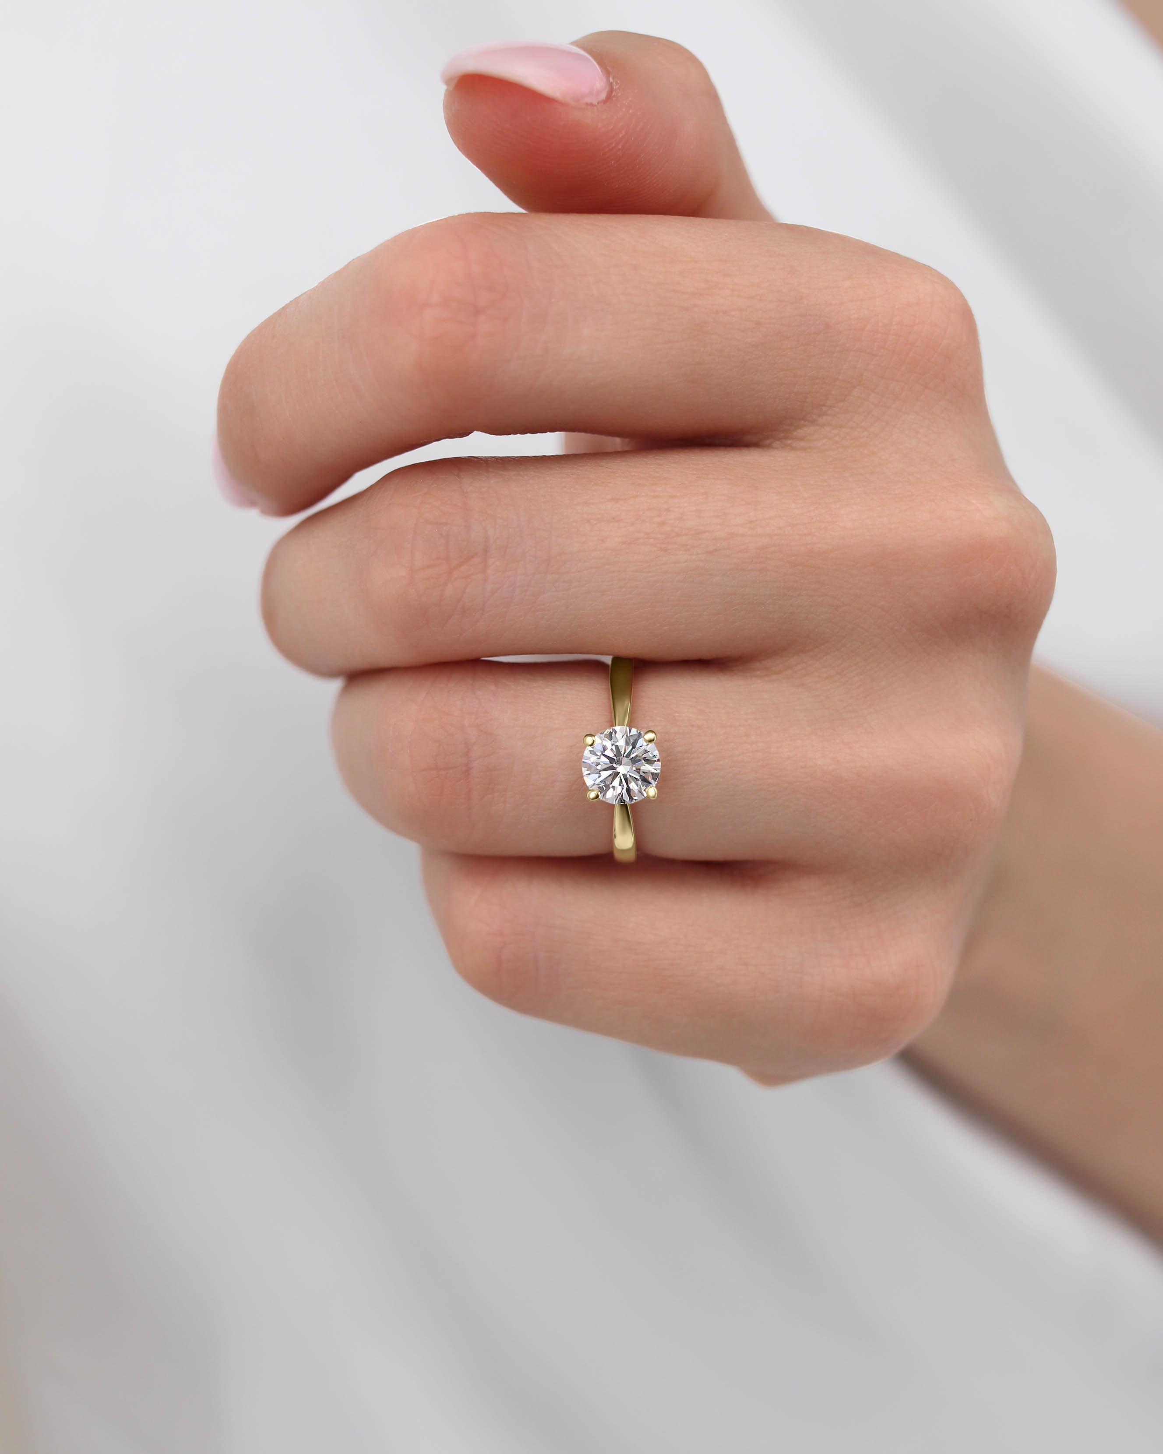
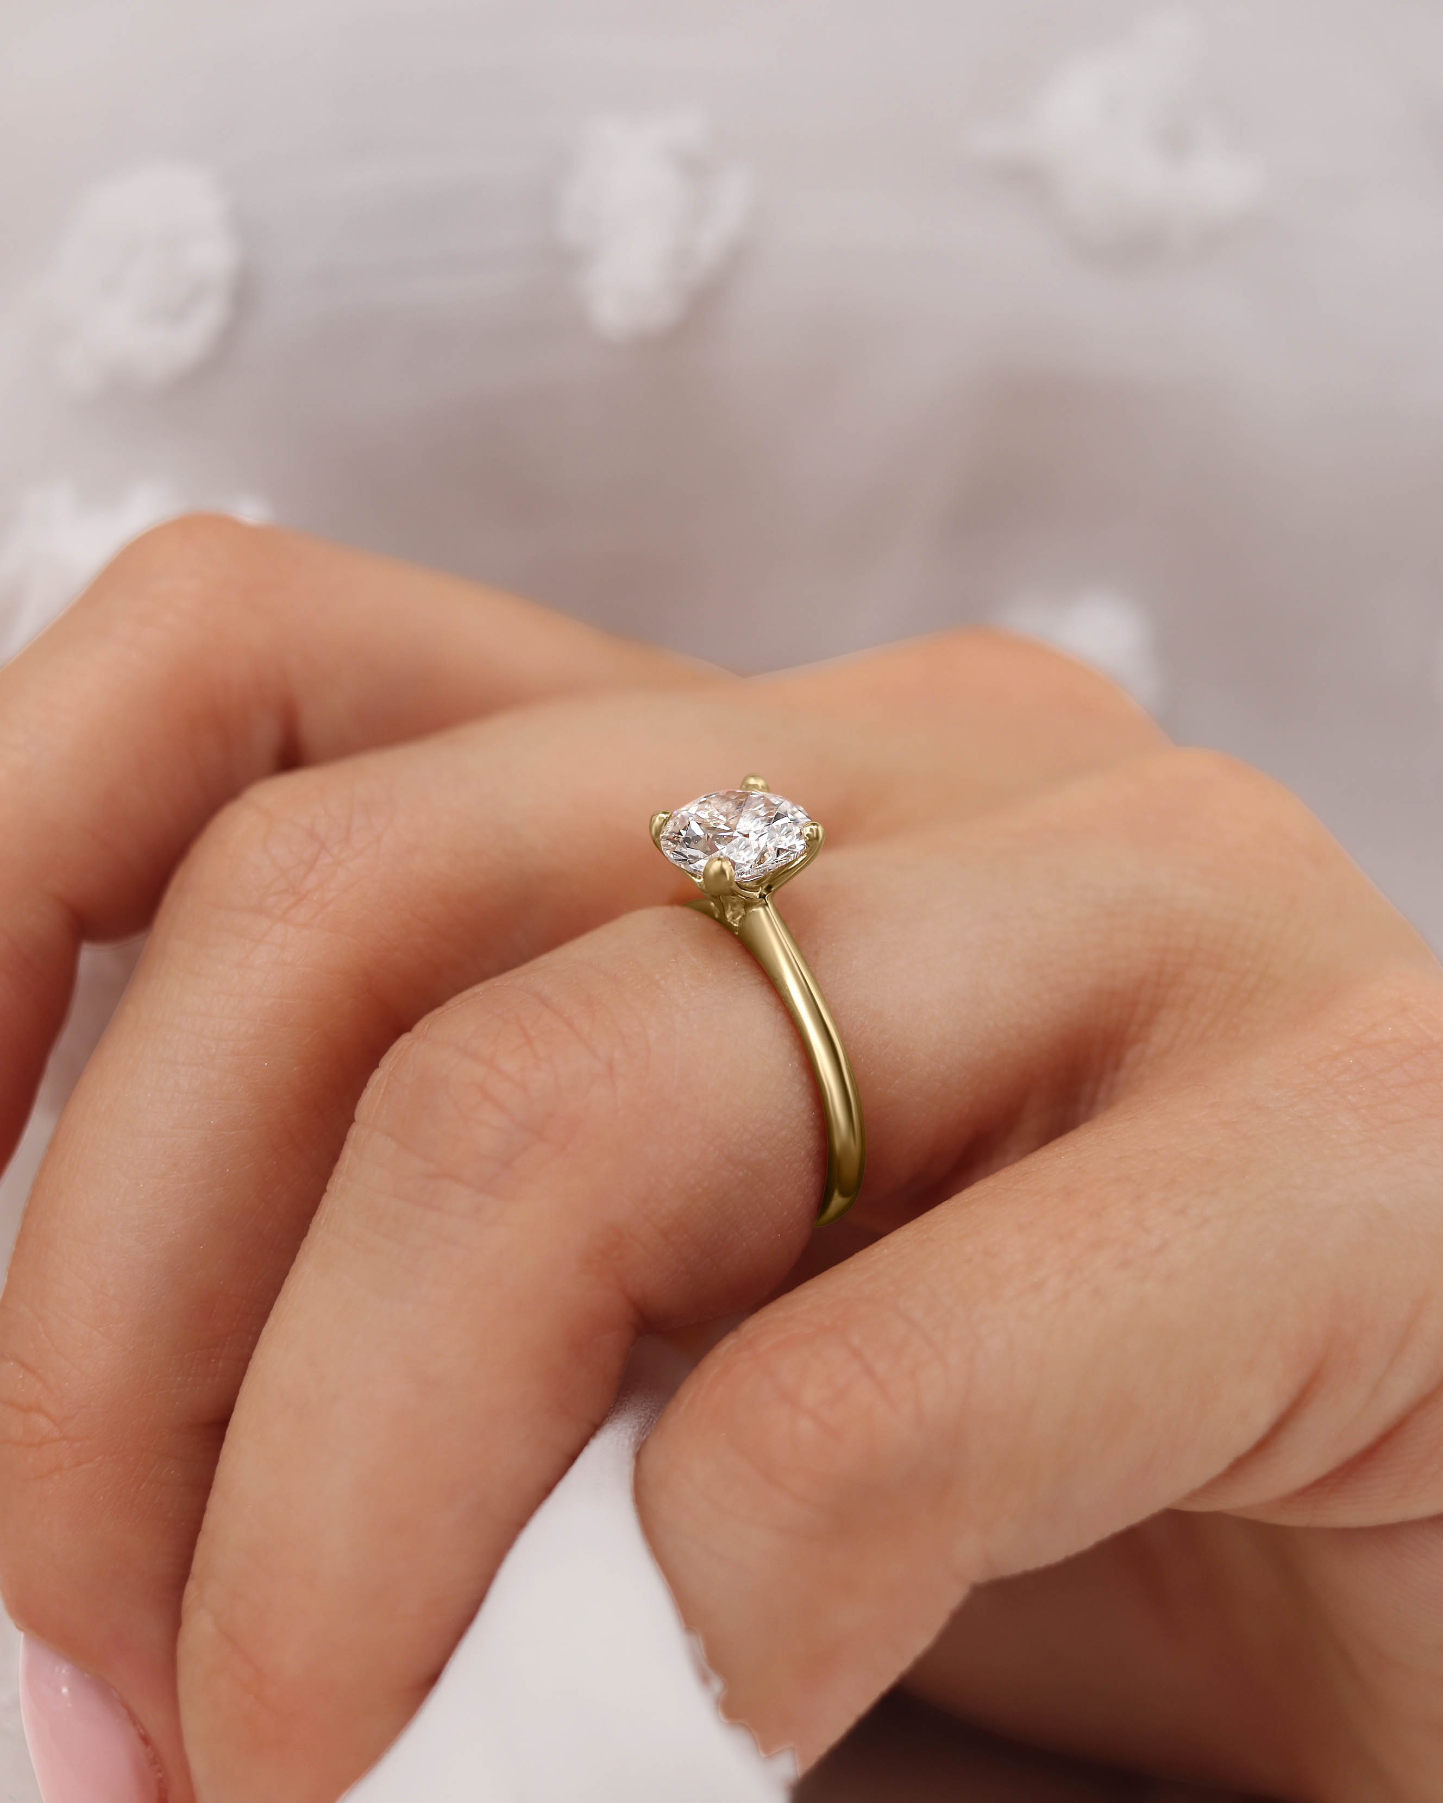
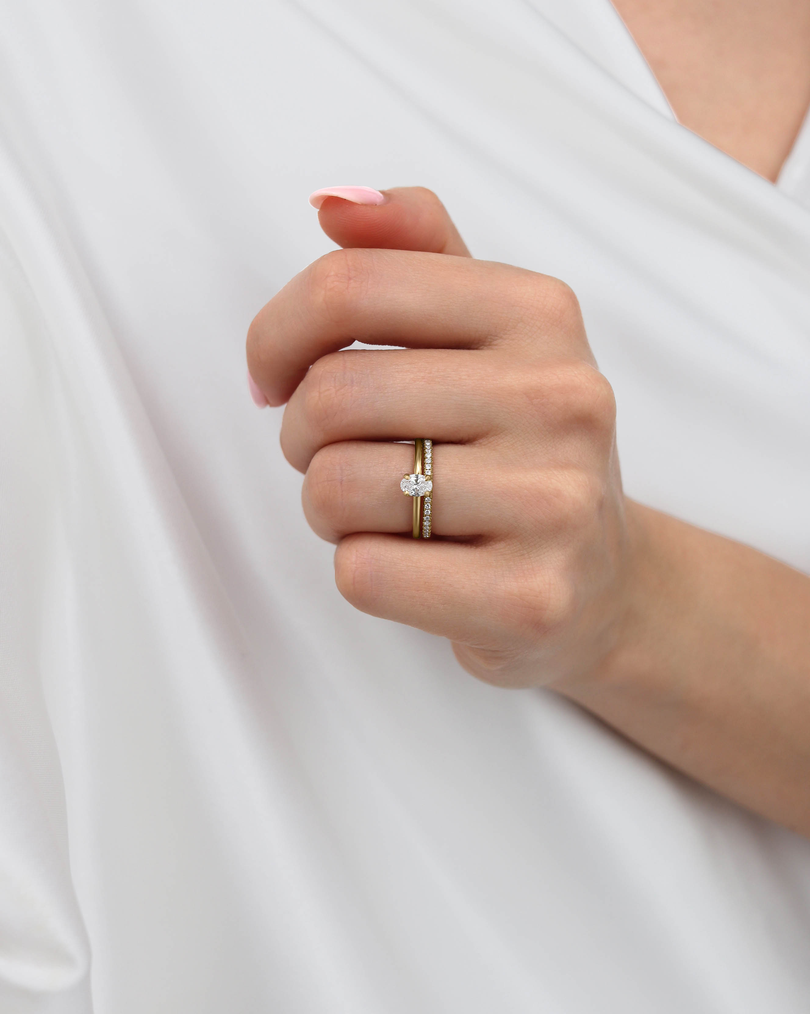
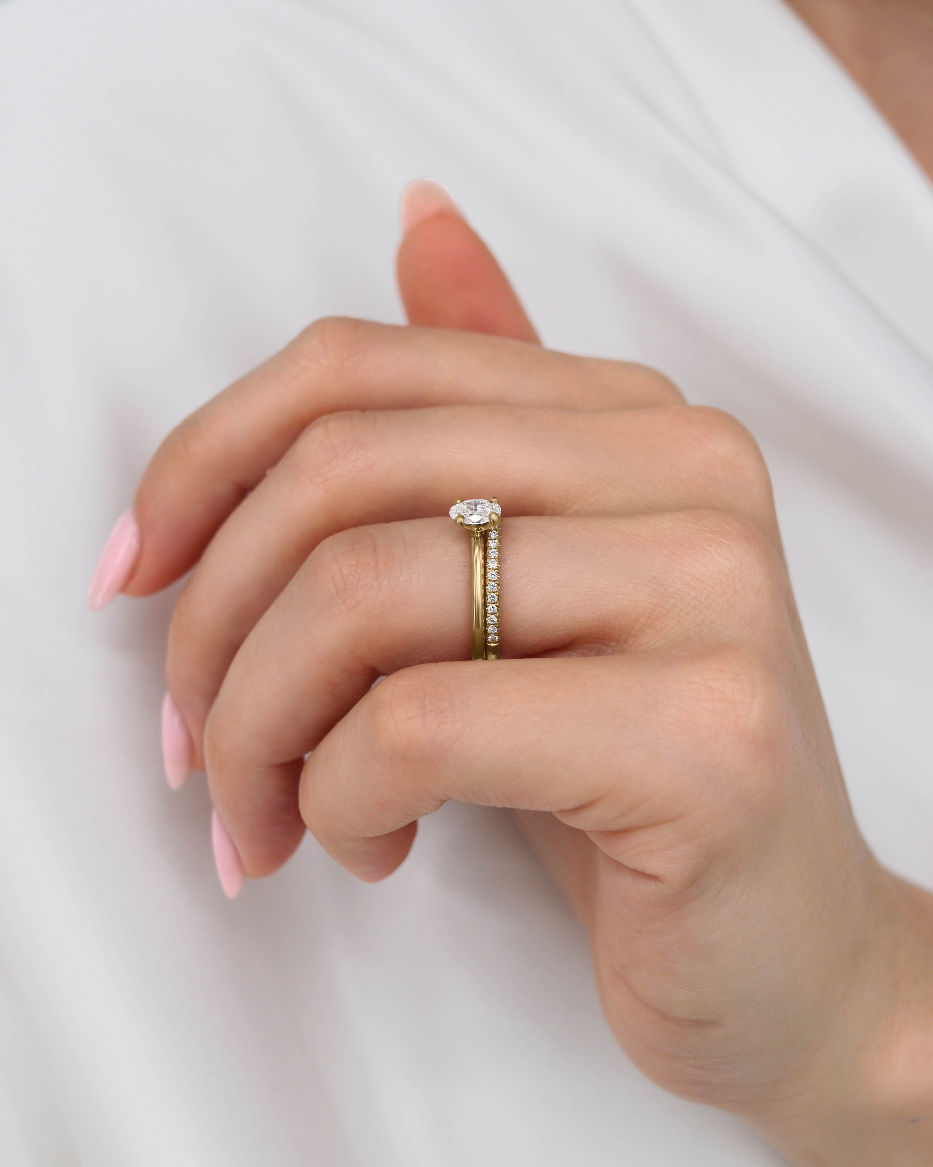
Once you have correct this mistake please send the send the whole batch all together with the revisions. Many thanks, Rowan

