Please re-edit the product below as it does not match the original.
The stones at the top are much too red.

Thank you.

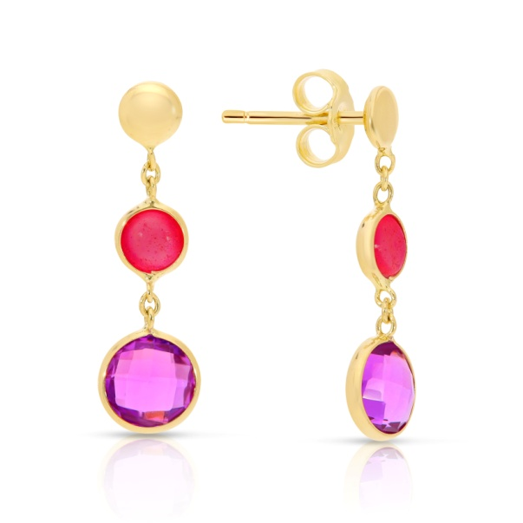
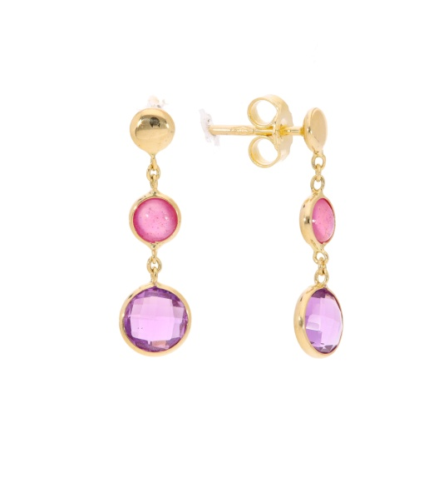
Keep in mind the original version and don't make them red, just slightly pink.

