Hello,
Please re-edit the image below as it shows small black stones in the original version.

Thank you.

BRN35377-RH.jpg
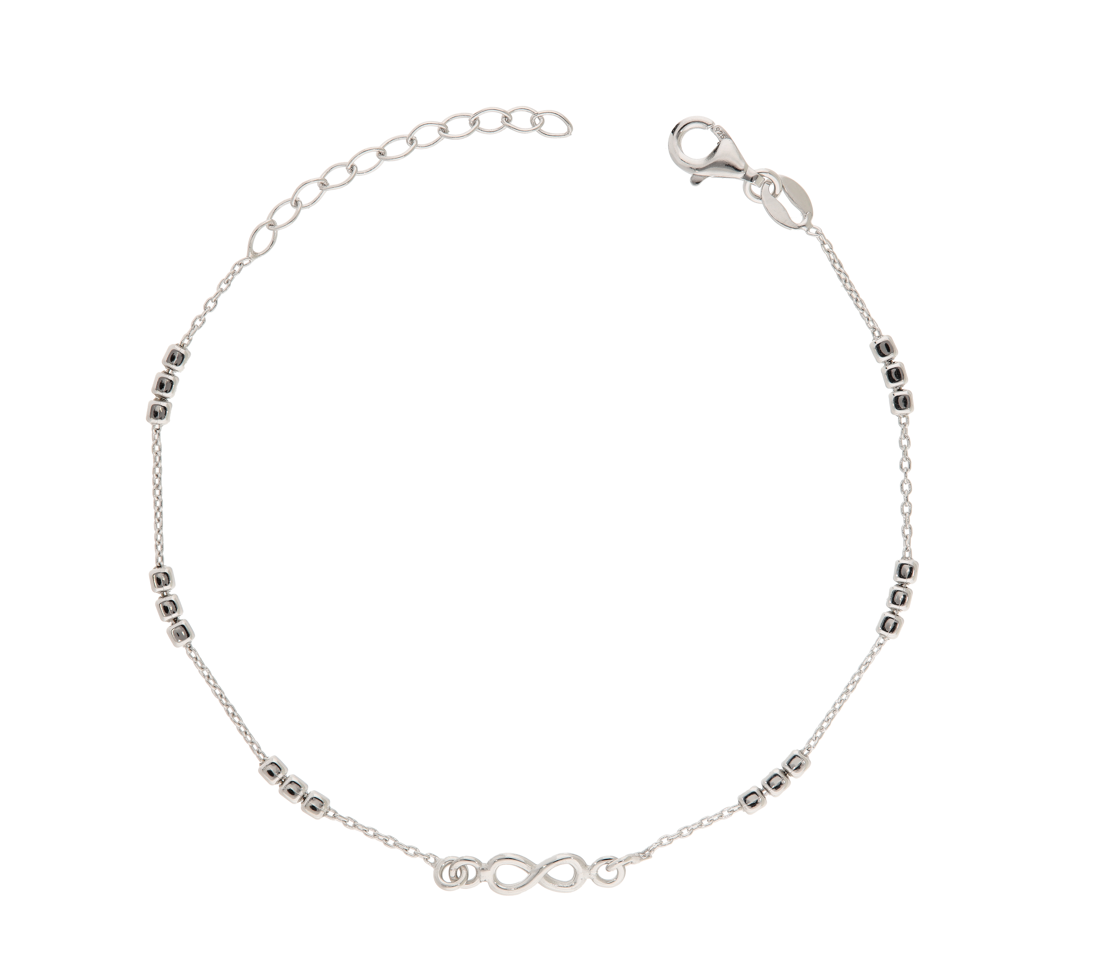

BRN35377-RH.jpg
BRN35377-RH.jpg
