We are moving all the complete images into seperate folders for the QC, as you complete new images dont put them in these folders jsut put them into the COMPLETE folder thanks!

these files are unreadable on our end, can you double check them. thanks!

Screenshot 2025-09-05 at 1.25.03 PM.png  
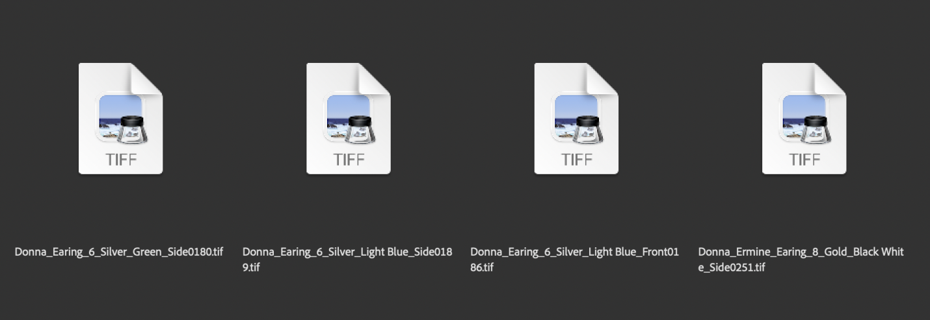

**Heres my initial QC notes.**

https://www.loom.com/share/6b5df282bc264fc88e24a35d2cdcf11a?sid=62f43623-8205-46a5-9e33-827396814dfe