I just took a look at a few and they're looking okay.

Masking looks good so far but cleanup is hit or miss.

Don't worry about updating them, I'll take care of it but just some things to note for next time --

-Remove tags inside shoes where they're showing

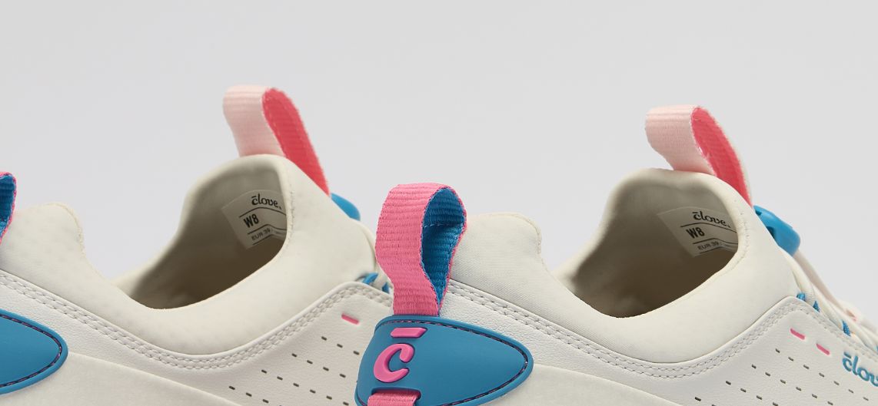

-Clean up the glue/seam on all shoes more (this looks messy)

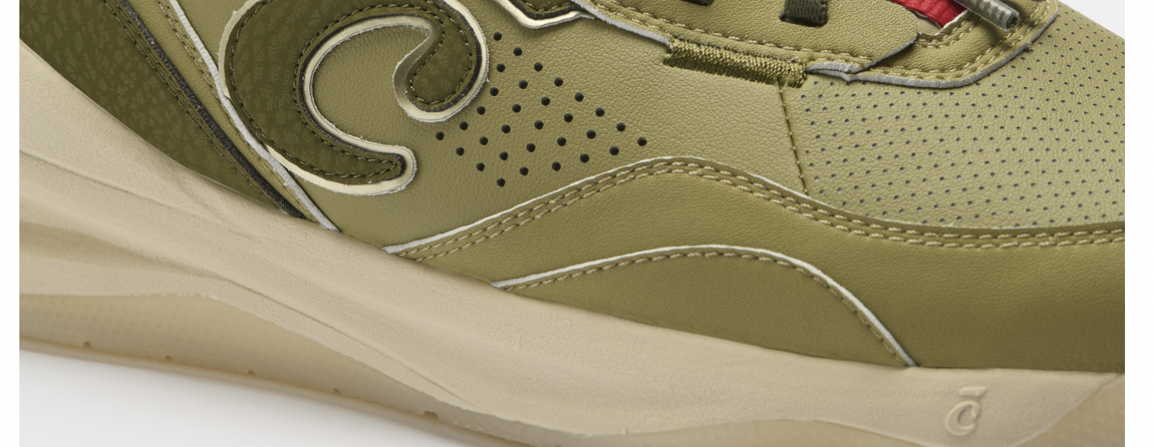

-There was no cleanup done on this image, only masking (seams/glue need to be smoothed out)

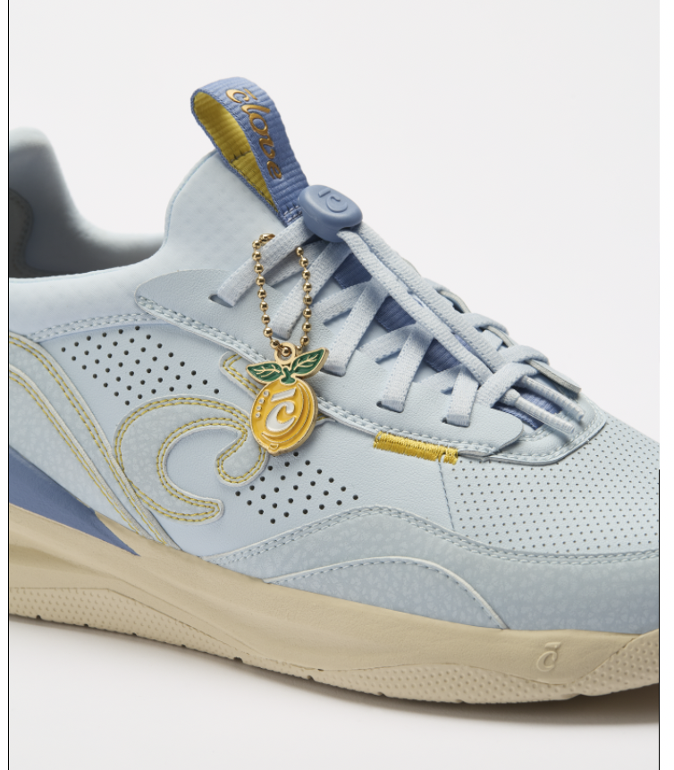

Here are some images that look good though! Tags were removed, seams are clean, and overall they look nice!

