v shaped one is okey.

You didn't need to reduce the distance for that one. Could you please undo it? The rest (color, honeycomb pattern etc) is okey

Please take this photo as reference.

image.png

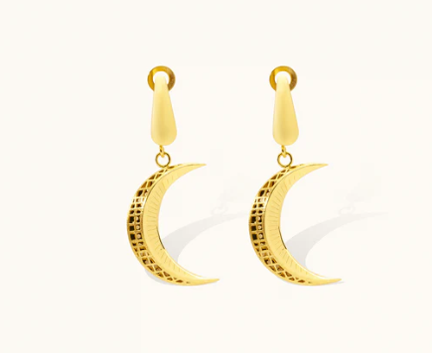

and the size also

