Hi again, here are the new photos.  
We need product only photos for these 2 earrings

1st earrings.  
Z_39.jpg  
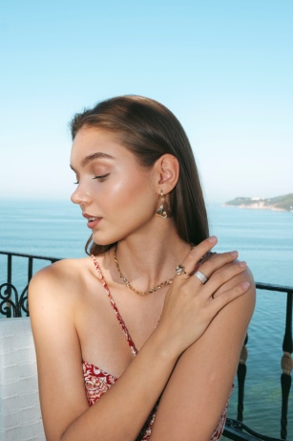

2nd earrings  
Z_40.jpg  
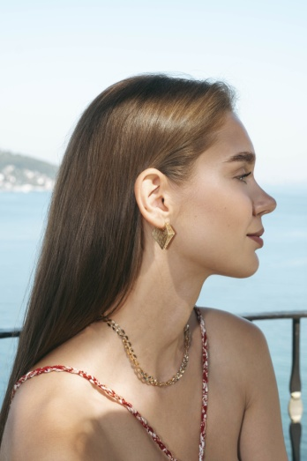

please take this photo as the reference pic.

image.png  
